Author Name: Charlotte Norsworthy
Affiliation: University of Georgia
Date Updated: 12/6/2016

Act Title: The 21st Amendment to the Constitution of the United States

Congress: 72nd Congress (March 4th, 1931 – March 4th, 1933)
Session/Sessions: 2nd
Statute No: 47 Stat. 1625
Public Law No:
Eid: 729921

Bill: SJR 211
Sponsor: Senator John J. Blaine (R-WI)
House Committees:
Senate Committees: Senate Committee on the Judiciary

Companion Bill: None
Related Bills: HJR 208, HJR 480, and SJR 202
House Rules: None
Past Bills:

Introduced Date- Law Date: February 15, 1933 – December 5, 1933
House Floor Days: 1 (February 20, 1933)
Senate Floor Days: 3 (February 14, 1933 – February 16, 1933)
Roll Call Votes: 8 (Voteview 72nd Senate RC# 265, 266, 267, 268, 269, 270, 271, House RC# 112)
Tags: amendment repeal, constitution, joint resolution, prohibition, alcohol, 21st amendment, 18th amendment
Contents
Summary 2
First Session Background 3
Senate Consideration of Sres 144 (January 20-21, 1933) 5
House Consideration of HJR 208 (March 14, 1932) 6
House Consideration of HR 10236 (March 25, 1932) 8
Senate Consideration of HR 10236 (May 18, 25, 1932) 8
House Consideration of HR 10017 (May 23, 1932) 9
Party Conventions (June 1932) 10
Senate Consideration of HR 12280, SJR 202 (July 1, 5-9, 11-16, 1932) 11
Midterm Elections (November 1932) 12
House Consideration of HJR 480 (December 5, 1932) 12
House Consideration of HR 13742 (December 20-21, 1932) 13
Senate Consideration of S 436 (December 23, 1932) 14
Senate Consideration of SJR 211 (February 15, 1933) 14
House Consideration of SJR 211 (February 20, 1933) 16
Aftermath 18
References 19

Summary

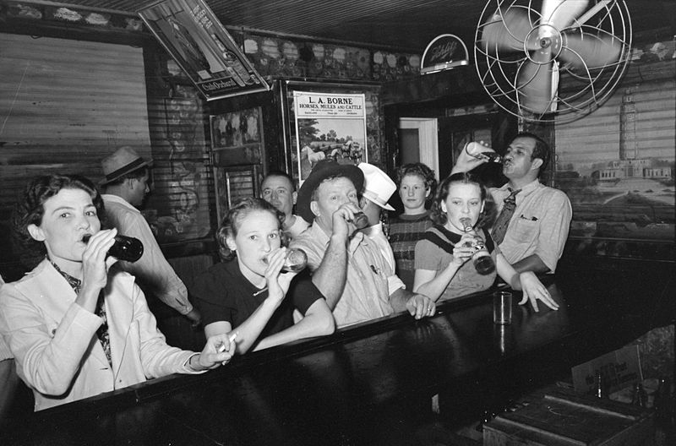
The Twenty-First Amendment repealed the Eighteenth Amendment, prohibiting the sale, production, and distribution of alcohol. The Eighteenth Amendment had been passed by the 65th Congress (1917-1919) and ratified by the states in 1919. The Twenty-First Amendment was fairly simple in language: it provided for the repeal of the Eighteenth Amendment, allowed states to still ban alcohol themselves and provided for its own ratification through ratification by state conventions. To date, it is the only Constitutional Amendment ratified by state conventions rather than by the usual state legislatures (Davis 2008). The New York Times suggested this was because congressional sponsors felt many state legislatures "remained beholden to pro-Prohibition interests."
Above: Patrons celebrate the passage of the Twenty-First Amendment, ending prohibition.

It was overwhelmingly adopted during the last days of the lame duck second session of the 72nd Congress (1931-1933). However, contentious debates over prohibition were common throughout the first congressional session. Opponents of prohibition used an array of procedural tools to force failed roll call votes on a number of proposals. They argued repealing or altering prohibition would decrease crime and increase revenue. Public support manifested through the party's convention platforms and the election of 1932 led a substantial number of members of Congress to change their positions on the issue. From the first roll call votes in 1932 to SJR 211's eventual passage, opponents of prohibition picked up 51 votes in the Senate and 107 votes in the House. The bulk of this increased support came from Democrats, but majorities of both parties supported the Twenty-First Amendment on final passage.

The Twenty-First Amendment was listed as landmark by Stathis (2014), Petersen (2001) and Clinton and Lapinski (2006), where it was rated the eighth most important enactment in the 72nd Congress. The House and Senate took 20 roll call votes on issues related to prohibition (15 in the Senate, five in the House). This included not only SJR 211, but also Sres 144, SJR 202, HJR 208, HJR 480, S 436, HR 10017 and amendments to HR 10236 (72 PL 154) and HR 12280 (72 PL 302). The Senate considered nine total amendments to SJR 211, five of which were dispensed with via roll call votes. The House passed SJR 211 under the suspension of the rules. Final passage of the measure in the Senate and House were agreed to by way of roll call votes, receiving over two-thirds of the vote for passage of the bill. SJR 211 was passed on February 20th, 1933, and was ratified December 5th, 1933.

First Session Background

The 72nd Congress met from March 4th, 1931, to March 4th, 1933, during the last two years of President Herbert Hoover's (R-CA) first term in office. The 1930 midterm elections were not kind to Hoover and the Republican Party. The country was entering the second year of the Great Depression and the President was not popular. Democrats gained 52 seats in the 1930 House elections and then won a number of special elections in the days that followed, giving them a seat majority. In the Senate, Democrats gained six seats and Republicans maintained control in the chamber 50-46.

The 72nd Congress was primarily concerned with passing legislation to alleviate the effects of the Great Depression. This including enacting the Reconstruction Finance Corporation Act (72 PL 2), the Federal Reserve Act Amendments (72 PL 44), the Revenue Act of 1932 (72 PL 154), the Emergency Relief Act (72 PL 302) and the Federal Home Loan Bank Act (72 PL 311). A number of other measures were considered but either not enacted (e.g., the Glass Banking Bill) or vetoed (e.g. Expansion of the Reconstruction Finance Corporation, Supplemental Appropriations, Amendments to the Tariff Act of 1930). Major laws not related to the Great Depression passed by the 72nd Congress include the Philippine Islands Independence Act (72 PL 311) and the 20th Amendment. The ratification of the 20th Amendment in January of 1933 ensured that the 72nd Congress would be the last Congress with a five-month lame duck period.

In addition to the Great Depression, there was substantial concern over prohibition, which had been adopted just over a decade earlier. Hoover was noted for calling prohibition a "noble experiment"—noble in that the intentions of the temperance movement were in an attempt to reunify families. Before prohibition, issues surrounding alcohol abuse and other alcohol-related illnesses and poverty concerned enough Americans to form a movement. Although this movement started with the foundation of alcohol regulation, it eventually evolved into a much stricter amendment, implemented by the Volstead Act during Woodrow Wilson’s administration.

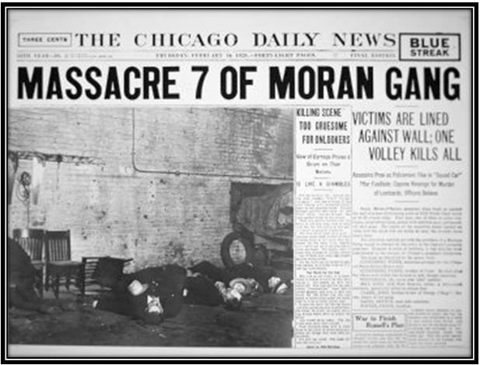
Above: Graphic stories and photographs from violent crimes like the St. Valentine’s Day Massacre led President Hoover to appoint a commission to examine the link between prohibition and crime.

Specifically, the Eighteenth Amendment was passed by the 65th Congress in December 1917 and ratified by the states in January 1919. It prohibited "the manufacture, sale, or transportation of intoxicating liquors." However, it did not define "intoxicating liquors." That task was left to the National Prohibition Act (66 PL 66)—or the "Volstead Act"—after its sponsor, Rep. Andrew Volstead (R-MN). The Volstead Act set a "stunningly severe definition of 'intoxicating'—anything ingestible that contained more than 0.5 percent alcohol (Okrent 2010, 111). It was passed in the 66th Congress over President Woodrow Wilson's veto on October 28th, 1919.

Prohibition appeared to have divided the country by region, as citizens and legislators from rural areas did not feel as much of the blunt of prohibition's enforcement (or lack thereof) or increased crime. Therefore, these individuals did not feel as though prohibition was a bad thing and was still fulfilling its original goal of rejoining families and essentially curing all of society’s problems during this time. Popular Reverend and prohibition supporter Billy Sunday said to a crowd of 10,000 people in Norfolk, Virginia: "We will turn our prisons into factories and our jails into storehouses and corncribs. Men will walk upright now, women will smile, and children will laugh (Moore 1997, 21)."

Prohibition itself was referred to as an experiment by Hoover because most in the country felt the Eighteenth Amendment was a failed attempt at alcohol regulation and led to an increase in crime. Many opponents of prohibition pointed to Al Capone, arguing his and other gangsters violent crimes were a direct result of their movement into the illegal alcohol trade (Eig 2010). On February 14, 1929, these violent crimes became more salient when seven members of Capone rival Bugsy Moran's gang were lined up against a wall and executed. Stories and graphic photographs from the "St. Valentine's Day Massacre" led newly elected President Hoover to appoint a National Commission on Law Observance and Enforcement with the intention of focusing on prohibition. The "Wickersham Commission", as it was dubbed after its chairman, presented a report in 1931 that linked prohibition to crime but did not take a definitive stance on the issue (Okrent 2010; Levine 1985).

Public support for the law was lagging. Support for prohibition dipped to 30.5 percent in a 1930 Literary Digest poll (Meier 1994). Many in the public felt that something had to be done about the Eighteenth Amendment, specifically due to persistent problems "wrought by poor law enforcement" and increasing crime as a result of the amendment (Anderson 2015). When finally considered in the House, Representative Mary Norton (D-NJ) remarked how the Twenty-First Amendment was long over-due, when she said before the House: "Mr. Speaker, and Members of the House, I am glad that I have lived to see this day. For 13 years the American people have looked forward to it. Let us do our part to make it a happy day” (Congressional Record, 72nd Congress, February 20, 1933, 4513).

Members of Congress and President Hoover were reticent to act on the issue in 1931. No votes on measures altering prohibition or the Volstead Act had been taken since they were enacted. And while prohibition was generally viewed as a Republican issue, members of both parties had supported it and were still serving. It seemed unlikely they would cast votes against it and appear to be "flip-flopping" on the issue.

Congressional supporters of prohibition were not helped when, in 1930, bootlegger George Cassidy was arrested for selling liquor to congressmen. Dubbed "the man in the Green Hat," Cassidy claimed to have sold alcohol to a majority of congressmen (Okrent 2010). Stories of member drinking—even prohibition supporters—were commonplace. In February 1929, the retiring Senator James Reed (D-MO) railed against prohibition and "the hypocrites in high places who vote dry and drink wet." Minority leader and later Speaker John Nance Garner (D-TX) was known to have private office he dubbed the "Board of Education." Garner and other lawmakers would drink bourbon during prohibition in order to, in his words, "strike a blow for liberty" (Champagne 1998).

Anti-prohibition activists were aided in 1927 when William Wheeler died. Wheeler, the leader of the Anti-Saloon League, was instrumental in the passage of prohibition. After his passing, Bishop James Cannon, Jr. filled his leadership void. Cannon, as Okrent (2010, 87), was "nasty, brutish and short." He lacked Wheeler's skill set and was beset with a number of scandals that impugned his reputation for high morality. This included allegations of mail fraud, financial irregularities and having an affair with his secretary (Jeffers and Kyvig 2000). Despite these advantages, with Hoover in the White House and substantial prohibitionist majorities in Congress, it seemed unlikely that the Eighteenth Amendment or the Volstead Act would be altered during the 72nd Congress.

Senate Consideration of Sres 144 (January 20-21, 1933)

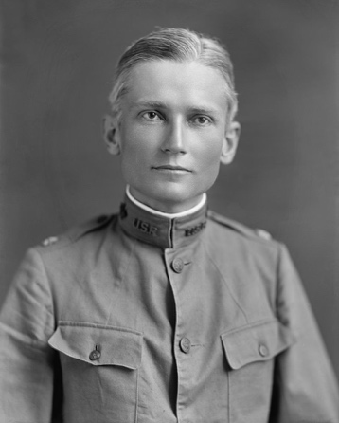
The first session of the 72nd Congress began in December of 1931. Prohibition was becoming increasingly unpopular and anti-prohibitionists (or "wets") had gained a substantial number of seats. Predicting a battle over the issue, the New York Times noted: "For the first time since the Volstead law was enacted over the veto of Woodrow Wilson, the anti-prohibitionists constitute more than a 'handful'." The article estimated that wets were still in the minority, holding between 174 and 177 of 435 House seats and between 27 and 30 of 96 Senate seats. Despite being in the minority in both chambers and leadership of both parties being made up of "drys," there was an expectation in the press that repeal or changes to prohibition laws would be considered in one or both chambers. This expectation was increased when later that month the Senate Judiciary Committee appointed a subcommittee of five senators to study proposals on the issue.

The subcommittee consisted of three drys: Senators Henry Ashurst (D-AZ); William Borah (R-ID); Thomas Walsh (D-MT) and two wets: Senators Hiram Bingham (R-CT) and John Blaine (R-WI). Blaine was appointed subcommittee chair. The subcommittee would hold hearings on a host of bills introduced in December 1931 and January 1932 that related to prohibition. These measures varied in content and included proposals to restrict the enforcement of the Volstead act, to amend the Volstead Act to permit beer up to 2.5 percent, to an outright repeal of the Eighteenth Amendment. These hearings occurred in mid-April and early May of 1932.
Above: Prior to coming to the Senate, Hiram Bingham (R-CT) was an academic and explorer most well-known for publicizing the location of the Inca city of Machu Picchu. He has been cited an inspiration for the Indiana Jones character.

Prior to the subcommittee hearings, however, the Committee on Manufacturing agreed to hold hearings on two measures introduced by Bingham. These bills, S 436 and S 2473, would not alter the Eighteenth Amendment, but would amend the prohibition act to legalize beer up to 4 percent by volume and tax it at a rate of five dollars per barrel. The hearings were held from January 8 to February 19, 1932.

Advocates of Bingham's measure concluded testimony on January 19th. Bingham then took action on the Senate floor to ensure a vote the prohibition issue. During the morning hour of January 20th, Bingham introduced a resolution, Sres 144, and asked that it "may go over, under the rule, in the regular order” (Congressional Record, 72nd Congress, January 20, 1932, 2316). Bingham argued that the purpose of the resolution was to "invite the governors of the States to secure an expression of opinion from their people [on prohibition]” (Congressional Record, 72nd Congress, January 21, 1932, 2404). Prior to the conclusion of morning hour on January 21st, Sres 144 was laid before the Senate.

Sres 144 was criticized by wet and dry senators. The minority leader, Senator Joseph Robinson (D-AR) declared it was an effort to "pass the buck" to the states and that it represented a "pitiable portrayal of impotence and cowardice on the part of [the Senate]” (Congressional Record, 72nd Congress, January 21, 1932, 2404). Robinson moved to refer it to the Judiciary Committee. Senator Smith Brookhart (R-IA), another "dry" senator, ridiculed it for "petition[ing] the governors of the States to petition the legislatures of the States to ask the people of the States to petition the Senate of the United States." Senator Millard Tydings (D-MD), a wet, asserted the resolution was a "vague, detached proposal" and argued the vote should be on repeal of the Eighteenth Amendment” (Congressional Record, 72nd Congress, January 21, 1932, 2412-2413). After Senator George Norris (R-NE), the Judiciary Committee Chair, dubbed it "perfectly ridiculous," Robinson withdrew his motion to refer.
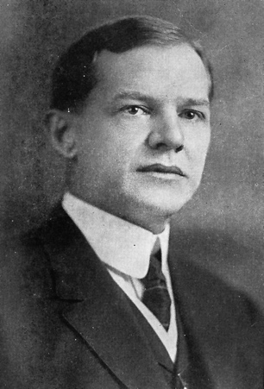
Sres 144 was rejected 18-64. The vote showed no clear partisan split. Eight Democrats joined ten Republicans in voting yes, and 34 Democrats and 30 Republicans voting no.

House Consideration of HJR 208 (March 14, 1932)

Like their Senate counterparts, House wets had also gained seats in the 1930 midterms but were in the minority. However, their efforts to force votes on matters related to prohibition were substantially aided by rules adopted by the new Democratic majority. Specifically, under the leadership of Rep. Charles Crisp (D-GA), Democrats liberalized the discharge rule so as to require only 145 signatures as opposed to 218 (see e.g. Schickler and Rich 1997; Pearson and Schickler 2009). Crisp, the son of a former House Speaker and current chairman of the Ways and Means Committee, had served as House Parliamentarian for six years and unsuccessfully argued for a 100 signature requirement in preceding Congress. Prior to the adoption of the new, more liberal rule, Crisp "stake[d] any little reputation I may have among my colleagues as to knowing the rules of the House that these rules will work and that they will not cause disorderly procedure but will ensure orderly procedure and at the same time ensure that a majority of this House can function” (Congressional Record, 72nd Congress, December 8, 1931, 73).
Above: The son of a former House Speaker and former House parliamentarian, Rep. Charles R. Crisp (D-GA) played a leading role in liberalizing the discharge petition rule for the 72nd Congress.

House wets first employed the new discharge petition rule in late February. Earlier in the month, the House Judiciary Committee began to hold hearings on HJR 208. The resolution, sponsored by Representatives John Linthicum (D-MD) and James Beck (R-PA), sought to amend the Eighteenth Amendment to permit individual states to determine the legality of alcohol themselves. HJR 208 had been introduced in the House on January 15th after a bipartisan conference of House wets had agreed on the substance and strategy. On February 16, 1932, the House Judiciary Committee rejected the Beck-Linthicum resolution 14 to 9. A discharge petition was prepared and laid before the Speaker's desk the following week. It amassed 110 of the 145 needed signatures within three hours and the remaining signatures were provided a few days later.

Linthicum moved to discharge the House Judiciary Committee on March 14th. Under the rule, debate was limited to ten minutes per side. Linthicum argued that if the House passed the resolution "depression would fade away like the mists before the noonday sun." He added that "[t]he immorality of the country, racketeering, and bootlegging will be a thing of the past." In opposition, Judiciary Chairman Hatton Sumners (D-TX) asserted this was the time to focus on economic issues and appealed "to wet and dry" for unity” (Congressional Record, 72nd Congress, March 14, 1932, 6000-6002). The discharge petition was rejected 187-239. This margin led both sides to declare victory.

Much like the Senate vote on Sres 144, it cut across the parties. Democrats broke 90-124 in opposition, with Republicans voting 97-114. As the figure below from Voteview.com demonstrates, the vote fell largely on the second dimension with Voteview correctly classifying 84% of the votes.

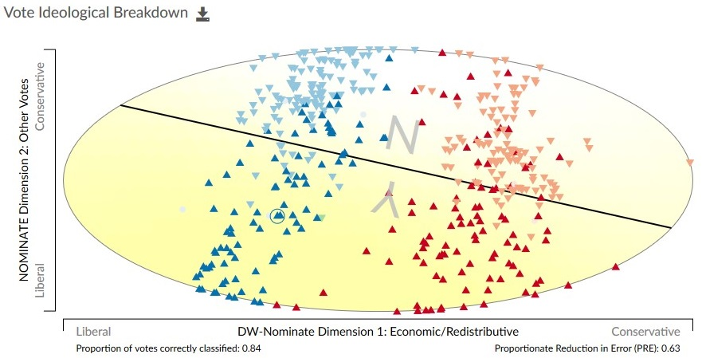
Source: Voteview.com (72nd Congress, rcnum 22).

House Consideration of HR 10236 (March 25, 1932)

Undeterred, House wets attempted a different tactic two weeks later. During debate over HR 10236, which would eventually be known as the Revenue Act of 1932 (72 PL 154), Rep. Thomas Cullen (D-NY) offered an amendment that would legalize and tax liquor that contained up to 2.75 percent alcohol. Rep. Thomas Blanton (D-TX) raised a point of order against the amendment on the grounds it was not germane. Crisp, the bill manager and opponent of the amendment, disagreed. The Chair concurred with Crisp and rejected Blanton's point of order.

Cullen and his supporters argued for the amendment on economic grounds. He argued the amendment would have yielded between 350 to 500 million dollars in revenue. Building off of this, Rep. Frank Oliver (D-NY) joked that "the wets offer to drink up the deficit. If that offer is not accepted, then we are going to ask the drys to balance the budget” (Congressional Record, 72nd Congress, March 25, 1932, 6831). Opponents accused the wets of trying to bypass the Constitution. For example, Rep. Ulysses Guyer (R-KS) asserted the "amendment seeks to do by indirection that which cannot be done directly...nullify the Constitution by act of Congress” (Congressional Record, 72nd Congress, March 25, 1932, 6834). Crisp suggested the amendment’s adoption would lead to the bill's defeat, adding that the revenue bill was "an imperative need" of the government. The Cullen amendment was the rejected via teller vote, 132-216.

Senate Consideration of HR 10236 (May 18, 25, 1932)

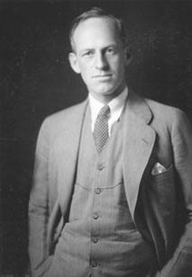
The House passed HR 10236, the Revenue Act, on April 1, 1932. After the measure was brought to the Senate floor, Senate wets sought to follow the lead of their House colleagues by offering anti-prohibition legislation as amendments to the bill. Bingham's bills legalizing 4 percent beer, S 436 and S 2473, were adversely reported by the Senate Manufacturing Committee on a 7 to 4 vote in mid-April. He immediately announced his intention to offer the proposal as an amendment to HR 10236.

On May 17, Bingham was beaten to the punch by another wet senator. Tydings offered an amendment to the Revenue bill that sought to create a construction fund through the legalization and taxation of beer of up to 2.75 percent alcohol. The amendment, offered at the start of a second consecutive Senate night session, caught the bill manager, Senator Reed Smoot (R-UT) off-guard. Smoot inquired as to whether Tydings really wanted to a vote on the amendment that night. Tydings asserted he was "just as sincere and earnest in my desire to have it adopted as [Smoot] is about the bill itself” (Congressional Record, 72nd Congress, May 17, 1932, 10425). Smoot declared he had no objection to a vote and Tydings began to speak on his amendment's behalf.
Above: The most vocal Democratic wet in the Senate, Millard Tydings (D-MD). He would later be known for his aggressive opposition to both the New Deal and McCarthyism.

Debate over the Tydings amendment mirrored the earlier House debate. Tyding, like Cullen, focused on the economic benefits of his amendment and opponents largely questioned the constitutionality of it. Tydings had declared he wanted to "have a real fight about it." This was obliged by dry senators. At one point during the night session, Brookhart interrupted Tydings by shouting "he would "vote [to give those suffering] $5,000,000,000 [for] bread; but I will not vote one cent to give them booze” (Congressional Record, 72nd Congress, May 17, 1932, 10437). Tydings responding by asking him where the five million would come from. Senator Morris Sheppard (D-TX), who sponsored the Eighteenth Amendment and was known as the 'Father of Prohibition,' asserted that in his "judgment no Senator can vote for this amendment without violating his oath to support the Constitution of the United States. In my judgment the one-half per cent or more provision is an honest and candid definition of intoxicating liquor” (Congressional Record, 72nd Congress, May 17, 1932, 10437).

The chamber recessed at 9:45pm and the debate continued on May 18. Debate was dominated by supporters of the Tydings amendment. The New York Times noted that Sheppard was the sole opponent of the Tydings amendment to speak on the floor. Six wets joined Tydings in support. In support of the amendment, Senator Jesse Metcalf (R-RI) recited a poem: "O' God Almighty, Lord divine, Who once turned water into wine; Forgive the wicked acts of men, Who try to turn it back again” (Congressional Record, 72nd Congress, May 18, 1932, 10516). Bingham then offered an amendment to the Tydings amendment, striking out 2.75 percent and inserting 4 percent. Almost immediately after it was submitted, Bingham's amendment was defeated 23-60. The Tydings amendment was then rejected by a similar 24-61.

Bingham tried again on May 25th. He amended his 4 percent proposal to 2.75 and applied the revenue towards a decrease in the sales tax on automobiles. Bingham said he hoped this change would lead to 30 votes. It did not. After a spirited debate largely between Bingham and Borah, the revised Bingham amendment fell 26 to 55.

None of the votes on the amendments were partisan. Approximately 30 percent of Democrats and 28% of Republicans supporting the Bingham Amendment in the second-degree and the Tydings Amendment. The coalition on Bingham's Amendment on May 25th was almost identical.

House Consideration of HR 10017 (May 23, 1932)

Two days before Bingham's revised amendment was defeated in the Senate, House wets again took advantage of the liberalized discharge petition rule to force another recorded vote. This time the target was HR 10017. HR 10017 also legalized the sale of 2.75 percent beer and taxed it at a rate of 3 cents a pint. The bill was co-sponsored by Representatives John O'Connor (D-NY) and William Hull (R-IL).

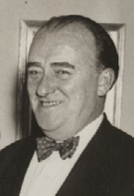
Dry House members expressed a great deal of frustration over the usage of the discharge rule. After O’Connor offered the motion to discharge, Blanton immediately raised a point of order against it on the grounds that it contradicted a ruling from the Speaker that "no two bills embracing similar subjects shall be submitted" to the House under the discharge rule (Congressional Record, 72nd Congress, May 23, 1932, 10950). The Speaker of the House, Rep. John Nance "Cactus Jack" Garner (D-TX) allowed some debate on the topic before overruling Blanton's point of order.

As limited by the rule, floor debate was short, though dominated by the wets. Much of their statements focused on economics, but a few also highlighted the wasted resources on enforcement. For example, Hull claimed that passing the bill would "aid the farmer" and "loosen the grip that crime has on Uncle Sam's throat” (Congressional Record, 72nd Congress, May 23, 1932, 10955). Others pointed to changing public opinion. A Literary Digest poll released in late April reported that 73% of the public now supported repealing prohibition (Meier 1994). Representative Adolph Sabath (D-IL) referenced it, arguing members should not "remain deaf to the demands of 72 percent of American citizens” (Congressional Record, 72nd Congress, May 23, 1932, 10953). Blanton, one of the few to speak against the petition, was booed after his speech. Despite this, the motion was defeated 169-228, a slightly larger margin than the one rejected Beck-Linthicum in April.
Above: Rep. John J. O’Connor (D-NY), a leading House Democratic wet. He would go on to chair the House Rules Committee. His opposition to the New Deal would lead to his defeat in the 1938 Democratic primary.

Party Conventions (June 1932)

In June the two parties held their nominating conventions. The Republican Convention met first. Hoover, while not popular, was eventually nominated for reelection. The party did not take an official stance on the 18th Amendment in their 1932 Party Platform. Rather, the party said that their focus was returning the issue of alcohol regulation back to the states, specifically proposing the amendment should be passed so that it "shall allow the States to deal with the problem as their citizens may determine," and that the Federal government should still protect citizens from "the return of the saloon and attendant abuses."

On the convention floor, Bingham was cheered as he spoke out against this. He advocated for immediate repeal of the 18th Amendment. Along with former Senator James Wadsworth (R-NY) and others, he pressed for a vote on a repeal plank. The vote was given, and repeal was defeated 690 to 460 (Jeffers and Kyvig 2000).

Later that month, the Democrats met. Democratic presidential candidates Garner and former Governor Al Smith (D-NY) had endorsed a full repeal of the Eighteenth Amendment prior to the convention. The Democratic front-runner, New York Governor Franklin D. Roosevelt (D-NY), had endorsed a revision of the Volstead Act in late February but advocated submitting the issue of repeal directly to the voters (Jeffers and Kyvig 2000). His position changed during the convention as full repeal became more popular. By the end of the convention, both Roosevelt and the Democratic platform advocated Congress pass a full repeal amendment that would be submitted to state conventions (Jeffers and Kyvig 2000).

Senate Consideration of HR 12280, SJR 202 (July 1, 5-9, 11-16, 1932)

The party platforms incentivized Republican wets to force recorded votes putting their dry Democratic opponents "on the record." Unsurprisingly, given their control of the chamber, they had more success in the Senate. HR 12280, which would eventually be enacted into the Federal Home Loan Bank Act (72 PL 302), was on the Senate floor. On July 1, Bingham announced his intention to offer his bill legalizing and taxing beer that contained up to four percent alcohol as an amendment to the bill. While it was discussed on July 1st, Bingham stated he would not formally offer it until the Democrats returned from their convention on July 5. He argued the amendment conformed to the revised Democratic platform and that he expected many new Democratic votes in support.

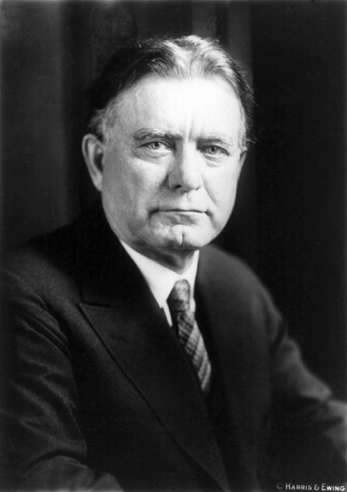
Bingham's announcement led to a protracted debate over prohibition and modifying the Volstead Act in the Senate. Debate over Bingham's amendment and other proposals consumed the chamber in early July. Democrats questioned Bingham's sincerity in proposing the amendment, which they dismissed as a rider. They argued it was a cynical attempt to provide electoral cover. Bingham largely conceded this point, arguing that Democrats who supported their party's platform and voted against his amendment would be providing "no better campaign document." He added that Democratic opposition would result in the Republicans carrying Connecticut.

Wet Democrats chastised the weakness of the Republican party platform on prohibition, asking Bingham and other Senate wets why they were so interested in the Democratic plank and not the Republican. Bingham responded, explaining "the reason is that I do not like the Republican plank and I do like the Democratic plank” (Congressional Record, 72nd Congress, July 7, 1932, 14750). Bingham's amendment was formally offered on July 7th. During a lengthy debate, Bingham was barred from further discussion under the two-speech rule. The following day, Borah, another leading Republican dry, effectively blocked a vote on Bingham's amendment by introducing a popular currency provision as a second-degree amendment.
Above: A leading Republican dry, Senator William Borah (R-ID) frequently sparred with Bingham over prohibition.

In response, Bingham withdrew the amendment and offered it again on July 11th. This time, his amendment followed the earlier Tydings amendment in legalizing and taxing 2.75 alcohol beer. Opponents largely focused on the sincerity of Bingham's amendment and the constitutional question. Dry opponents argued supporters of the amendment had no idea what the scientific standard for "intoxicating" was. Mocking the length and detail of the debate, Senator Huey Long (D-LA) recited a definition of drunkenness, which he claimed he found in the North Carolina Law Journal: "Not drunk is he who from the floor; Can rise again or drink once more; But drunk is he who prostrate lies; And cannot either drink or rise!” (Congressional Record, 72nd Congress, July 11, 1932, 14981).

Robinson moved to refer the Bingham amendment to the Judiciary Committee. This was agreed to (thus killing the amendment) by a 50-25 vote. Democrats voted to refer the measure by a 24-13 margin. Bingham argued the vote demonstrated that despite the rhetoric at the convention, most Democrats did not support modifying the Volstead Act.

In response to the vote, Senator Carter Glass (D-VA) introduced a measure repealing the Eighteenth Amendment but prohibiting saloons and leaving legalization of liquor to the states. Glass, a prominent dry, argued this was essentially the Republican convention platform. After his unanimous consent request to take up the measure, SJR 202, was denied, Glass asked that it lay on the table, noting he would move to take it up as a later stage "chiefly to test the good faith and sincerity of the Senator from Connecticut and other Republicans who have engaged in 'testing the sincerity' of the Democratic Party” (Congressional Record, 72nd Congress, July 13, 1932, 15184).

On July 16th, Glass moved the Senate proceed to consider SJR 202. Norris moved to commit SJR 202 to the Judiciary Committee. Bingham, supporting the Glass resolution, raised a point of order against Norris's motion on the grounds that "he cannot move to send a resolution to a committee when the resolution is not before the Senate” (Congressional Record, 72nd Congress, July 16, 1932, 15649). This was upheld by the Chair and the question recurred on Glass's motion to proceed. Prior to the vote, Senator James Couzens (R-MI), pointed out that over 2,000 pages of material on "the liquor question" were inserted into the Congressional Record during the first session of the 72nd Congress. Glass's motion was then adopted, 50-26, with 31 Democrats and 19 Republicans voting in favor. No further action was taken on SJR 202 and the first session of the 72nd Congress adjourned later that day.

Midterm Elections (November 1932)

The November elections had an even more significant effect on the prohibition issue than the nominating conventions. Hoover lost to Roosevelt by a landslide, with Roosevelt capturing 88.9 percent of the electoral college vote. Democrats gained control of the Senate by picking up 12 seats and increased their House margin by 97 seats.

While a number of prominent Republican wets like Bingham, Blaine and Hull were defeated, the wave greatly benefited anti-prohibitionists in the aggregate. The New York Times estimated they had 292 House seats and gained a number of important Senate seats. A large number of state referendums also resulted in the adoption of wet policies.

House Consideration of HJR 480 (December 5, 1932)

The second session of the lame duck 72nd Congress met on December 5, 1932. Almost immediately after convening, Rep. Henry Rainey (D-IL), the majority leader, moved the House suspend the rules and pass HJR 480. HJR 480 was a proposed constitutional amendment that would repeal the Eighteenth Amendment upon the ratification by "conventions" in three-fourths of the states. Debate is limited to 40 minutes on motions to suspend the rules, and while supporters asked for unanimous consent to extend debate to four hours, their requests were rejected.
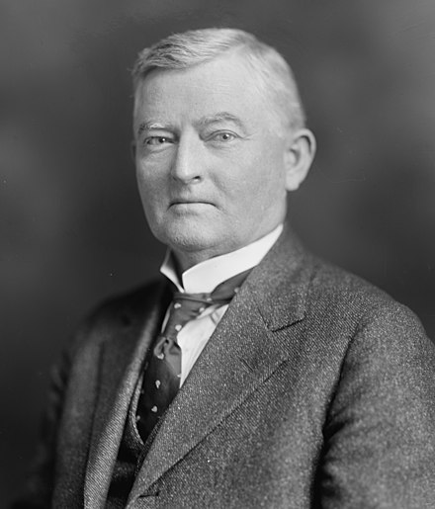
Opponents of the resolution focused their arguments almost exclusively on the procedural tactics employed by the majority. Specifically, they complained that HJR 480 was being rushed through the chamber under a procedure that minimized debate and barred amendments. For example, Rep. Bertrand Snell (R-NY), the minority leader, announced his support for the amendment but argued the majority "[by] rushing this through today under suspension of the rules, with only 20 minutes of debate on each side, before we are fully organized for business, [was] breaking the precedents of 150 years." Proponents, like Rep. Emanuel Celler (D-NY), countered by claiming the House "has been discussing this matter for 12 years." Others, like Rep. Fiorello La Guardia (R-NY), pointed to public opinion: "Now is the opportunity for Members to vote the will of the people regardless of their own personal views. We must act in our representative capacity” (Congressional Record, 72nd Congress, December 5, 1932, 8-10).
Above: Speaker of the House John Nance “Cactus Jack” Garner (D-TX) was known to have private office he dubbed the "Board of Education." He and others would drink in it during prohibition to, in his words, "strike a blow for liberty" (Champagne 1998).

The motion to suspend failed 272-144 (two-thirds required) by six votes. It received majority support of both parties, with Republicans voting 104-101 in favor and Democrats 170-44. This was a substantial increase in Democratic support from the 41% that supported the motion to discharge Beck-Linthicum in March. After the vote, Speaker Garner announced this would be the last vote on the topic in the 72nd Congress.

House Consideration of HR 13742 (December 20-21, 1932)

Several weeks later, the House opted to consider a HR 13742, sponsored by Rep. James Collier (D-MS). HR 13742 was another "beer bill" that sought to legalize and tax beverages up to 2.75 percent alcohol. The Collier bill had been reported by the House Ways and Means Committee on December 16. Debate on the measure began on December 20.

Debate over the Collier bill mirrored earlier debates. Proponents pointed to the economic relief the legislation would provide. Cullen, for instance, asserted the tax of 5 dollars per barrel would raise between 125 and 150 million dollars in tax revenue in the first year. He added that the American people were staggering under heavy economic burdens and argued Congress should "first administer a tonic in the form of beer." Other proponents again pointed to public opinion. Opponents again took issue with the constitutionality of the bill, with Rep. Frank Crowther (R-NY), explicitly arguing that 2.75 percent would be viewed as "intoxicating." He added that he did "not think it is constitutional to pass a beer bill while the Eighteenth Amendment is in the Constitution” (Congressional Record, 72nd Congress, December 5, 1932, 748-750).

Debate and amending continued through December 21. The House defeated over 100 proposed amendments before passing the bill, 230-165. Despite this success, optimism was tempered. Numerous newspaper reports stated that Hoover was intent on vetoing the bill should it pass the Senate.

Senate Consideration of S 436 (December 23, 1932)

HR 13742 was referred to the Senate Judiciary Committee on December 22, 1932. After the Judiciary Committee completed consideration of it and reported it out, Robinson announced it would then be referred to the Senate Finance Committee. The next day, Bingham, expressing concern at the prospect of delay, moved the Senate proceed to S 436. He announced he planned on submitting part of the Collier bill as a substitute for S 436, noting that the first section of the Collier bill dealt "with a revenue matter" and thus must originate in the House.

Bingham's motion to proceed was rejected 23 to 48. Robinson accused Bingham of trying to "gain some sort of partisan advantage" by making the motion” (Congressional Record, 72nd Congress, December 23, 1932, 959). He argued that eliminating the revenue portion of the Collier bill eliminated the most important part of the bill. Robinson concluded by claiming there would be no delay and the Collier bill would move through the committee system.

Senate Consideration of SJR 211 (February 15, 1933)
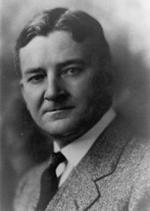
The Senate Judiciary Committee reported SJR 211 out on January 9, 1933, with an amendment. SJR 211, sponsored by Blaine, called for a modified repeal of the Eighteenth Amendment. The proposal largely followed the Republican Party platform in the sense that it allowed Congress to regulate or prohibit saloons and states retained the right to ban alcohol. Moreover, it called for ratification through submission to state legislatures instead of conventions (Jeffers and Kyvig 2000). The committee reported the measure out favorably by a 11 to 5 margin.

Despite being reported out of committee favorably, the prospects for SJR 211 did not look strong. Anti-prohibition interest groups came out against Blaine's proposal, advocating instead for both "outright repeal" and submission to state ratifying conventions. Speaker Garner and House Democratic leaders also announced their opposition on the grounds that it did not conform with the Democratic platform. Garner asserted that if SJR 211 passed the Senate in its current form, it would be dead on arrival in the House.
Above: Senator John J. Blaine (R-WI), the sponsor of SJR 211 (the "Blaine Bill").

The lame-duck Senate was also tied up with other business. The Glass Banking bill (S 4412) passed the chamber on January 25th, but only after overcoming an eight-day filibuster against it led by Long and five additional days of debate and amending. Legislation pertaining to Philippines independence, Treasury-Post Office Appropriation and Military Appropriations was still pending. With uncertain support for the Blaine bill and substantial wet majorities in the 73rd Congress, postponing action on prohibition repeal seemed likely.

Despite this, Blaine offered a motion to proceed to the consideration of SJR 211 on February 13th. The Senate recessed for the day almost immediately afterwards. Following a brief discussion of the motion to proceed on the 14th, Sheppard announced he felt "justified in fighting this motion with every weapon at [his] command” (Congressional Record, 72nd Congress, February 14, 1933, 4008). The 57-year-old 'Father of Prohibition' then commenced an eight-and-a-half-hour filibuster against Blaine's motion to proceed (Jeffers and Kyvig 2000; Okrent 2010).

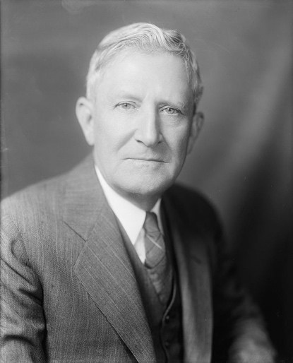
Dismayed at the time being consumed on an issue he thought was doomed to failure in the 72nd Congress, Tydings, perhaps the leading Senate Democratic dry, offered to lay Blaine's motion on the table. Tydings asserted he would not have taken this action if he "thought there was the slightest chance of this measure being enacted” (Congressional Record, 72nd Congress, February 14, 1933, 4057). He was not alone in this assessment. The Washington Post editorial board declared the Blaine bill "has not the slightest chance of passing through both houses before March 4." During debate over the tabling motion, Robinson dubbed the filibuster "a pitiable spectacle." Despite opposing nearly all previous attempts to alter the Eighteenth Amendment or the Volstead Act, Robinson claimed Tydings motion amounted to "an unfair prejudgment of the attitude of the Senate on this question” (Congressional Record, 72nd Congress, February 14, 1933, 4057). Robinson's comments proved prescient, as the motion to table failed 31 to 44.
Above: Senator Morris Sheppard (D-TX), the “Father of Prohibition,” gave an eight-and-a-half-hour speech in an attempt to filibuster SJR 211.

After the Tydings tabling motion failed, Bingham submitted a cloture petition and Blaine announced his intention to keep the Senate in session throughout the evening. After none of his fellow drys came to his relief, Sheppard surrendered the floor at around 10pm. He was followed by Senator Charles McNary (R-OR), the assistant majority floor leader. McNary asked for, and received, unanimous consent that the Senate vote on "the pending motion at 1 o'clock tomorrow afternoon” (Congressional Record, 72nd Congress, February 14, 1933, 4057).

The following day, the Blaine motion to proceed was quickly adopted by an overwhelming 58-23 margin. Newspaper coverage credited this increase in support to "something resembling a death-bed repentance on the part" of Robinson. Immediately after initial reading of the bill, Robinson continued his repentance. He submitted an amendment striking the clause providing state legislatures ratify the amendment and inserting language providing for ratification by conventions. He argued this amendment was in line with platforms taken by both parties. Blaine argued his motivation for having ratification done by state legislatures was twofold: First, the state legislatures could move quicker and second, it would minimize the costs for the states (Jeffers and Kyvig 2000; Davis 2008). Blaine then offered a unanimous consent request to limit each Senator from speaking for no longer than 20 minutes. Brookhart objected to this on the grounds that he had to listen to Blaine speak for hours on this measure. After some discussion, Robinson's convention amendment was easily adopted, 45-15.

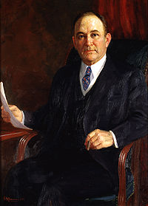
Robinson then proposed an amendment to strike Section 2, leading Borah (R-ID) to lash back with debate on how Section 2 offered protection to so-called "dry states." Robinson responded by not pressing his amendment and instead modifying it to strike out Section 3, "which [was] the provision giving Congress concurrent power to 'regulate or prohibit the sale of intoxicating liquors to be drunk on the premises where sold...'” (Congressional Record, 72nd Congress, February 15, 1933, 4171). Much of the debate circulated around who should have control of liquor traffic related laws and the implementation of those laws, be it federal or state control. Senator Robert Wagner (D-NY) was particularly passionate on this concern, remarking: "We saw the delicate balance between State and Federal authority rudely disturbed and have experienced the pernicious effect of that disturbance upon every branch of our Government” (Congressional Record, 72nd Congress, February 15, 1933, 4147). Robinson's amendment was eventually agreed to by a narrow, 33-32 margin.

The next day, February 16th, four amendments were overwhelmingly rejected as senators attempted to strike and add sections. Glass attempted to substitute the text of SJR 202 for current SJR 211. An amendment by Senator David Reed (R-PA) striking section two from the Glass substitute was defeated 14-70. The Glass amendment was then defeated 46-38. The final two amendments were proposed by Senators Thomas Gore (D-OK) and Reed. Reed proposed to add the saloon provision back into the bill. This amendment was defeated 37-47. Gore then attempted to insert wording that permitted states from allowing the sale of alcohol for private profit. This was immediately rejected via voice vote. Gore asked for the yeas and nays, but the request was not granted.
Above: Press coverage credited the passage of SJR 211 to Senate Minority Leader Joseph Robinson (D-AR), who opposed all previous wet proposals but had “something resembling a death-bed repentance” on the issue.

The Senate passed SJR 211 via a roll call vote on February 16th, 1933, 69 to 27, five votes more than the two-thirds required. Okrent (2010, 352) noted: "Of the twenty-two members who had voted for the Eighteenth Amendment sixteen years earlier and were still senators, seventeen voted to undo their earlier work." Democrats split 39-9 (or 81.25%) in favor, Republicans 30-18 (or 62.5%). This amounted to a nearly 400 percent increase in support from Democrats and 200 percent increase in support from Republicans when compared to their initial vote on Sres 144 the year before.

House Consideration of SJR 211 (February 20, 1933)

On February 20, 1933, Rainey moved to suspend the rules and pass SJR 211. Prior to making his motion, Rainey predicted SJR 211 would pass comfortably by twenty votes. As dictated by the suspension procedure, debate in the House was considerably shorter in comparison. The short debate was described as "frenzied" and the New York Times reported that "Garner had difficulty maintaining order." Rainey attempted to lead the debate with a quote from Senator Sheppard, but he was immediately called to order by Rep. John Rankin (D-MS) on the grounds that it is against House rules to "refer to a Senator and quote what he said” (Congressional Record, 72nd Congress, February 20, 1933, 4508).

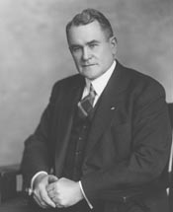
Proponents of SJR 211 pointed to public opinion, the party platforms, increased revenue and a potential reduction in crime in support of the amendment. For example, Oliver described the state of the Union during prohibition: "The legislative road to heaven has been infested with bandits." He argued that prohibition was that road and eliminating it would eliminate the bandits. He concluded with a toast: "Let us have one on the House. Prosit!" O'Connor followed Oliver. Expressing excitement that rights would be returned to the states, he said: "Let us send the repeal amendment to the States where it belongs and from whose jurisdiction it never should have been taken." Celler argued that the country "should flee from prohibition as one would from a foul dungeon” (Congressional Record, 72nd Congress, February 20, 1933, 4512-16).

Opponents focused on the removal of the section barring saloons and criticized members for changing their positions on the issue. Rep. Malcolm Tarver (D-GA) announced his opposition to resolution and claimed "[t]here are few, if any, men who have won honor by fighting on both sides in any war." Guyer claimed a vote in favor of the resolution was a vote "for the return of the saloon, the most sinister influence that ever cursed American life and politics." Blanton, who was "booed" by wets on the floor, spoke of death threats he received due to his support for prohibition and encouraged other drys to continue to "hold the line” (Congressional Record, 72nd Congress, February 20, 1933, 4512-16).
Above: One of the most vocal House drys, Rep. Thomas L. Blanton (D-TX) was booed during his final speech against SJR 211.

SJR 211 was then adopted 292 to 126, exceeding the necessary two-thirds threshold by 15 votes. Democrats split 183-34 (or 84%) in favor, Republicans 111-92 (or 55%) in favor. Wets had picked up 107 votes since the first House roll call on the motion to discharge Beck-Linthicum. Democratic support had nearly doubled. As the figure below from Voteview.com demonstrates, the vote now fell largely on the first dimension.

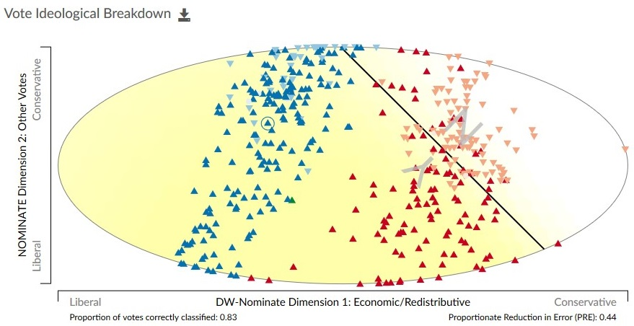
Source: Voteview.com (72nd House, rcnum 112).

Aftermath
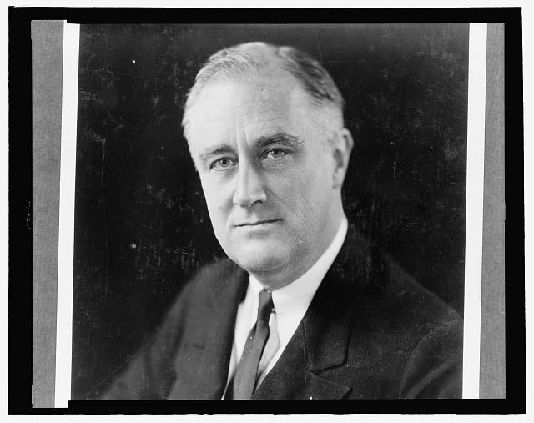
The Twenty-First Amendment was then presented to the Secretary of State on February 21, 1933, by the Committee on Enrolled Bills. It was then proposed to the state conventions for ratification. The Twenty-First Amendment was formally ratified on December 5, 1933, after Utah became the 36th state to ratify it. It remains both the only constitutional amendment to repeal another amendment and the only one ratified by state ratifying conventions.

The Collier beer bill was not adopted in the 72nd Congress. Shortly after the 73rd Congress convened though, it passed the Beer-Wine Revenue Act (or "Cullen-Harrison Act" after its sponsors). That act (73 PL 3) legalized and taxed alcohol up to 3.2 percent by weight. Upon signing it, Roosevelt declared "I think this would be a good time for a beer (Smith 2007)."
Above: After signing the Beer-Wine Revenue Act in the 73rd Congress, President Franklin D. Roosevelt (D-NY) famously declared "I think this would be a good time for a beer” (Smith 2007).

References

Andersen, Lisa, 2015. "Prohibition and Its Effects." The Gilder Lehrman Institute of American History, January 18.

Brown, Everett Somerville. 2003. Ratification of the Twenty-first Amendment to the Constitution of the United States: State Convention Records and Laws. Clark, NJ: The Lawbook Exchange, Ltd.

Champagne, Anthony. 1998. "John Nance Garner." In Masters of the House: Congressional Leadership over Two Centuries. Roger H. Davidson, Susan Webb Hammond and Raymond W. Smock, eds. Boulder: CO: Westview Press. 156-158.

Clinton, Joshua and John Lapinski. 2006. "Measuring Legislative Accomplishment, 1877-1994," American Journal of Political Science 50(1): 232-249.

Davis, Ethan P. 2008. "Liquor Laws and Constitutional Conventions: A Legal History of the Twenty-first Amendment."

Eig, Jonathan. 2010. Get Capone. New York, NY: Simon & Schuster.

Jeffers, Honoree F. and David E. Kyvig. 2000. Repealing National Prohibition. Kent, OH: Kent State University Press.

Levine, Harry G. 1985. "The Birth of American Alcohol Control: Prohibition, the Power Elite, and the Problem of Lawlessness." Contemporary Drug Problems, 12:63.

Meier, Kenneth J. 1994. The Politics of Sin: Drugs, Alcohol and Public Policy: Drugs, Alcohol and Public Policy. Routledge.

Moore, James. 1997. Very Special Agents. New York, NY: Pocket Books.

Okrent, Daniel. 2010. Last Call: The Rise and Fall of Prohibition. New York, NY: Simon and Schuster.

Pearson, Kathryn, and Eric Schickler. 2009. "Discharge Petitions, Agenda Control, and the Congressional Committee System, 1929–76." The Journal of Politics 71(4): 1238-1256.

Petersen, R. Eric. 2001. "Is It Science Yet? Replicating and Validating the Divided We Govern List of Important Statutes." Paper presented at the Annual Meeting of the Midwest Political Science Association, Chicago, IL.

Poole, Keith and Howard Rosenthal. 1997. Congress: A Political-Economic History of Roll Call Voting. New York, NY: Oxford University Press.

Schickler, Eric, and Andrew Rich. "Controlling the Floor: Parties as Procedural Coalitions in the House." American Journal of Political Science 41: 1340-1375.

Smith, Jean Edward. 2007. F.D.R. New York, NY: Random House.

Stathis, Stephen W. 2014. Landmark Legislation, 1774-2012: Major U.S. Acts and Treaties, 2nd Edition. Washington: CQ Press.

Stevens, Robert D. 1982. "But is the Record Complete? A Case of Censorship of the Congressional Record." Government Publications Review 9(1): 75-80.

See "Ratification of the 21st Amendment Ends Prohibition." 1933. The New York Times, December 5.
Proposals included HJRs 11, 18, 20, 22, 82, 83, 85, 99, 105, 109, 116, 117, 118, 173, 178, 186, 196, 208, 209, 210, 212, 213, 214, 217, 218, 220, 221, 222, 228, 232, 233, 234, 235, 236, 237, 238, 239, 240, 241, 242, 243, 244, 247, 257, 258, 264, 283, 284, 296, 307, 427, 436, 449, 450, 451, 452, 453, 456, 457, and 459 in the first session and HJRs 480, 484, 485, 489, 491, 508, 516, 534, 592 in the second session. SJRs include: 84, 90, 114, 128, 144, 192 and 202. As discussed later, other related bills included Sres 144, HR 10236 (72 PL 154), HR 12280 (72 PL 302), HR 10017, HR 13742, S 436, S 2473 and Sres 259.
See "Progressive Era to New Era," The Library of Congress; "The Volstead Act," The National Archives.
See "The Noble Experiment," The Nebraska State Historical Society.
See also, Eig, Jonathan. 2010. "What You Didn’t Know About Gangster Al Capone." NPR . https://www.npr.org/2010/08/09/128872365/what-you-didnt-know-about-gangster-al-capone
"Hoover Names 10 Lawyers and One Woman Educator to Study Law." 1929. The New York Times, May 21.
See also Frappolli, Amelia. 2018. "That Time Congress Debated Prohibition and Used Beer Bottles as Props on the Floor." Roll Call, November 2; "The Man in the Green Hat," The United States Senate. https://www.senate.gov/artandhistory/history/minute/The_Man_in_the_Green_Hat.htm
"Reed Denounces Dry Law." 1929. The New York Times, February 19.
Speers, L.C. 1931. "Prohibition Test is Nearer with New Congress Line-Up." The New York Times, December 20.
On the subcommittee composition, see: The New York Times. 1931. "5 Senators Named to Take Up Repeal," December 27. On the press expecting the issue to be considered, see: The New York Times. 1931. "Vote on Prohibition Promised in House by Party Leaders," December 2; The New York Times. 1931. "Watson and Borah for Dry Law Vote," December 3.
The hearings were held on April 14-15, 19-21, May 10th and 17th, 1932 on the following bills: S 308; S 309; S 314; S 422; S 2462; S 2478; S 3148; SJR 31; SJR 84; SJR 90; SJR 128. See "Modification or Repeal of National Prohibition: Hearings before the Subcommittee of the Committee on the Judiciary, Part 1." U.S. Senate, 72 Cong. 1 (1932); "Modification or Repeal of National Prohibition. Hearings before the Subcommittee of the Committee on the Judiciary, Part 2." U.S. Senate, 72 Cong. 1 (1932).
Hiram Bingham III was first elected to the U.S. Senate in 1924 to fill the vacancy caused by the suicide of Senator Frank Brandegee (R-CT). He was elected to a full term in 1926. Prior to coming to the Senate, Bingham was a noted academic and explorer perhaps most notable for publicizing the location of the Inca city of Machu Picchu, which he erroneously referred to as "The Lost City of the Incas." Bingham is frequently cited as an inspiration for Indiana Jones. His Senate career had been less notable. In November of 1929, by a vote of 54 to 22, he became the third U.S. Senator to be formally censured. Bingham had placed a current lobbyist, Charles Eyanson, on his Senate payroll as a tariff advisor. See "Senate by 54 To 22 Censures Bingham for Using Lobbyist," 1929. The New York Times, November 5.
See "Referendum Vote Senate Aim Today," 1932. The Washington Post, January 21; "Norris Assures Wets of Time for a Hearing". 1931. The New York Times, December 18; "Hearings Mapped on Anti-Dry Bills". 1931. The New York Times, December 25; "Barbor Sees Beers as Temperence Aid". 1932. The New York Times, January 21; "Amendment of the Prohibition Act: Hearings before the Subcommittee of the Committee on Manufactures." U.S. Senate, 72 Cong. 1 (1932).
The text of Sres 144: Whereas several States have already taken appropriate action for the purpose of obtaining a referendum of their people upon the prohibition question; and Whereas several periodicals and newspapers in the United States have conducted so-called polls on the prohibition question, the importance of which polls it is difficult to estimate: Therefore, Is it Resolved, That the Senate would welcome any action that the governors of the several States might take in recommending to their respective legislatures that such action be taken by the State as may be necessary to obtain the opinion of the people of the State with respect to (1) the repeal or modification of the eighteenth amendment, and (2) the repeal or modification of the national prohibition act (commonly known as the Volstead Act). Resolved further, that the Secretary of the Senate be directed to transmit a copy of this resolution to the governor and to the legislature of each of the several States (Congressional Record, 72nd Congress, January 20, 1932, 2316).
See "Senate, 55-15, Bars Referendum Plan." 1932. The New York Times, January 22; "Senate Wets Lose First Liquor Vote." 1932. The Washington Post, January 22. See also Voteview, 72nd Senate, rcnum 47 (Poole and Rosenthal 1997). https://voteview.com/rollcall/RS0720047
"Wets Select Plan for Test In House." 1932. The New York Times, January 12.
See "House Committee Rejects Wet Plan." 1932. The New York Times, February 17; Folliard, Edward. 1932. "110 House Wets Sign Liquor Vote Petition." The Washington Post, February 26; Krock, Arthur. 1932. "Wet Bloc Polls 187 But Loses in Test of Dry Law in House." The New York Times, March 15; Folliard, Edward. 1932. "Vote on Liquor Referendum is Fixed March 14." The Washington Post, March 2.
Voteview, 72nd House, rcnum 22 (Poole and Rosenthal 1997). https://voteview.com/rollcall/RH0720022
The text of the Cullen amendment, offered as a second-degree amendment to an amendment from Crisp: That there shall be levied and collected on all nonintoxicating beer, lager beer, ale, porter, or other similar nonintoxicating fermented liquor containing one-half of 1 per cent and not more than 2.75 per cent of alcohol by weight brewed or manufactured and hereafter sold or removed for consumption or sale within the United States, by whatever name such liquors may be called, a tax at the rate of 3 cents per pint, such article to be bottled at the brewery: Provided, That no such article shall contain more than 2.75 per cent of alcohol by weight: And provided further, That the manufacture and transportation of such articles shall be conducted under permits to be issued in accordance with the national prohibition act and under such regulations, including assessment and collection of the tax, as shall be promulgated by the Secretary of the Treasury and the Attorney General of the United States: And provided further, That no such article shall be permitted to be transported into any State or Territory of the United States, or the District of Columbia, the laws of which forbid the manufacture or sale thereof (Congressional Record , 72nd Congress, March 25, 1932, 6827).
"House Drys Win, 216-132." 1932. The New York Times, March 26.
See "Beer Tax Bill Vote Demanded in House." 1932. The New York Times, April 13; "Senate to Have Beer Vote." 1932. The Washington Post, April 20.
Tydings and Smoot had agreed to recess earlier as Tydings complained there were far too many "empty seats." The unanimous consent request was objected to by Senator Hiram Johnson (R-CA). Johnson claimed: "We all have the unfortunate experience at times, of course, of speaking to a few rather than too many, and we all feel that those who are absent have missed a rare treat, but, nevertheless, it is a fate that comes to all of us in this body (Congressional Record, 72nd Congress, May 17, 1932, 10433)." See also McDonnell, J.B. 1932. "Fight On Beer Levy Forced in Tax Bill Work." The Washington Post, May 18; "War Time Surtax Beaten." 1932. The New York Times, May 18.
See "Beer Tax Rejected by Senate, 61 to 24." 1932. The New York Times, May 19.
See "Bingham Amends Beer Tax Measure to Gain Five Votes." 1932. The Atlanta Constitution, May 22.
For the Bingham Amendment in the second-degree and the Tydings Amendment, see Voteview, 72nd Senate, rcnum 107-108 (Poole and Rosenthal 1997). For the Bingham Amendment on May 25th, see Voteview, 72nd Senate, rcnum 125 (Poole and Rosenthal).
On the discharge rule, Beck argued it was "preposterous that [a bill of this importance] should only be permitted 20 minutes of debate." Crisp responded by arguing that this vote was only to discharge. If discharged, the House could debate it as much as they wanted.
Linthicum, in what would be one of his final House speeches before his death in early October, touched on both issues: You have prohibition on the books, but you have prohibition, in fact, nowhere in this country. There are to-day thousands of speak-easies spread throughout the land. You have no regulation of the liquor traffic, whereas if you repeal the eighteenth amendment you can devise methods for the control of liquor. You have tried this noble experiment for 12 years, have arrested 700,000 people in trying to enforce it, and have convicted 500,000. You have crowded the jails to overflowing and are now busily providing for more jails. You have collected $60,000,000 in fines, and something like $231,000,000 in property have been seized or confiscated. A revenue of $10,984,000,000 has been lost to the Government, and yet the drink bill has aggregated $28,000,000,000. The whole country has been thrown into disorder, immorality established, the criminal class financed and abetted (Congressional Record, 72nd Congress, May 23, 1932, 10953).
Approximately 44% of Democrats and 42% of Republicans voted for the motion to discharge. See see Voteview, 72nd House, rcnum 55 (Poole and Rosenthal). See "73% Favor Repeal in Prohibition Poll." 1932. The New York Times, April 29; "Beer Bill Rejected, 228 To 169, In House." 1932. The New York Times, May 24; Folliard, Edward. 1932. "House Rejects O'Connor-Hull Beer Measure." The Washington Post, May 24.
See "Republican Party Platform of 1932," The American Presidency Project.
See "Garner Enters Race at Chicago as Wet." 1932. The New York Times, June 22.
House Republican wets petitioned Speaker Garner to report a repeal amendment to the floor, but the Speaker was not compliant. Absent the possibility of a roll call vote, they took to giving floor speeches in favor of repeal. On June 5, 1932, Democrats objected a unanimous consent request by Rep. John Schafer (R-WI) to speak for five minutes on the issue. This led Schafer and other Republicans to vote down a motion to adjourn (see "Wets Demand Vote." 1932. Wall Street Journal, July 7. "Republican Wets Demand House Vote." 1932. The New York Times, July 7.)
Bingham argued: It has seemed for many months and even years as though that [modifying the Volstead Act] was impossible; but, thanks to the Democratic platform in Chicago-which now pledges the Democratic Party to securing immediate modification of the Volstead Act in so far as it may be done under the Constitution-I am about to propose an amendment to this bill and ask that it be printed and lie upon the table (Congressional Record , 72nd Congress, July 1, 1932, 14447). See also "Bingham Offers Senate Beer Test." 1932. The New York Times, July 2.
Folliad, Edward T. 1932. "G.O.P. to Test Democrats on Beer Measure." The Washington Post, July 6. Other proposals debated but not voted on in the Senate during this period include SJR 114, sponsored by Senator William Barbour (R-NJ); SJR 192, sponsored by Senator Henry Ashurst (D-AZ) and Sres 259, introduced by Senator Thomas Gore (D-OK).
In another instance, Tydings chastised Republicans for not bringing forward a prohibition proposal in line with their platform. Smoot, a leading dry, argued that nothing the majority did would appease Tydings: "Unless it were straight-out saloons, liquor, beer, any God's thing that would make a man drunk” (Congressional Record, 72nd Congress, July 5, 1932, 14573).
Borah's amendment was likely to be adopted and would replace the text of the Bingham amendment with the currency proposal. Bingham argued Borah's amendment was an attempt to protect Democrats who "want to go before the country on a platform favoring the immediate modification of the Volstead Act to provide for the manufacture and sale of beer but will not take the opportunity they now have to vote for its immediate ratification” (Congressional Record, 72nd Congress, July 7, 1932, 14859). See also Folliad, Edward T. 1932. "Borah Balks Senate Vote on Beer Plan." The Washington Post, July 6.
Robinson stated this argument explicitly: "[T]he Senator from Connecticut is not a qualified judge to determine what constitutes an intoxicating beverage; he does not know anything about it;, he never had any experience with it; he is not a competent witness. In all seriousness, this involves a scientific question” (Congressional Record, 72nd Congress, July 8, 1932, 14852). See also "Dare Democrats to Vote Beer Now," 1932. The New York Times, July 8.
Folliad, Edward T. 1932. "Bill Legalizing Beer Is Shelved by Senate." The Washington Post, July 12. See also Voteview, 72nd Senate, rcnum 207 (Poole and Rosenthal 1997).
See "Glass Drafts Dry Repealer." 1932. The Wall Street Journal, July 14; "Prohibition Politics." 1932. The Washington Post, July 16; "Glass Moves for Repeal, Barring the Saloon." 1932. The New York Times, July 14.
The ruling from Vice President Charles Curtis (R-KS): "The Chair rules, under Rule XXII, that the motion to commit cannot be made until after a vote is had on taking up the joint resolution, and that is not yet before the Senate” (Congressional Record, 72nd Congress, July 16, 1932, 15649).
Voteview, 72nd Senate, rcnum 216 (Poole and Rosenthal 1997). https://voteview.com/rollcall/RS0720216
See “Election of 1932,” The American Presidency Project.
See e.g., "Wets in Control in Both Houses." 1932. The New York Times, November 9; Hurd, Charles W. B. 1932. "The Week in America; Democrats Sweep Nation." The New York Times, November 13.
"Garner Forces the Issue." 1932. The New York Times, December 6. See also Voteview, 72nd House, rcnum 87 (Poole and Rosenthal 1997).
See e.g., "House Votes for Beer 230 to 165." 1932. The Wall Street Journal, December 22; McDonnell, J. Bernard. 1932. "House Today Begins Debating Beer Bill: Hoover Felt Certain to Veto." The Washington Post, December 20; "Beer Bill By Monday Is Garner Forecast." 1932. The Wall Street Journal, December 14; "House Margin a Surprise." 1932. The New York Times, December 22. See also Voteview, 72nd House, rcnum 90 (Poole and Rosenthal 1997).
"Beer by Christmas Defeated as Senate Demands More Time." 1932. The New York Times, December 22. See also Voteview, 72nd House, rcnum 228 (Poole and Rosenthal 1997).
"Modified Repeal Now Before the Senate." 1933. The New York Times, January 10.
"Shouse Hits Blaine Plan." 1933. The New York Times, February 7.
"Closure Defeated, but Long is Curbed." 1933. The New York Times, January 20.
Tydings described his attitude on the filibuster and motion in greater detail in a floor discussion with Sheppard: "Mr. President, I do not want to be offensive or rude to the Senator from Texas. May I point out, however, that we have only 16 legislative days left of this Congress; that there are 12,000,000 people out of employment, 5,000 banks have failed, there is economic chaos from one end of the Nation to the other, and as long as we take up these extraneous matters we cannot do a thing for the distress of the country” (Congressional Record , 72nd Congress, February 14, 1933, 4052).
"Wasting Time." 1933. The Washington Post, February 16. For more on the Sheppard filibuster, see "Senate Filibuster on Repeal Checked After 8-Hour Siege." 1933. The New York Times, February 15.
McDonnell, J. Bernard. 1933. "Senate Votes Today on Dry Repeal Plan." The Washington Post, February 16. The text of SJR 211 as read is below: "That the following article is hereby proposed as an amendment to the Constitution of the United States, which shall be valid to all intents and purposes as part of the Constitution when ratified oy the legislatures of three-fourths of the several States: ARTICLE - SECTION 1. The eighteenth article of amendment to the Constitution of the United States is hereby repealed. SEC. 2. The transportation or importation into any State, Territory, or possession of the United States for delivery or use therein of intoxicating liquors, in violation of the laws thereof, is hereby prohibited. SEC. 3. Congress shall have concurrent power to regulate or prohibit the sale of intoxicating liquors to be drunk on the premises where sold. SEC. 4. This article shall be inoperative unless it shall have been ratified as an amendment to the. Constitution by the legislatures of the several States, as provided in the Constitution, within seven years from the date of the submission hereof to the States by the Congress” (Congressional Record, 72nd Congress, February 15, 1933, 4138-4139).
Kyvig (2000, 170) adds: "Privately, [Blaine] added that he thoughts drys would have a better chance to block repeal with convention ratification." For more on this, also see Davis (2008).
"Resolution Passes 63-23." 1933. The New York Times, February 17. For the final Senate vote on SJR 211, see Voteview, 72nd Senate, rcnum 272 (Poole and Rosenthal 1997). For the Tydings tabling motion, the Blaine motion to proceed and the five amendment votes, see Voteview, 72nd Senate, rcnum 265-271 (Poole and Rosenthal 1997).
"House Wets Count Upon Repeal Today." 1933. The New York Times, February 20; "House has Frenzied Day." 1933. The New York Times, February 21.
Notably, Blanton was no stranger to this kind of treatment. He had been booed during earlier speeches as well and was a highly controversial figure in the House. Blanton was loathed for asking for roll call votes on a wide number of issues, raising frequent points of order on the floor and often aggressive during debate. His antics ate into floor time and caused delay. First elected to the House in 1917, Blanton's behavior came to a boiling point in 1921 when he entered a curse word into the Congressional Record. A resolution expelling him from the House was introduced. While many anticipated Blanton would apologize, he instead gave an hour and half long speech defending himself, declaring that "the man who is not afraid to lose his own head does not consider political head (Congressional Record, 67th Congress, October 27, 1921, 6886)." His defense was largely led by the noted parliamentarian, Rep. Robert Luce (R-MA). A Republican, Luce announced it was difficult to defend Blanton but he felt duty-bound to oppose expulsion, which he felt was too extreme an option. Luce argued: "A seemingly righteous precedent set now may be turned to unrighteous ends next year (Congressional Record, 67th Congress, October 27, 1921, 6890)." After the expulsion resolution fell by eight votes, Blanton was unanimously censured. Blanton would faint on the floor afterwards. For more, see Stevens (1982); "Censure to Blanton," 1921. The Washington Post.October 28; Fishbein, Rebecca. 2018. The Time the Word 'Damn' Almost Got a Man Kicked Out of Congress. Vice. July 19. For the vote to expel see Voteview, 67th House, rcnum 119 (Poole and Rosenthal 1997). https://voteview.com/rollcall/RH0670119
Voteview, 72nd House, rcnum 112 (Poole and Rosenthal 1997). https://voteview.com/rollcall/RH0720112

