Author Name: Rachel Robinson

Affiliation: University of Georgia

Date Updated: 4/5/2022

Act Title: The Standard Time Act of 1918

Congress: 65th Congress (1917-1919)
Sessions/Sessions: 1st & 2nd
Statute No: 40 Stat. 450

Public Law No: 65 PL 106

Eid: 650106

Bill: S 1854
Sponsor: Senator William M. Calder (R-NY)
House Committees: House Committee on Interstate and Foreign Commerce
Senate Committees: Senate Committee on Interstate Commerce

Companion Bill: None

Related Bills: HR 2609; HR 4644

House Rules: Hres 267

Past Bills: 64 SJR 135; 64 HJR 229; 64 HR 20354; 64 HR 20499; S 7828

Introduced Date – Law Date: April 17, 1917-March 19, 1918
House Floor Days: 1
Senate Floor Days: 2

Roll Call Votes: 1

Tags: standard time; daylight saving time; interstate commerce; special order; morning hour

Contents
Summary 2
Background 3
Initial Senate Consideration (June 27, 1917) 5
House Consideration (March 15, 1918) 6
Secondary Senate Consideration (March 16, 1918) 9
Aftermath 10
References 11

Summary
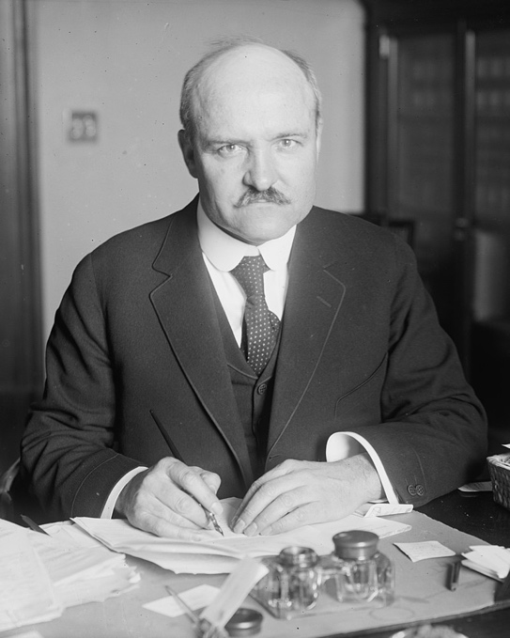
The Standard Time Act of 1918 (or “Calder Act” after its sponsor) established that standard time in the United States be divided into five time zones, created by the Interstate Commerce Commission in concurrence with zones previously established by the national railroad system. It also dictated that on the last Sunday of March each year the clock be advanced an hour and then returned an hour on the last Sunday of October of that same year in an effort to save fuel. It was considered and adopted after the outbreak of World War I during the 1st and 2nd sessions of the 65th Congress.

While the measure would be repealed just over a year after enactment, passage during the 65th Congress was not particularly controversial. Supporters of the bill argued the time change would lead to monumental fuel savings and help the country to catch up to their European allies and enemies who already used the system. Opposition was minimal, but a member’s expressed fear that the time change could cause logistical issues with railway schedules and, seeing the bill as an attempt to change the laws of nature, did not see it as a serious piece of legislation. There was one roll call vote during consideration of the bill in the House on the passage of the bill, 253 yeas, 40 nays, 6 “present,” and 133 non-voting.
Above: Upon passage of the Standard Time Act, its sponsor, Senator William Calder (R-NY), predicted it would be "a very popular measure" and "no effort [would] be made to repeal it." The daylight saving provision of the law was repealed just over a year later after widespread confusion.

President Woodrow Wilson (D-NJ) signed the bill into law on March 19, 1918, and the first time change occurred within two weeks of its passage. The Standard Time Act of 1918 was considered a “landmark law” by Stathis (2014) and rated the 14th most important piece of legislation in the 65th Congress by Clinton and Lapinski (2006). It was repealed on August 20, 1919 (66 PL 40).

Background

The 65th Congress met from March 4, 1917, to March 4, 1919 during the fifth and sixth years of Democratic President Woodrow Wilson’s presidency. Democrats controlled the majority within the Senate, holding 54 seats over the Republican’s 42 seats. Republicans held a plurality in the House of Representatives with 216 seats over the Democrat’s 214 seats, but in combination with Progressives and Socialist Representatives, the Democrats maintained control. The Congress coincided with World War I and is known for legislature such as the Selective Service Act of 1917, The Departmental Reorganization Act of 1918, Declaration of War against Germany and later Austria-Hungary, and approving the Eighteenth Amendment proposing the Prohibition Amendment to the Constitution.

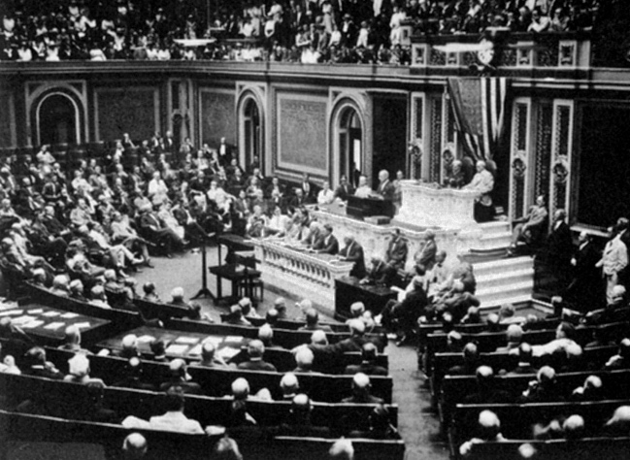
The 65th Congress got off to a tumultuous start due to the impending possibility of the United States entering World War I. On Monday April 2, 1917, the United States Senate and House convened for a special session to address President Wilson’s request to declare war. The President’s proclamation stated: “Whereas public interests require that the Congress of the United States should be convened in extra session at 12 o’clock noon on the 2nd day of April, 1917, to receive a communication concerning grave matters of national policy which should be taken immediately under consideration…” (Congressional Record, 65th Congress, April 2, 1917, 101). HCR 2 provided that both houses meet on April 2nd to hear from the President regarding the status of potential involvement in the war. Following the President’s address, SJR 1, which would officially declare war on Germany was referred to the Committee on Foreign Relations. SJR 1 was passed by the Senate on April 4 and by the House of Representatives the following day. President Wilson approved it on April 6, 1917 officially involving the United States in the war.
Above: President Wilson addresses Congress regarding war in Europe.

As war was breaking out in Europe, nations were actively seeking ways to increase efficiency. Daylight saving time became a popular solution. Supporters argued that adjusting time so work hours better coincided with periods of natural daylight would increase productivity, result in health benefits and cut down on costs associated with lighting and heating. This modern argument is most frequently credited to British builder William Willett who unsuccessfully championed the concept from 1905 until his death in 1915 (Prerau 2009). The daylight saving movement spread quickly over Europe, with the Germans first adopting it in late April, 1916. Great Britain and other countries followed suit the following month.

The daylight saving movement was slower in the United States, where it was combined with a federal effort to standardize time zones. Four standard time zones had been established in the United States and Canada in 1883 by railroad magnates seeking to minimize confusion (Clark and Cunningham 2018). Prior to the implementation of the railroad time zone plan, times varied across regions resulting in over 50 separate schedules in the United States alone. In May of 2016, during the first session of the 64th Congress, joint resolutions were introduced in both chambers of Congress proposing the creation of a commission to investigate legally standardizing time in the United States. Neither SJR 135, sponsored by Senator Francis Newlands (D-NV), nor HJR 229, sponsored by Representative Martin Madden (R-IL), were acted upon in the 64th Congress.

In January of 1917, the National Daylight Saving Committee hosted a two-day convention in New York City. During the convention, the Committee announced its support for a plan that would establish a five-month daylight saving period. This proposal was supported by both the American Federation of Labor and President Wilson. Legislation had been introduced in both the House and the Senate earlier in the month that combined the daylight saving period proposal with the establishment of five standard U.S. time zones (Eastern, Central, Mountain, Pacific and a fifth to include Alaska). Neither measure was reported out of committee before the lame-duck 64th Congress concluded.

By the start of the 65th Congress, twelve advanced democracies had adopted daylight saving policies by the time the bill was introduced in the Senate including England, France, Germany, Italy, Norway, Sweden, Denmark, Holland, Portugal, Australia, Iceland, and parts of Canada (Congressional Record, 65th Congress, March 15, 1918, 3565). The policy had initially been met with objection in England, but Representative Melville Kelly (Progressive-PA) ensured the House that the policy was now seen favorably. With mounting costs and disdain for the War, the bill’s supporters found quick passage crucial as a means of not only increasing savings but also getting on equal footing with both their allies and enemies on the issue. Kelly, during the debate over Hres 267, included words of support from the American Federation of Labor and argued in favor of a daylight saving proposal due to numerous potential benefits. He stated: “It will result in saving of fuel, in added time for the production of food, in increase in outdoor exercise and recreation, and in general improvement of health” (Congressional Record, 65th Congress, March 15, 1918, 3565).

Initial Senate Consideration (June 27, 1917)

S 1854 was introduced by Senator William M. Calder (R-NY) on April 17, 1917 and reported to the Senate Committee on Interstate Commerce. The report submitted by the committee emphasized and championed the potential benefits of such a measure during war time. This report included the support of President Wilson; Harvard Economics professor Thomas Nixon Carver; the President of the Pittsburgh Chamber of Commerce and other influential figures. In it, Carver argued: “It would be a great help to the movement for the increase of the production of food if workingmen had an extra hour of daylight in the evening for work in their gardens. An hour’s work a day in a garden, if wisely directed, will produce an amazing amount of food.” The report concluded with the opinion of the committee “that the possible benefits…are more than sufficient to offset the objections which have been presented.”

Senator Joseph Robinson (D-AR) reported the bill, with one amendment, out of the committee on May 25, 1917. Robinson requested unanimous consent for consideration of the bill on the morning of June 27, 1917 to which an objection was made by Senator Harry New (R-IN) on the grounds of the morning business being incomplete and his request was denied. During the morning hour on June 27, Robinson again requested unanimous consent for consideration and this time his request was granted. The bill was read, and debate commenced in the Committee of the Whole.

The committee reported one amendment to the bill, adding that the act should begin to take effect after January 1, 1918, which was debated briefly and eventually met with no opposition. There was no major point of opposition within the Senate debate; most members who questioned the bill were simply confused on the logistics of a time change. Senator Reed Smoot (R-UT) raised a question of how a time change would affect railroads, and whether or not they would need to reprint their timetables, the most significant point made in opposition to the bill throughout the debate.

The proponents of the bill, namely Robinson, argued that, after discussions with representatives from railroad companies, while “it will occasion some little inconvenience…in the view of the very large economic value which the bill has, the saving will result in fuel, lights, and the conservation of time for all classes of laborers throughout the country, the difficulty is more than offset by the advantages of the bill” (Congressional Record, 65th Congress, June 27, 1917, 4350). Robinson also noted that the United States Chamber of Commerce was in support of the bill, and that numerous foreign countries had adopted a similar policy with little difficulty. He expressed amazement in regard to the finances conserved in those countries and suggested similar savings would occur in the United States should be bill become law.

When the morning hour ended at 2 o’clock, the Presiding Officer called for consideration of unfinished business and debate on S 1854 was briefly halted. Robinson’s request to continue debate on S 1854 was met with no objections, and debate continued briefly. Smoot noted that he “had a great deal of correspondence upon the measure,” and that “90 percent of all of it was in favor of the bill.” He then gave his support for its passage. The amendment provided by the committee was concurred in and the bill was passed by voice vote. The Christian Science Monitor noted that the bill passed “[without] the least sign of opposition.”

House Consideration (March 15, 1918)

After passage in the Senate on June 27, 1917, S 1854 was referred to the House Committee on Interstate and Foreign Commerce on July 6, 1917. On February 9, 1918, in the 2nd session of the 65th Congress, Rep. Thetus W. Sims (D-TN), Chairman of the Committee on Interstate and Foreign Commerce, reported the bill, with amendment, out of committee to be referred to the House Calendar.

A month later on March 9, 1918, Sims referred a special order [Hres 267], which “provide[d] for the consideration of Senate bill 1854” to the House Committee on Rules (Congressional Record, 65th Congress, March 9, 1918, 3297). On March 15th, Sims requested unanimous consent to bring up Hres 267 following the bill that was being considered. Rep. Otis Wingo (D-AR), arguably the loudest opponent of the measure in the House debate, questioned if this request “practically [gives] the daylight-saving bill privileged status on this day,” and objected to Sims’ request, claiming that S 1854 “does not appeal to my sense of seriousness to agree even to a rule on that bill” (Congressional Record, 65th Congress, March 15, 1918, 3549).

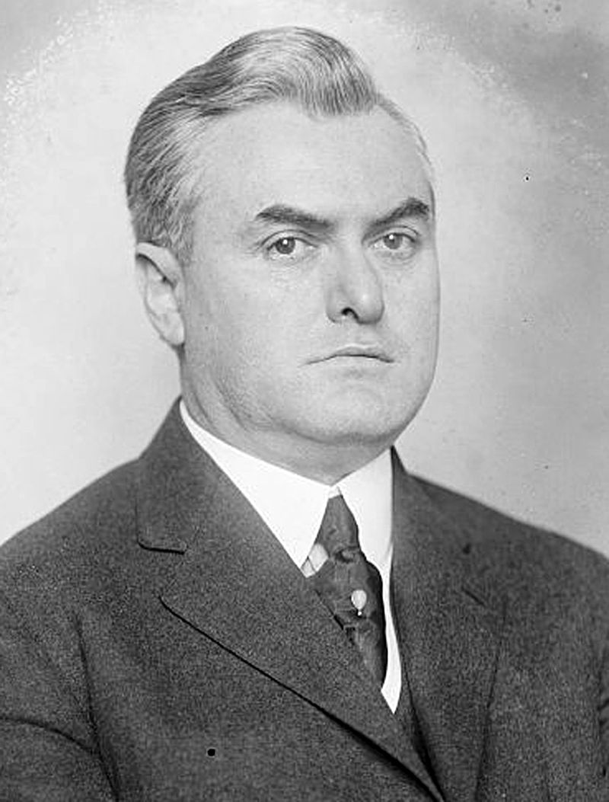
The special order was debated later that day. Rep. Philip Campbell (R-KS) urged his fellow representatives to act quickly on the bill as they had been too conservative on the issue and the bill was “tardy in coming before the House (Congressional Record, 65th Congress, March 15, 1918, 3564).” The terms of the rule provided that it would be in order to consider the bill, which would then be considered and amended under the standard House Rules. It also provided for one hour of debate. The amount of debate time was discussed, and Sims suggested keeping the time at one hour and seeing how the discussion developed before extending any debate time. The previous question motion was requested and ordered on the resolution and the rule was agreed to--both via voice vote.

The bill was then read with the reported committee amendments: mainly to change the months of daylight-saving from April to September to March to October in order to maximize fuel savings, and some logistical changes regarding when the bill would take effect. Once debate began, a lengthy argument over the allotted time for debate occurred with many representatives arguing over the rules for yielding the floor to another and attempting to extend debate time in order to say their personal piece.
Above: During debate, Rep. Otis Wingo (D-AR) asserted the bill’s supporters had "never seen the sun rise in twenty years" and predicted the measure would provide relief to "the slackers of the Nation who are too lazy to get up early."

Once again, the primary question posed by opponents of the bill related to railroad schedules. With the time change only established in certain parts of Canada and not adopted at all in Mexico, members like Rep. Finis Garrett (D-TN) questioned, “What effect will it have upon the international train schedules on those roads that run into Canada and Mexico in this country?” (Congressional Record, 65th Congress, March 15, 1918, 3566). Similar to the occurrence in the Senate, a lack of understanding and confusion over the potential benefits created the most opposition to the bill within the House debate.

Wingo (D-AR) once again commented on the lack of gravity and seriousness he thought the bill held. He remarked: “We should not be wasting our time on such bills, but should go on with the war-finance bill, the great supply bills for the Army and Navy, and other measures for speeding up the war. While our boys are fighting in the trenches we are here like a lot of school boys ‘tinkering’ with the clocks” (Congressional Record, 65th Congress, March 15, 1918, 3571). He also claimed the bill to be “for the relief of the slackers of the Nation who are too lazy to get up early” as many hard working Americans would get up before sunrise either way (Congressional Record, 65th Congress, March 15, 1918, 3571).

The supporters of the bill were able to combat the main arguments of the opposition with proof of its potential benefits and testimony from numerous proponents of the measure. Not only did nearly all of the United States’ wartime allies and enemies adopt a time change measure, but the President, Chamber of Commerce, American Federation of Labor, and many other institutions strongly promoted the bill’s passage. Representative John Rogers (R-MA) discussed the possible energy and fuel cost conservations in his remarks about the successful time change adopted in England claiming “it is said that in 1917 [England] saved nearly £3,000,000 as a result of the daylight-saving plan, and thereby released the equivalent in coal for her war vessels and for her war industries” and recalling the citizens of Great Britain singing the praises of the new daylight-saving movement (Congressional Record, 65th Congress, March 15, 1918, 3571).

In response to the opposition’s claim that the bill lacked a sense of seriousness, Rep. Frederick Hicks (R-NY), urged that “the full merit of this proposed legislation has been obscured behind the clouds of ridicule and lack of understanding, some of the darkness which this bill seeks to eliminate” (Congressional Record, 65th Congress, March 15, 1918, 3570). And against those who claimed the bill was an attempt to alter nature he responded: “This measure does not propose to change either the laws of nature or the habits of man. But it does seek to alter the conditions under which we work and play” (Congressional Record, 65th Congress, March 15, 1918, 3570). Changing the clocks forward or back an hour would not alter the actual time spent working, as the opposition questioned, but would just allow for work to begin when the sun rose and for more naturally lit hours of recreation after the workday was complete.

After numerous submissions of postcards and letters written to representatives by their constituents in favor of passing the bill, the time for debate expired and Sims moved the previous question on the bill and committee amendments for final passage. The previous question was ordered, and all committee amendments on the bill were agreed to by voice vote. The bill was ordered to be read for a third time and the question of its passage was put by voice vote. Rep. Robert Thomas (D-KY) raised a point of order that a quorum was not present, resulting in a roll call vote.

The bill passed with 253 yeas, 40 nays, six “present,” and 133 non-voting, and was returned to the Senate for consideration of the approved amendments. Sizeable majorities of both parties voted in favor of it. Republicans supported the measure 132-4 and Democrats broke 118 to 36 in favor. Most of the Democratic opposition was concentrated in the South, with Southern Democrats supporting the bill 56 to 30.

Secondary Senate Consideration (March 16, 1918)

On March 16, 1918, the Presiding Officer presented the amendments approved by the House, including extending the saving period from March until October, to the Senate chamber. Calder, who originally introduced the bill, gave a speech on the benefits of the final passage of the bill stating: “I predict, Mr. President, that this is going to be a very popular measure, and that after its beneficial effect is felt for the first year of its operation no effort will be made hereafter to repeal it…it will become apparent that it is one of the most important conservation measures ever enacted by the Congress of the United States, and I have taken great pleasure in being its sponsor in this body (Congressional Record, 65th Congress, March 16, 1918, 3595).”

Calder then made a motion to concur in the amendments made by the House of Representatives. The motion to concur was agreed to via voice vote and the bill was sent to be signed into law by President Woodrow Wilson.

Aftermath
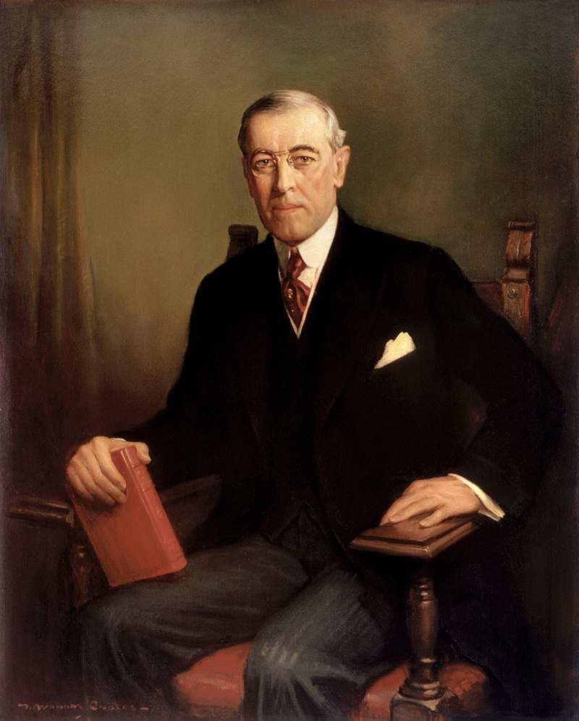
President Woodrow Wilson signed S 1854 into law on March 19, 1918, with its first implementation barely two weeks later on March 31st. The bill was met with much confusion across the country. Only slightly over a year after its passing and after the end of World War I, Congress attempted to repeal the daylight-saving provision of the Calder Act but was vetoed by President Wilson. Yet Congress persisted, and passed a separate bill repealing daylight saving time the following month (Downing 2005; Prerau 2009). This again drew a veto from Wilson, but this time the veto was overridden in both chambers. The repeal bill, HR 3854, then became law on August 20, 1919 (66 PL 40).

After its repeal, usage of daylight saving time varied across localities in the United States, though it was not widely employed (Bartky and Harrison 1979). This changed briefly during World War II, when Congress passed the War Time Act (S 2160; 77 PL 403) (Clark and Cunningham 2018; Parrish 2002). That law expired in 1945. Over twenty years later, passage of the Uniform Time Act of 1966 (S 1404; 89 PL 387), which promoted the usage of uniform time zones, reestablished daylight saving time in a majority of the United States to the degree it is used today.
Above: President Woodrow Wilson signed the Standard Time Act into law on March 19, 1918. He then vetoed two laws repealing the daylight saving provision during the 66th Congress. The second veto was overridden, and the provision was repealed on August 20, 1919.

As it was in 1919, daylight saving time remains controversial. In 2015, the HBO comedy series Last Week Tonight featured it in a short segment “Daylight Saving Time – How is This Still a Thing?” A substantial amount of scholarship has also debated the effects and merits of daylight saving. For example, Barnes and Wagner (2009) performed a study assessing the impact of daylight saving time on the sleep and performance of employees and found negative effects caused by the time change. Others have examined the potential effects of the policy, debating its linkage it to sleep loss, productivity, automobile and workplace accidents (see e.g. Ferguson et al. 1995; Sullivan and Flannagan 2002; Kamstra, Kramer and Levi 2000; Kotchen and Grant 2011).

In recent years, adjustments to the current form of daylight saving time have been considered or requested. For example, on the 100th anniversary of the passage of the Standard Time Act, Politico detailed an attempt by Senator Marco Rubio to pass a “permanent daylight saving time”. This would be an attempt to maximize the intended benefits of this policy without the potential negative consequences of the time change. Also of note, according to a March 8, 2019 CBS News article, several states are considering taking steps to quit the practice of daylight saving time altogether including: California, Texas, Pennsylvania, Michigan, and Wisconsin.

References

Barnes, Christopher M., and David T. Wagner. 2009. "Changing to Daylight Saving Time Cuts into Sleep and Increases Workplace Injuries." Journal of Applied Psychology 94(5): 1305.

Bartky, Ian R., and Elizabeth Harrison. 1979. "Standard and Daylight-Saving Time." Scientific American 240(5): 46-53.

Clark, Corrie E. and Lynn J. Cunningham. 2018. “Daylight Saving Time.” Congressional Research Service, May 29.

Clinton, Joshua and John Lapinski. 2006. “Measuring Legislative Accomplishment, 1877-1994.'' American Journal of Political Science 50(1): 232-249.

Downing, Michael. 2005. Spring Forward: The Annual Madness of Daylight Saving. Berkeley, CA: Counterpoint Press.

Ferguson, Susan A., David F. Preusser, Adrian Lund, Paul Zandor and Robert Ulmer. 1995. "Daylight Saving Time and Motor Vehicle Crashes: The Reduction in Pedestrian and Vehicle Occupant Fatalities." American Journal of Public Health 85(1): 92-95.

Kamstra, Mark J., Lisa A. Kramer, and Maurice D. Levi. 2000. "Losing Sleep at The Market: The Daylight Saving Anomaly." American Economic Review 90(4): 1005-1011.

Kotchen, Matthew J., and Laura E. Grant. 2011. "Does Daylight Saving Time Save Energy? Evidence from A Natural Experiment in Indiana." Review of Economics and Statistics 93(4): 1172-1185.

Parrish, Jenni. 2002. "Litigating Time in America at the Turn of the Twentieth Century." Akron Law Review 36:1.

Poole, Keith and Howard Rosenthal. 1997. Congress: A Political-Economic History of Roll Call Voting. New York, NY: Oxford University Press.

Prerau, David. 2009. Seize the Daylight: The Curious and Contentious Story of Daylight Saving Time. New York, NY: Basic Books.

Stathis, Stephen W. 2014. Landmark Legislation, 1774-2012: Major U.S. Acts and Treaties, 2nd Edition. Washington: CQ Press

Sullivan, John M., and Michael J. Flannagan. 2002. "The Role of Ambient Light Level in Fatal Crashes: Inferences from Daylight Saving Time Transitions." Accident Analysis & Prevention 34(4): 487-498.

Voteview, 65th House, rcnum 101 (Poole and Rosenthal 1997). https://voteview.com/rollcall/RH0650101
The 65th Congress officially met over three sessions. The first session met from April 2, 1917-Oct 6, 1917, the second from Dec 3, 1917 to Nov 21, 1918 and the third from Dec 2, 1918, to March 4, 1919. https://history.house.gov/Institution/Session-Dates/60-69/
The official party breakdown for the House of Representatives consisted of 214 Democrats, 215 Republicans, 3 Progressives, 1 Independent Republican, 1 Prohibitionist, and 1 Socialist. The Speaker of the House was Democrat: James Beauchamp Clark (D-MI). See https://history.house.gov/Congressional-Overview/Profiles/65th/.
For more see https://history.state.gov/milestones/1914-1920/wwi
For example, see the following op-eds: “Daylight and Standard Time.” 1916. The Christian Science Monitor, September 8; “Saving Daylight.” 1917. The Washington Post, February 1; “An Extra Hour of Daylight.” 1915. The Washington Post, March 26.
While Willett popularized the concept, its origins substantially predate him and is frequently linked to ancient civilizations (see e.g. Prerau 2009; Mellor, Richard. 2016. “The Builder Who Changed How the World Keeps Time,” March 9. (http://www.bbc.com/future/story/20160310-the-builder-who-changed-how-the-world-keeps-time.) Daylight saving time is also often erroneously linked to Benjamin Franklin. But the essay penned by Franklin frequently cited was satirical (see Klein, Christopher. 2012. “8 Things You May Not Know about Daylight Saving Time.” History.com, March 9. https://www.history.com/news/8-things-you-may-not-know-about-daylight-saving-time).
See e.g. “Daylight Saving in Germany.” 1916. The Christian Science Monitor, May 16; “British Set Clocks Hour Ahead Today.” 1916. The Washington Post, May 21.
These regions had their own established “sun times.” The led to a great deal of inconvenience for the railroad system which had to follow the time of the sun in the various states across the country the railroads traveled through. For more see Clark and Cunningham 2018; “Standard Time was Adopted in the U.S. 32 Years Ago this Day.” 2015. The Washington Post, November 18; Stromberg, Joseph. 2011. “Sandford Fleming Sets the World’s Clock.” The Smithsonian Magazine, November 18. https://www.smithsonianmag.com/smithsonian-institution/sandford-fleming-sets-the-worlds-clock-389930/.
See “Commission Standard Time is Proposed.” 1916. The Christian Science Monitor, May 26; “Congressional Briefs: Commission to Standardize Time.” 1916. The Washington Post, May 28.
See “See Help for All in Saving Daylight.” 1917. The New York Times, January 31; “Labor for Daylight Plan.” 1917. The New York Times, January 23; “President Favors Saving of Daylight.” 1917. The New York Times, February 17.
In the House, HR 20354 and HR 20499 were introduced by Rep. William Borland (D-MO). In the Senate, S 7828 was introduced by Sen. Jacob Gallinger (R-NH). See “Daylight Saving Plan.” 1917. The Christian Science Monitor, January 13.
"Daylight Saving. Report of the Committee on Interstate Commerce." U.S. Senate, 65 Cong. 1 (1917).
Smoot (R-UT) admitted to not having read the bill and attempted to show his understanding of the time change: “instead of calling it 7 o’clock in the morning you will call it 6 o’clock in the morning, but it is the same time of day” (Congressional Record, 65th Congress, June 27, 1917, 4349).
Robinson (D-AR) requested to have reports from the various countries, as well as from the United States Chamber of Commerce, in support of the time change and its economic benefits included in the record (Congressional Record, 65th Congress, June 27, 1917, 4350-4353).
The unfinished business was S 2961, which would later become the Lever Food and Fuel Control Act (HR 4961, 65 PL 41). The bill sponsor was not present, so Robinson’s request to set aside S 2961 was granted.
“Senate Passes Daylight Bill.” 1917. Christian Science Monitor, June 28.
Although Wingo (D-AR) spends the majority of the time yielded to him ridiculing the bill and expressing how trivial he thinks it to be, he later in the day launched into a passionate speech retracting his previous words and praising his fellow Congressmen. See Congressional Record, 65th Congress, March 15, 1918, 3571.
Hres 267 reads: “Resolved, that immediately upon the adoption of this resolution the House shall proceed to the consideration of S. 1854, entitled “An act to save daylight and to provide standard time for the United States,” under the general rules of the House” (Congressional Record, 65th Congress, March 15, 1918, 3564).
Campbell also cited Benjamin Franklin’s support for the concept. He argued: “We are the last among the great nations to take advantage of the opportunities that Ben Franklin said over 150 years ago the world would have of saving candlelight and fuel by changing the clock (Congressional Record, 65th Congress, March 15, 1918, 3564).”
See “7 Months' Saving of Daylight Voted,” 1918. The New York Times, March 16.
An interesting look into each representative’s views on specific congressional procedures, see: Congressional Record, 65th Congress, March 15, 1918, 3568 – 3570.
Wingo’s proclamation was met with applause. He would also suggest that the next “propaganda [the measure’s supporters] will start will be a change in thermometers (Congressional Record, 65th Congress, March 15, 1918, 3566).”
One proponent of the bill, Rep. Richard Wayne Parker (R-NJ) received laughter and applause after his declaration that: It is of no consequence whether the bill technically goes too far in saying that everybody shall be bound by the new time, because, although time and tide wait for no man, and the sun does not stand still for the American Congress, and it did once for Joshua [laughter], it is beyond all question that on the whole this bill will work for the practical advantage of the community…whether for peace or war (Congressional Record, 65th Congress, March 15, 1918, 3570).
Rogers’ (R-MA) remarks on the successful implementation of daylight saving in England were met with applause in the chamber.
See “Saving Daylight! Postcards to Congressmen,” 1918. Library of Congress Prints and Photographs Division.
Voteview, 65th House, rcnum 101 (Poole and Rosenthal 1997). https://voteview.com/rollcall/RH0650101
See “Pass Daylight Saving Bill, Awaits Wilson,” Harrisburg Telegraph, March 16, 1918.
See “Turn Your Clock Forward 1 Hour; Then Forget It,” The Washington Times, March 30, 1918.
Downing (2018) notes: “[Implementation of the law] didn’t go smoothly. In 1918, Easter Sunday fell on March 31, which led to a lot of latecomers to church services. Enraged rural and evangelical opponents thereafter blamed daylight saving for subverting sun time, or “God’s time.” Newspapers were deluged by letter writers complaining that daylight saving upset astronomical data and made almanacs useless, prevented Americans from enjoying the freshest early morning air, and even browned out lawns unaccustomed to so much daylight.” Downing, Matthew. 2018. “One Hundred Years Later, the Madness of Daylight Saving Time Endures.” Smithsonian Magazine, March 9. https://www.smithsonianmag.com/history/100-years-later-madness-daylight-saving-time-endures-180968435/. See also Downing (2005).
The repeal amendment was included in the original Agriculture Appropriations Act of 1919 (HR 3157). This measure was vetoed by President Wilson. The House attempted to override the veto, but this was defeated by eight votes, 253-138. A subsequent Agriculture Appropriation Act was passed without the repeal language (HR 7413; 66 PL 22). See “Plan New Rider to Kill Daylight Law,” The Washington Times, July 17, 1919. For the roll call vote on the House override attempt, see Voteview, 66th House, rcnum 29 (Poole and Rosenthal 1997). https://voteview.com/rollcall/RH0660029
For the override votes, see Voteview, 66th House, rcnum 69 (Poole and Rosenthal 1997). https://voteview.com/rollcall/RH0660069; Voteview, 66th Senate, rcnum 34 (Poole and Rosenthal 1997). https://voteview.com/rollcall/RS0660034
See “Daylight Saving Time-How is This Still a Thing?” 2015. Last Week Tonight, March 8. https://www.youtube.com/watch?v=br0NW9ufUUw
Glass, Andrew. 2018. “President Wilson Signs Standard Time Act.” Politico, March 19. https://www.politico.com/story/2018/03/19/wilson-signs-standard-time-act-march-19-1918-467550
Frank, Steve. 2019. “Some States Making Moves to Opt Out of Daylight Saving Time.” CBS News, March 8. https://www.cbsnews.com/news/daylight-saving-time-clocks-forward-states-could-opt-out-permanently-standard/

