Author Name: Harrison Rogers
Affiliation: University of Georgia
Date Updated: 5/22/2022

Act Title: The Oil Pollution Act of 1990

Congress: 101st Congress (1989-1990)
Session/Sessions: 1-2
Statute No: 104 Stat. 484-575
Public Law No: 1010380
Eid: 101 PL 380

Bill: HR 1465
Sponsor: Rep. Walter B. Jones (D-NC)
House Committees: Merchant Marine and Fisheries; Public Works and Transportation; Foreign Affairs; Interior and Insular Affairs; Science, Space and Technology
Senate Committees: Environment and Public Works

Companion Bill: S 686
Related Bills: HR 3641; HR 3027; HR 2325; HR 3394; HR 3277; Hres 287
House Rules: Hres 277; Hres 452
Past Bills: 99 S 2799; 99 HR 5300; 97 HR 5906; 95 HR 6803; 95 S 2083

Introduced Date- Law Date: March 16, 1989-August 18, 1990
House Floor Days: 4
Senate Floor Days: 5
Roll Call Votes: 17 (1 in the Senate, 9 in the House on HR 1465; 5 in the Senate on S 686, 1 in the House on Hres 277; 1 in the House on Hres 452)
Tags: oil spills, environment, petroleum, liability
Contents
Summary 2
Background 3
House Consideration of HR 1465 (November 1-2, November 8-9, 1989) 7
Senate Consideration of the HR 1465 Conference Report (August 2, 1990) 12
House Consideration of the HR 1465 Conference Report (August 3, 1990) 13
Member Spotlight 15
Aftermath 18
References 21

Summary

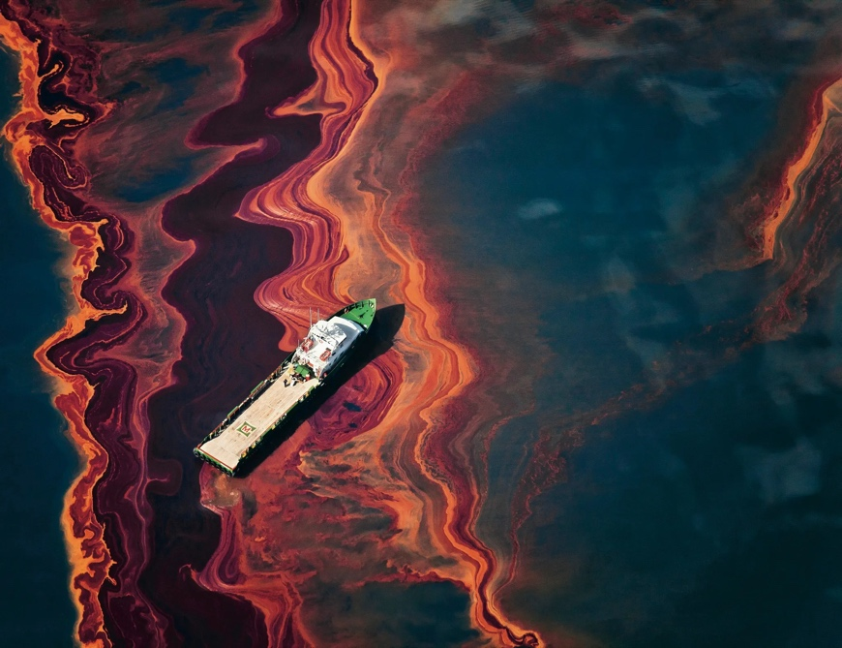
The Oil Pollution Act of 1990 (OPA 90) was signed into law on August 18, 1990, a year and a half after the disastrous Exxon Valdez oil spill. The bill broke years-long gridlock over oil pollution legislation in Congress (CQ Almanac 1989), expanding the federal government’s capacity to prevent and respond to oil spills, improving payment of claims stemming from damages and cleanup, and increasing safety requirements for oil tankers and facilities. It contains key provisions that require oil tankers to be double-hulled, require oil industry facilities to maintain detailed spill prevention and response plans, and allow states to set liability limits higher than those enumerated in the bill. OPA 90 played a key role in the Deepwater Horizon oil spill in 2010, though some criticized its usage in the incident (Griggs 2011).
Above: oil in the Gulf of Mexico following the Deepwater Horizon oil spill in 2010.

Despite calls for new oil pollution legislation following Deepwater Horizon, the Oil Pollution Act of 1990 remains intact and continues to be relevant. For example, in September of 2021, Hurricane Ida caused more than 2,300 spills in the Gulf Coast area. Oil spills are catastrophic events, causing mass animal deaths and posing health risks for humans. OPA 90 also remains pertinent as it has been cited for causing unintended consequences in the oil industry, mainly due to the specifics of the bill’s liability provisions (Morgan 2011; Lev 2016). Should a shift towards renewable forms of energy occur in the future, OPA 90 would likely wane in relevance.

A bipartisan bill being considered due to a recent tragedy, the Oil Pollution Act of 1990 was never in real danger of failing to pass Congress. There were fights over a few of the bill’s provisions, however. State preemption, or the idea that states should be allowed to set higher liability limits than those found in federal law, was of heavy contention on the House floor. After debate, a state preemption amendment was approved 279-143 by the lower chamber. Another controversial amendment would have lowered standards of negligence in the bill, making it easier for oil companies to be found at fault in the event of a spill (CQ Almanac 1989). The House initially voted in favor of the amendment by a vote of 213-207. Oil industry groups, along with the Bush Administration, frantically began lobbying overnight for its removal (CQ Almanac 1989). The next day, the simple negligence amendment was rejected 185-197 (Congressional Record, 101st Congress, November 9, 1989, 28269). The Oil Pollution Act of 1990 then went to a conference committee between it and similar Senate legislation. The Senate approved the ensuing conference report 99-0, and the House approved it 375-5. Following passage of the report by both congressional chambers, the self-proclaimed environmentally friendly President George H. W. Bush (R-TX) signed OPA 90 into law.

Background

Functions of the Act
The 101st Congress passed the Oil Pollution Act of 1990 (OPA 90) in response to the Exxon Valdez oil tanker crashing into the Bligh Reef and spilling eleven million gallons of crude oil into Prince William Sound, located in Alaska. Before the passage of OPA 90, oil spills were governed by a patchwork of several different laws, the latest being the Comprehensive Environmental Response, Compensation, and Liability Act (CERCLA) passed in 1980. Kurtz 2004 notes that CERCLA was limited because “matters of spill prevention, liability, damage restitution, and creation of a spill cleanup fund were ignored” (p. 206). On the broader collection of oil pollution laws existing prior to OPA 90, “critics said that the structure in place was inadequate to handle a major spill, compensate individual claimants such as fishermen, and keep the entire compensation issue from bogging down in lengthy court battles” (CQ Almanac 1989).

In passing OPA 90, Congress attempted to address the aforementioned criticisms of their previous pieces of legislation. OPA 90 altered liability limits and clarified which parties are responsible for certain claims. It appropriated funds for the Oil Spill Liability Trust Fund, which pays for costs incurred by the federal government during cleanup of a spill. The bill also bolstered the requirements for facilities to maintain spill contingency plans. This was done to ensure that containment and cleanup efforts would begin immediately after an oil spill took place, as Exxon’s spill response had been highly criticized for being slow.

Furthermore, OPA 90 required vessels to have double hulls to provide them with better protection against crashing incidents similar to Exxon Valdez. It also allowed the Coast Guard to direct shipping companies on spill cleanup and stated the president is the only authority that can deem a federal cleanup to be complete (CQ Almanac 1990). This represented a purposeful decrease of petroleum industry control in cleanup efforts since the industry has an incentive to cut costs; it is presumed the Coast Guard will act with more direct interest in containing and removing pollution.

Changes during Consideration
The bill initially proposed in Congress looked somewhat different from that eventually passed by both chambers. The two committees that HR 1465 had been referred to, the House Committee on Merchant Marine and Fisheries and the House Committee on Public Works and Transportation, decided after several hearings that the original bill needed more in the areas of oil spill prevention and removal. As a result, the House Merchant Marine and Fisheries Committee added a prevention and removal package to the bill (Millard 1993). During the conference committee on the bill, a compromise on the double hull provision was reached that required all U.S. oil tankers to have them, but not until the year 2010. This was done to address the oil industry’s concerns that double hulling their fleets would be expensive and time-consuming (CQ Almanac 1990).

The initial House version of the bill would have implemented an existing 1984 treaty on liability limits for oil tankers, pending Senate ratification. This provision was rejected by Senate conferees, as they thought the limits set forth in the treaty were too low and could possibly preempt state and federal law. Thus, the treaty provision died in conference committee (CQ Almanac 1990). Also, on liability, the House bill held both cargo owners and shipowners liable, while the Senate version held only shipowners liable. An agreement was reached in conference committee that reflected the Senate’s position (CQ Almanac 1990).

The Dangers OPA 90 Attempts to Prevent
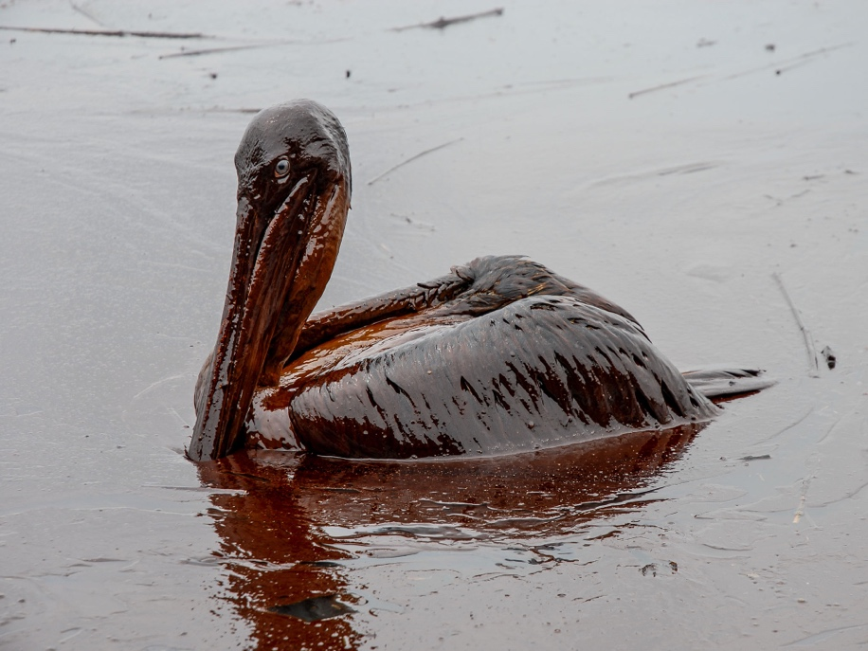
Oil spills are highly harmful for both the environment and humans. It is estimated that 100,000 to 300,000 birds were killed in the immediate aftermath of the Exxon Valdez spill (Piatt et al. 1990). Oil contamination of an area can also cause algal blooms, which occur when algae hijack an ecosystem, causing the death of many other plants and animals. Oil pollution is long-lasting, as ten years after the Exxon Valdez spill, “Patches of contaminated sediment and subsurface oil [persisted] at selected sites” (Hoff & Shigenaka 1999, p. 115). Moreover, oil spills have detrimental health effects for humans; many of the agents used in oil pollution cleanup are toxic and cause illnesses (Eklund 2019). Mental health is affected as well, as exposure to the Exxon Valdez spill was shown to be positively correlated with generalized anxiety disorder and depressive symptoms (Institute of Medicine 2010).
Above: a pelican covered in spilled oil.

Liability Caps and Liability Insurance
Caps setting a maximum on liability compensation have been a source of constant disagreement throughout Congress’ history on oil pollution legislation. Petroleum industry proponents have lobbied for lower liability caps, while environmental advocates have generally supported increased caps or no caps at all (unlimited liability). In support of their position, petroleum industry groups cite economic concerns, positing that the cost of liability insurance can fluctuate depending on the liability caps set by legislation. Environmental groups, in turn, hold that higher liability caps decrease the frequency with which oil pollution occurs. Some environmentalists also argue that low liability limits actually encourage oil spills.

Faced with this debate, OPA 90 addressed liability by “[broadening] the scope of damages (i.e., costs) for which an oil spiller would be liable” and “…[setting] liability limits (or caps) for cleanup costs and other damages” (Ramseur 2017, p. 14-15). OPA 90 does include an unlimited liability provision, but only for pollution removal costs due to offshore activity (Ramseur 2017). The size of the liability cap for offshore facilities, or whether to have one at all, was as contentious during OPA 90’s consideration as it had been historically. According to Taylor 2010, President Bush (R-TX) “threatened to veto the act if that liability cap were not part of it. He got his way, but to go as far as to threaten a veto over the lack of a liability cap suggests that it was a pretty substantial part of the debate.”

Adjustments to Liability Caps under OPA 90
While OPA 90 set caps on most all forms of liability, it also directed the president to periodically adjust these limits to keep pace with inflation. However, liability limits set under OPA 90 were not first adjusted until 2006, when an amendment to the legislation altered liability caps for vessels. Subsequent limit adjustments have been put in place by bureaucratic agencies through rulemaking and have been tailored towards both onshore and offshore facilities (Ramseur 2017). This process took time to transpire, as at the time of the Deepwater Horizon oil spill in 2010, the liability cap for offshore damages was still $75 million, an unadjusted amount from the original language of OPA 90. To address this, President Barack Obama (D-IL) issued Executive Order 12777 in 2013, which delegated the president’s responsibility to increase liability limits to the federal bureaucracy. As a result, the Bureau of Ocean Energy Management began handling liability cap increases for offshore facilities, issuing its first rule on the matter in 2014, which raised the $75 million limit to approximately $134 million (Federal Register 2014). The Coast Guard undertook the task of adjusting limits for onshore facilities’ liability, issuing its first inflation-related increase in 2015 (Federal Register 2015).

Liability in Previous Congresses
As previously acknowledged, questions of liability had been undertaken numerous times in Congresses prior to the 101st. The passage of the Clean Water Act of 1977, which amended the Clean Water Act of 1972, set a $50 million liability cap for oil spill cleanup for onshore and offshore facilities. The previous liability cap was $14 million. The legislation also set dollars-per-ton liability rates for oil-containing vessels, dependent on vessel type (CQ Almanac 1977). The 1977 bill did not address liability for damages; neither did the 1972 bill (Copeland 2016). Another act dealing with liability was in the works in 1977, though it did not see passage. HR 6803 would have set liability caps for cleanup costs at $50 million but would have extended liability to spills of chemicals that the EPA deemed harmful. Disagreement over the chemical liability provision was credited with the death of the bill (CQ Almanac 1978).

The very next year, Congress passed the Outer Continental Shelf Lands Act Amendments of 1978, which placed a $35 million liability cap on damages for offshore facilities but set unlimited liability for cleanup costs. In 1982, another change to liability limits was proposed, as the House passed HR 5906 by voice vote. This bill would have altered the 1978 amendments and set a liability cap of $75 million for both damages and cleanup costs for offshore rigs. However, the Senate never undertook the measure, so the bill was effectively killed (CQ Almanac 1982).

Four years later, in 1986, the House and Senate passed oil pollution liability laws that would have created a $350 million fund, financed via a tax on barrels of oil, to cover costs that exceeded the set liability limits. However, the two chambers were unable to agree on the undermentioned issue of state preemption, so uniform bills were not passed (CQ Almanac 1986). In review, the constant changing of liability limits prior to OPA 90 reflected the ever-shifting debate and political muscling occurring between the respective oil and environmental lobbies.

On the Lack of Prior Legislation
Although there had been interest in additional oil pollution legislation in the years leading up to OPA 90, not much progress was made. Kurtz 2004 notes, “These issues [liability and compensation for damage and removal costs] remained bottled up within the confines of an industry-friendly alliance; consisting of oil companies, shippers, insurance carriers, financiers, select congressional committees, and the Interior Department” (p. 206). In the absence of a major oil pollution incident, Congress was able to effectively keep the issue mired without significant repercussions.

Another bottleneck on passing oil pollution legislation in the years prior to Exxon Valdez was the friction between the House and Senate on the inclusion of a provision which would have allowed for federal liability law to supersede existing state liability laws. The House was insistent that such a provision be included in any potential legislation, and the Senate was equally insistent against its inclusion (CQ Almanac 1990). The leading proponents of state preemption were a collection of senators from coastal states, led by Senator George Mitchell (D-ME). Many of the senators supported state preemption because their home states had unlimited liability provisions in existing state law, and they did not wish to see them hindered by federal law. Mitchell’s own state of Maine had a no-limit liability statute (CQ Almanac 1989).

How OPA 90 Came About
Nevertheless, the Exxon Valdez spill presented a public debacle that was too large to keep under the control of industry-friendly committees and too large for congressional disagreement over a provision to stop. According to Shigenaka, “The toll inflicted by the spill on birds and other wildlife like sea otters, documented by news media across the country and around the world, as well as the length of time required for the shoreline cleanup, resulted in high visibility and constant public awareness.” Ordinary American citizens began engaging in symbolic acts of protest against Exxon, and many interest groups picked up their congressional lobbying efforts (Kurtz 2004). Environmental groups were among those exerting the largest amount of pressure on Congress (CQ Almanac 1990); thirty-nine of the eighty-five groups participating in hearings were environmental related (Kurtz 2004). They were notably effective in using their newfound political capital to influence policy. Representative George Miller (D-CA) noted, “Their [environmentalists’] fingerprints are on the bill” (CQ Almanac 1990).

In response to the political pressure ensuing from the spill, fifteen different committees and subcommittees held hearings on the matter (Kurtz 2004). This increased committee activity was particularly significant, as Talbert et al. note, “oversight hearings can force reviews of current policy in a way that the more structured-bill referral process can not…A derelict committee may be prodded into action by challenger committees seeking a piece of its jurisdiction” (1995, p. 401). In essence, the House Merchant Marine and Fisheries Committee and House Public Works and Transportation Committee had an increased motivation to act on oil pollution legislation because they wanted to protect their hold on their respective jurisdictions and maintain control over the issue.

Following the public spectacle that was Exxon Valdez, the reaction of the American public and lobbying groups, and the incentives for previously dormant committees to act, there was momentum of gigantic proportions behind crafting new legislation. Representative W. J. Tauzin (D-LA), chairman of the House Merchant Marine and Fisheries subcommittee tasked with OPA 90, frankly stated, “‘momentum for a bill is too large’ to resist” (CQ Almanac 1989). Exxon Valdez represented an event of such imposing magnitude that it was able to push OPA 90 through roadblocks to previous legislation with comparative ease.

House Consideration of HR 1465 (November 1-2, November 8-9, 1989)

Committee Consideration
House Merchant Marine and Fisheries Subcommittee on Coast Guard and Navigation
On May 24, 1989, the House Merchant Marine and Fisheries Subcommittee on Coast Guard and Navigation agreed to HR 1465, the earliest House version of the Oil Pollution Act of 1990, by voice vote (CQ Almanac 1989). The bill had originally been introduced by Representative Robert Michel (R-IL) on March 16, 1989 (Congressional Record, 101st Congress, March 16, 1989, 4488), eight days prior to the Exxon Valdez oil spill.

Preceding approval of HR 1465, the subcommittee had been divided over the issue of state preemption of oil spill liability laws. The panel opted to reject state preemption, instead agreeing to language that would prevent claimants from seeking compensation for damage or cleanup costs under state law, provided the items were covered under the future federal law. Even though state preemption was a combative issue, subcommittee Chairman W. J. Tauzin (D-LA) predicted, “‘no one will let [preemption] kill this bill.’”

However, some subcommittee members still found the bill’s strong language against state preemption as off-putting. Rep. Gerry Studds (D-MA) sought to delay the bill, arguing that the subcommittee should review existing state laws to see exactly which provisions of state law would get preempted by the bill’s language. Committee Chairman Walter Jones (D-NC) disagreed, arguing that state preemption had been offered in the past as a means of compromising with the Senate, and adopting state preemption from the start would be an unnecessary giveaway. Subcommittee Chairman Tauzin agreed, saying, “‘If we concede now [on preemption], we’re [sic] giving up before the fight’” (CQ Almanac 1989).

House Merchant Marine and Fisheries Committee
Nevertheless, proponents of state preemption were not satisfied. Representatives from coastal states, backed by President George H.W. Bush (R-TX), Senate Majority Leader George Mitchell (D-CA), and a consortium of environmentalists, continued to push the issue during committee markup despite it having been defeated in subcommittee. However, a majority of members remained reluctant to alter their positions. On June 21, 1989, during markup of HR 1465, the House Merchant Marine and Fisheries Committee in effect defeated, by a vote of twenty-six to sixteen, an amendment proposed by Rep. Studds that would have practically removed all federal preemption provisions in the bill. As a move of appeasement, the committee did agree to an amendment offered by Chairman Jones and others that kept federal preemption but limited it to setting liability caps for spillers and compensating spill victims. The committee further gave states broad discretion to clean up spills (CQ Almanac 1989). Markup complete, HR 1465 then moved to the House Public Works and Transportation Committee, as it also had jurisdiction over oil spill liability legislation (CQ Almanac 1989).

House Public Works and Transportation Committee
Upon taking up the issue, the House Public Works and Transportation Committee decided to consider its own version of oil spill legislation, HR 3027 (CQ Almanac 1989). HR 3027 was introduced by Rep. Glenn Anderson (D-CA) on July 27, 1989. It was similar to HR 1465 in that it established liability caps for non-negligent spillers, created an oil spill fund to pay for cleanup costs, and articulated clear processes for victim compensation. However, HR 3027 also included provisions designed to prevent future oil spills and provide for quicker cleanup in the event a spill occurred. This spurred the House Merchant Marine and Fisheries Committee to add a prevention and response package to HR 1465.

Notably, the issue of state preemption did not arise in the House Public Works and Transportation Committee’s markup of their bill, as members relied on promises from committee leaders to allow for amendments to be offered on the House floor. The committee agreed to HR 3027 by voice vote on August 3, 1989, also agreeing to HR 1465 after inserting HR 3027’s language into it (CQ Almanac 1989). The 101st Congress then broke for its August recess a few days later.

Truce Between HR 1465 and HR 3027
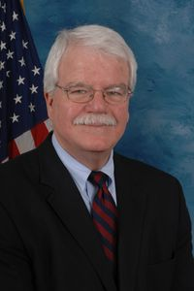
Faced with two differing pieces of legislation, key committee members and House leadership agreed on a compromise package, HR 3394, and introduced it on October 3, 1989. It was a product of negotiations between the House Merchant Marine and Fisheries Committee, the House Public Works and Transportation Committee, and the House Science, Space, and Technology Committee. HR 3394 included many changes suggested by members seeking to placate the concerns of environmentalists. With the bill, House leadership believed they had solved most areas of contention, with exception to three issues they decided to leave for the House floor: whether state liability laws should preempt federal liability law, whether simple negligence or gross negligence should precipitate unlimited liability, and whether citizens should be allowed to sue federal officials over enforcement of the act.
Above: Rep. George Miller (D-CA), who was an ardent environmentalist.

The key players involved in HR 3394 had hoped that it would receive quick consideration from the House Rules Committee, but that was not to be the case. Chairman George Miller (D-CA), of the House Interior Subcommittee on Water, Power, and Offshore Energy Resources, upset that his committee did not get to markup the original legislation, objected to the compromise bill. In response, the House Rules Committee delayed consideration of a rule for HR 3394 until further agreement could be reached (CQ Almanac 1989).

Reaching the Floor
On November 1, 1989, Rep. David Bonior (D-MI) moved the House to consider Hres 277, a special rule that provided for consideration of HR 1465 under an open rule (Congressional Record, 101st Congress, November 1, 1989, 26843). While members were generally supportive of the open rule, some opposed a provision in Hres 277 that waived any points of order against amendments by Reps. Miller and Studds to be considered en bloc. The main purpose of the Studds-Miller amendment was to prevent federal liability law from preempting state laws, among several other provisions. The rule furthermore provided that amendments in addition to the Studds-Miller package be considered under the five-minute rule. After some debate, Hres 277 was adopted by a 238-154 vote.

Debate and Amending Process
General Debate
On November 2, 1989, the Committee of the Whole opened general debate on HR 1465. Representatives Walter Jones (D-NC), Glenn Anderson (D-CA), John Paul Hammerschmidt (R-AR), and Claudine Schneider (R-RI) were each given thirty minutes of speaking time. Robert Davis (R-MI) and Robert Roe (D-NJ) were each given twenty minutes, while George Miller (D-CA) and Donald “Don” Young (R-AK) were each given fifteen minutes. Rep. Walter Jones, the newly listed chief sponsor of HR 1465 in its compromise form, gave the first speech. Jones stated, “This is the strongest oilspill [sic] bill ever presented to Congress. It is the result of 14 [sic] years of effort in the House… More than once during these years of frustration, it was said that it would take a major oil-spill disaster to achieve enactment of this bill. Unfortunately, this has proved true” (Congressional Record, 101st Congress, November 2, 1989, 26933).

Rep. Young (R-AK), whose home state the Exxon Valdez spill occurred in, also spoke in support, highlighting several Alaska-specific provisions in the bill (Congressional Record, 101st Congress, November 2, 1989, 26934). Several other members joined in support of HR 1465. Rep. Robert “Bob” Clement (D-TN), who sat on both the House Merchant Marine and Fisheries and Public Works Committees, showed unity between the two panels when he stated, “Their [the chairmen of the two committees] expeditious handling of this measure will help restore public confidence in our Nation’s ability to prevent oilspills [sic] and to respond effectively when they do occur” (Congressional Record, 101st Congress, November 2, 1989, 26943).

To the extent any representative expressed doubts about the bill during initial debate, it was contained to amendments by Reps. George Miller and Gerry Studds that were to be considered later. Overall, general debate on HR 1465 was supportive and congratulative. This was reflective of the work that had been done in drafting HR 3394, the compromise text, as well as the House’s bipartisan attitude toward the legislation, driven by the Exxon Valdez disaster.

Studds-Miller Amendment
While the text of HR 3394, now inserted into HR 1465, had been thought of as containing significant giveaways to environmental groups, Reps. Miller and Studds still had reservations about the bill. They offered amendments that would bar federal law from preempting state laws on liability limits and insurance requirements, permit state courts to hear oil spill lawsuits brought under the bill, and allow states to have a say in determining when a federal spill cleanup effort was complete (CQ Almanac 1989). Debate on the Studds-Miller amendments en bloc was limited to sixty minutes, equally divided between supporters and opponents of the measures, and took place on November 8, 1989 (Congressional Record, 101st Congress, November 8, 1989, 27939).

In support of his proposed alterations, Rep. Miller said, “The amendment that I am offering on behalf of myself and the gentleman from Massachusetts [Mr. Studds] is an amendment to correct the glaring flaw in HR 1465, by preserving the rights of States [sic] to set higher standards for oil pollution liability and more complete systems of compensation than are allowed under this bill or under current law.” Miller went on to outline that his and Studds’ amendments would vastly expand states’ control over spill cleanup efforts. He also noted the related oil spill legislation the Senate had already passed included similar provisions (Congressional Record, 101st Congress, November 8, 1989, 27948).

Nevertheless, state preemption had been contentious in committee, and thus it was on the House floor. Rep. John Paul Hammerschmidt, the first member recognized to speak in opposition, rebutted, “A key feature of this bill [HR 1465] is Federal [sic] preemption of State [sic] laws on liability. Without such preemption, we would return to a patchwork of overlapping and conflicting laws which may actually impede prompt payment of justifiable claims” (Congressional Record, 101st Congress, November 8, 1989, 27948). Rep. Norman Shumway (R-CA) spoke on the other provisions of the Studds-Miller amendment, stating, “This amendment packages four highly controversial and, I believe, highly objectionable amendments. It is not merely an amendment to eliminate Federal [sic] preemption of State [sic] liability laws. It goes much, much farther” (Congressional Record, 101st Congress, November 8, 1989, 27950).

While state preemption had been defeated numerous times in committee, this time it did not fail. The House altered the Studds-Miller amendment to specify that a federal official had sole authority in declaring spill cleanup efforts complete, then voted 279-143 to approve the en bloc package. This marked a reversal of the House’s more than a decade long stance against state preemption. Opponents of state preemption had one last stand, coalescing around an amendment offered by Rep. William Hughes (D-NJ) that would have barred state liability limits from exceeding the federal liability limits set forth in HR 1465. The Hughes amendment failed 171-252.

Miller Amendment on Negligence
In addition to the Studds-Miller amendment package, Rep. George Miller offered an amendment that would have changed the language of HR 1465’s negligence provision for liability caps from “gross negligence” to “simple negligence”. In support of his amendment, Miller stated, “Do we want to reward the oil transporters by limiting liability even when they disregard the reasonable standards of conduct? I do not think we do” (Congressional Record, 101st Congress, November 8, 1989, 27977). In opposition, Rep. Tauzin kept it simple: “The bill we have works. The Miller amendment destroys it” (Congressional Record, 101st Congress, November 8, 1989, 27982). Despite heavy opposition, Rep. Miller’s negligence amendment initially passed 213-207 on the evening of November 8, 1989.

Oil industry groups were immediately appalled by the amendment, arguing it would essentially eliminate the liability caps set forth in the bill because all spills involve some degree of negligence (CQ Almanac 1989). Bush administration officials, along with the authors of HR 1465, were afraid the amendment would cause President Bush to veto the bill. They had lobbied against the amendment during its consideration and continued to lobby overnight for the amendment’s removal (CQ Almanac 1989). The next day, on November 9, the House voted 185-197 to reject the amendment, without debate (Congressional Record, 101st Congress, November 9, 1989, 28269).

Final Passage Vote
Shortly after rejecting the Miller amendment on negligence, the House passed HR 1465 by a vote of 375-5. Of the five members voting against the bill, all were Republicans, and three were from Texas, a state known for its oil production (Congressional Record, 101st Congress, November 9, 1989, 28270). Overall, the final passage vote was a fair representation of the Oil Pollution Act of 1990: a bipartisan bill spurred into passage by a recent disaster. HR 1465 was characterized in the press as a bill “aimed at preventing accidents, improving cleanups, and holding tankers and oil companies liable for spills.” Conference between HR 1465 and a similar Senate bill was expected to occur in early 1990.

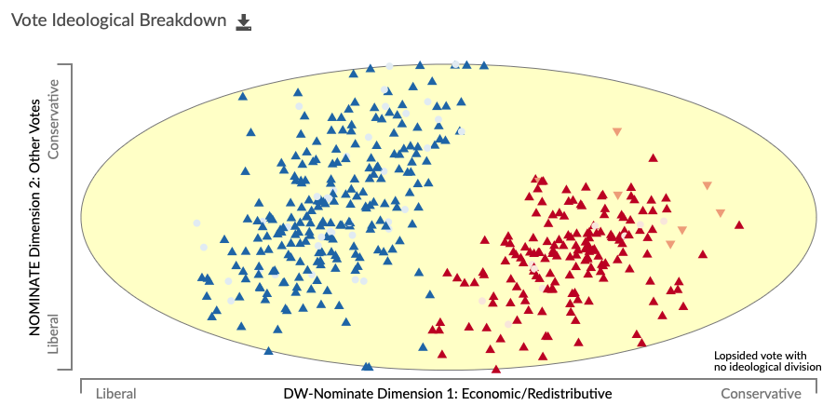
The figure from voteview.com shows the vote was not considered divided along ideological lines (Poole & Rosenthal 1997). Voteview.com (101st House, rcnum 335): https://voteview.com/rollcall/RH1010335

Senate Consideration of the HR 1465 Conference Report (August 2, 1990)
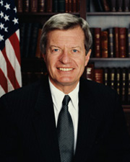
Above: Senator Max Baucus (D-MT).
The discussion on the Senate floor regarding the Oil Pollution Act of 1990 conference report was one of bipartisanship and the importance of passing OPA 90. Senator John Chafee (R-RI) said, “Mr. President, this year in many respects, has not been a good one in the Senate. So much legislation is highly partisan, passed over the objections of one group or another, with the threat of a veto always hovering in the background. This oil spill legislation is different. It is a good result and deserves approval” (Congressional Record, 101st Congress, August 2nd, 1990, 21715). Members spoke of the compromises made within committee sessions and how those compromises were the right choice for this legislation. Senator Ernest Hollings (D-SC) spoke of the compromises made on the issues of requirements of the coast guard, requirements of tankers, and contingency plans. Members also spoke of how they thought the bill would be preventive and, in turn, keep events such as the Exxon Valdez disaster from occurring again. Senator Max Baucus (D-MT) said, “Many in the industry seem to have decided that it is cheaper to spill and pay for its cleanup than it is to prevent spills and develop effective techniques to contain them. This compromise legislation developed by the House and Senate oil spill conference will change that” (Congressional Record, 101st Congress, August 2nd, 1990, 21716).

The conference report was agreed to by a 99-0 vote within the Senate on August 2nd, 1990.

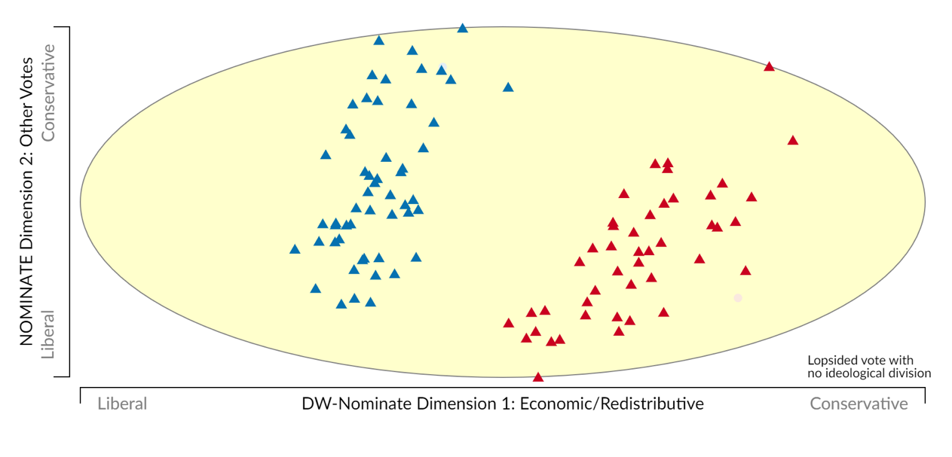
The vote was considered lopsided with no ideological division (Poole & Rosenthal 1997). Voteview.com (101st Senate, rcnum 518): https://voteview.com/rollcall/RS1010518

House Consideration of the HR 1465 Conference Report (August 3, 1990)

Hres 452
House Resolution 452 did two things, neither of which are irregular for passage of a bill within the House. First, it pulled the conference report up for consideration onto the floor. Next, it waived any point of order against the conference report, meaning that what the House was going to vote on was the last version and no additional changes will be made. This point was especially important to members of the House during this time, as HR 1465 had already taken over a year to come to this point of final consideration.

The primary cause for debate regarding Hres 452 was section 6003 and its content regarding North Carolina and oil drilling. Rep. Charles Pashayan Jr. (R-CA) said, “Section 6003 would prohibit the Secretary of the Interior from conducting a lease sale, issuing any new leases, approving any exploration plan, approving any development and production plan, or approving any application for a permit to drill or permitting any drilling for oil or gas on any OCS lands offshore North Carolina. Section 6003 is a straitjacket for Secretary Lujan with regard to OCS lands off the shores of North Carolina” (Congressional Record, 101st Congress, August 3rd, 1990, 22271).

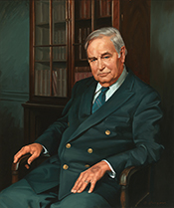
During Rep. Ralph Regula’s (R-OH) allotted time, he discussed the U.S. economy, oil exports, import statistics, and what a vote for the previous question motion will mean for the people of the United States. Regula stated, “A ‘yes’ vote on the motion on the previous question will be to lock out the American people from an energy resource that they own. A ‘yes’ vote will be to enhance the power of Dictator Hussein. A ‘no’ vote on the previous question will be a vote for energy independence, a vote for energy for the East and the Northeast of the United States, for natural gas. It will be a vote for growth, and it will be a vote for jobs” (Congressional Record, 101st Congress, August 3rd, 1990, 22276). Directly after Regula concluded speaking, Rep. Walter Jones (D-NC) said, “Mr. Speaker, I would say to the gentleman from Ohio [Mr. REGULA] that just finished, I am not sure he is familiar with what the amendment does. It does not stop drilling, it merely provides to October 1, 1991, an opportunity for additional scientific information” (Congressional Record, 101st Congress, August 3rd, 1990, 22276).
Above: Rep. Walter B. Jones (D-NC), chairman of the House Merchant Marine and Fisheries Committee and chief sponsor of HR 1465.

The majority of the time spent debating Hres 452 saw members rise in support of the previous question motion and urge their fellow representatives to vote in favor. Rep. Gerry Studds (D-MA) said, “I rise in enthusiastic and relieved support of this conference report” (Congressional Record, 101st Congress, August 3rd, 1990, 22281). The votes against Hres 452 can be viewed as conservative members taking a stance in support of business. This explains the recorded vote over the previous question motion, while the conference report later passes unanimously. Conservative members wanted a recorded vote to show their support for oil industry while still supporting OPA 90 in the end.

Hres 452 was adopted 281 to 82. As seen by the voteview figure, the ‘no’ votes were primarily conservative members of the Republican party.

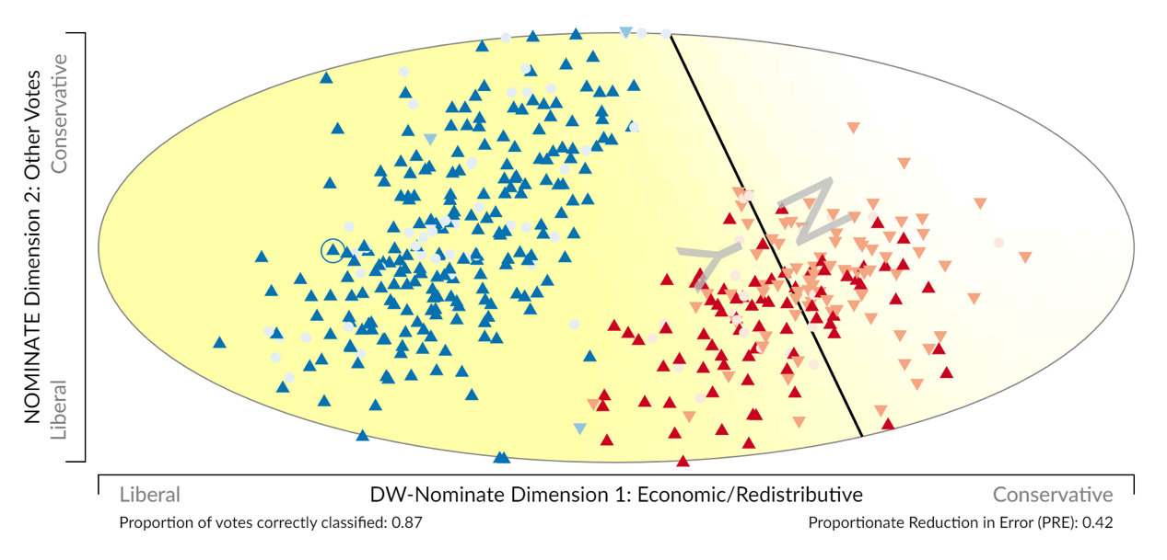
Voteview.com (101st House, rcnum 670): https://voteview.com/rollcall/RH1010670

HR 1465 Conference Report
Following the passage of Hres 452, the conference report for HR 1465 was open to the floor for debate and remarks. The remarks made during this time were overwhelmingly positive and in support of the passage of OPA 90. Members spoke of the combined effort of the House and Senate and Republicans and Democrats that worked together to ensure that OPA 90 be passed. Rep. Robert Roe (D-NJ) said, “No less than seven committees in the House of Representatives and three Senate committees have combined their talents, energy, and hard work to craft the important legislative proposal before us today” (Congressional Record, 101st Congress, August 3rd, 1990, 22284). Members also spoke of the importance of OPA 90 in regard to the bipartisanship that it signaled to the country. The explanation behind the force driving cooperation between houses and parties was the severity of the Exxon Valdez spill and the overwhelming amount of oil spills around the country. Rep. Walter Jones (D-NC) said, “On March 16, 1989, I introduced H.R. 1465, the Oil Pollution Act of 1989. Just days later, the Exxon Valdez ran aground on Bligh Reef in Alaska. This biggest oil spill in U.S. history proved what my committee had been saying for years: we had to completely rewrite and update our woefully inadequate oil spill laws. Today, we bring before the House the conference report on H.R. 1465...It is truly the product of the House as a whole” (Congressional Record, 101st Congress, August 3rd, 1990, 22285). Any word against HR 1465 primarily came in the form of wishing it implemented international protocols. Rep. Robert Davis (R-MI) said, “I am terribly disappointed that the final product does not implement the international protocols necessary part of a complete worldwide oil spill response regime” (Congressional Record, 101st Congress, August 3, 1990, 22286-22287).

H.R. 1465 passed unanimously with 360 to 0 with 72 members not voting. The passage of H.R. 1465 was the final step for OPA 90 within Congress.

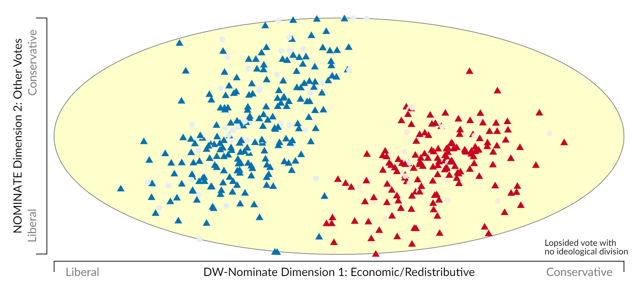
Voteview.com (101st House, rcnum 671): https://voteview.com/rollcall/RH1010671

Member Spotlight

Life History
Charles Ellis “Chuck” Schumer was born on November 23, 1950, in Brooklyn, New York. His mother was a homemaker, and his father owned a pest extermination business. Schumer attended James Madison High School, where he graduated from in 1967. Following graduation, he enrolled at Harvard University. While at Harvard, a transformative experience for Schumer was volunteering on Senator Eugene McCarthy (D-MN)’s presidential campaign. He credits this as having steered him towards a life in politics; when he returned to the university, he promptly changed his concentration from science to social studies. Schumer received his undergraduate degree in 1971 and matriculated at Harvard Law School without delay, receiving his juris doctorate in 1974.

After law school, Schumer was admitted into the New York bar in 1975, however he did not pursue a legal career. Instead, he ran for a seat in the New York State Assembly as a Democrat. At twenty-three years of age, he became the legislative body’s youngest member since Theodore Roosevelt. In 1980, five years later, Schumer decided to run for a U.S. House seat in New York’s Sixteenth Congressional District, a Democratic stronghold. Schumer was endorsed by New York City’s Democratic mayor, Ed Koch, as well as the seat’s outgoing representative, Elizabeth Holtzman (D-NY). Schumer also spent more money than any other candidate. Bolstered by his endorsements and campaign funds, he won the Democratic primary and went on to win the general election with 77.5% of the vote.

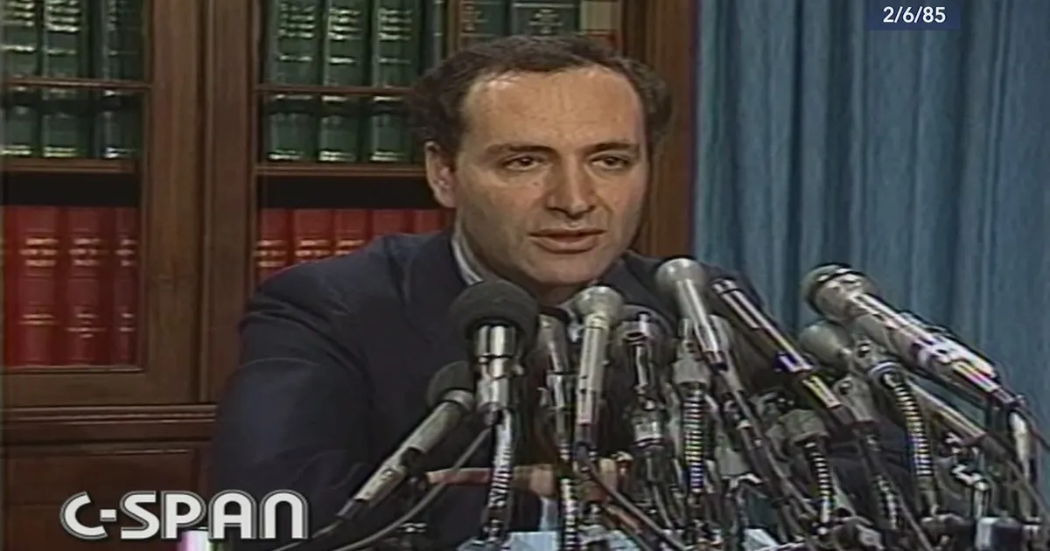
As a newly minted representative, Schumer noted, “‘with a Republican President and a Republican Senate, there’s [sic] a real need for my contribution.’” Schumer was quick to contribute by taking a tough stance on crime and advocating against proposed cuts to low-income housing builds. He was given assignments on the House Banking Committee and the House Judiciary Committee. As evidence of the trust Democratic leadership would come to place in him, he was put in charge of Democratic strategy for the 1995 Waco hearings. Schumer ultimately received a congratulatory phone call from President Bill Clinton (D-AR) for his handling of the affair. Schumer is credited with being the principal author of several major pieces of legislation, of which the 1994 crime bill, the Brady bill, and an assault weapons ban are included. As one reporter put it, Schumer established himself as “a force to be reckoned with”, noted for having “played pivotal roles in a diverse array of legislation” during his time in the House.
Above: then-representative Chuck Schumer speaking in 1985.

After spending twenty years as a representative, Schumer set his sights on a larger aim. In March of 1997, he announced that he would be running as a candidate for U.S. Senate in the Democratic primary. In his first major address of the race, Schumer portrayed himself as a centrist, articulating his support for tax cuts and bipartisan education initiatives. Although he quickly raised millions of dollars, Schumer lagged the incumbent, Senator Alfonse “Al” D’Amato (R-NY), in fundraising totals.

Throughout the early days of Schumer’s Senate campaign, it was widely speculated whether Geraldine Ferraro, the 1984 Democratic vice-presidential nominee, would also enter the primary. In January of 1998, Ferraro’s campaign announcement finally arrived. Even though she opened as the front-runner in the polls, Schumer had already acquired the endorsements of six members of Congress, nine New York state senators, and fifty-three members of the state Assembly by the time she announced. The primary was contested until the final minute, but Schumer ended up besting Ferraro and one other challenger rather handily. His fundraising ability and strong advertising campaign, as well as perceived missteps by Ferraro, were credited with his win.

In the general election, Schumer quickly pivoted to D’Amato, criticizing him as being a conservative with social views that a majority of New Yorkers did not support, as well as calling attention to past ethics complaints against the incumbent senator. D’Amato decided to focus on his ability to bring federal money to New York, leaning on his “Senator Pothole” nickname. He also attempted to paint Schumer as a liberal who was ‘out of touch’ with areas of the state outside New York City. Schumer countered by continuing to present himself as a moderate and highlighting his legislative record. Schumer’s tactics prevailed, winning him the race 55% to 44%.

During his time in the Senate, Schumer has gradually climbed up the Democratic ranks. From 2005 to 2008, he served as chair of the Democratic Senatorial Campaign Committee. He also served as chair of the Democratic Policy and Communications Committee from 2007 to 2011. In 2017, Schumer was elected Democratic senate leader following the retirement of the leader at the time, Senator Harry Reid (D-NV). After the 2020 election, which saw Democrats gain a de facto majority in the Senate, Schumer assumed the role of Senate majority leader for the first time. He stated that his priorities were “‘income and wealth inequality, climate [change], racial justice, health care, and improving our democracy.’” This marked a shift from the centrist positions he took when he was initially elected to the Senate.

Anecdotes of Interest
Under Investigation
In September of 1981, seven months after he had been sworn in for his freshman term in Congress, Schumer came under investigation by a Federal grand jury based on accusations that he had illegally used New York State Assembly staffers on his congressional campaign the previous year. In early 1983, more than a year later, the U.S. attorney for the eastern district of New York recommended the federal government seek an indictment in the case. The Justice Department, led on the matter by Associate Attorney General Rudolph “Rudy” Giuliani, chose to end its investigation, however. They held Schumer’s alleged violations were not under federal jurisdiction.

The case then went to the office of Brooklyn District Attorney Elizabeth Holtzman, who had endorsed Schumer to succeed her in Congress a few years prior. Holtzman held there would be a conflict of interest if her office investigated the matter and requested Governor Mario Cuomo (D-NY) appoint a special prosecutor. Cuomo rejected the request, so Holtzman appointed a special prosecutor herself. The case was slow to proceed for the next two years, until Holtzman’s office attempted to obtain the Federal grand jury testimony from the original investigation. The request was denied, and Holtzman ultimately declared in mid-1985 that Schumer had not violated state law. Throughout the ordeal, Schumer maintained his innocence and argued the accusations were from political enemies with a vendetta against him.

Well-Traveled
Every year, Schumer visits all sixty-two of New York’s counties to continue fulfilling a promise he made when first elected to the Senate in 1998. “‘At the close of twenty-one years, my beliefs are clear as ever: Senators who stay in Washington and never return home are simply not doing their job,’” Schumer has stated on the matter. He completes this fast-paced tour mainly via chartered plane, landing at small airports across the state. In November of 2020, Schumer completed his twenty-second consecutive tour despite the coronavirus pandemic.

A Penchant for Surprise
Each spring, Schumer picks several college commencements to attend. However, he lets few people know of his plans, preferring to make his entrance a surprise. As such, his name never appears on a program, and often times university officials will have to wing an introduction speech after spotting him in the crowd. On some occasions, he arrives after the ceremonies have already started. At all the commencements, the senator tells the same story of how he graduated law school, turned down a study abroad scholarship to be with his girlfriend, and then was promptly dumped by her. “‘There I was: no scholarship, no trip around the world, no girl,’’ he often recalls. Of course, the tale goes on to mention how he overcame those woes.

Aftermath
Effectiveness
Prevention
It can be argued that the main goal of the Oil Pollution Act of 1990 (OPA 90) was to deter oil spills from occurring. The verdict on OPA 90’s achievement of this goal is mixed. In the years immediately following the bill’s passage, “The number and volume of oil spills from tank vessels in U.S. waters [fell] considerably without an obvious increase in oil prices since the enactment of the Act” (Kim 2002, p. 197). In the long term, though, the number of spillage incidents has decreased, while the volume of spilled oil per year has remained somewhat consistent. It appears the volume of oil spilled from tankers has continued to decrease drastically, but has been compensated by oil spilled from mainly deepwater ports, fixed offshore and inshore platforms, and facilities. A substantial amount of offshore oil pollution also stems from runoff. Overall, OPA 90 was successful in addressing tanker oil spills like that of Exxon Valdez, but not so successful in curbing spills from other sources. This would perhaps suggest that new policy and/or prevention efforts are needed.

Removal
Another goal of OPA 90 was to ensure a quick response to oil spills. The Deepwater Horizon spill in 2010 provided the most strenuous test of the legislation to date. An analysis of the Coast Guard’s response to the spill found that the command structure for cleanup efforts was quick to materialize, but there was a slight lag in the mobilization of needed resources. This was because the Coast Guard took time to elevate the spill to ‘national significance’, likely due to British Petroleum’s understatement of the magnitude of the spill in its earliest days. Going forward, it would seemingly be best for the government to quickly conduct its own information gathering efforts in the face of a spill.

OPA 90 also requires facilities to maintain oil spill response plans. In the Deepwater Horizon incident, spill response plans were existent, but they were not sufficient. This was due to lack of detail and an understatement of the environmental risk should a spill occur at the Gulf of Mexico site. Analyzing OPA 90’s use in the Deepwater Horizon spill suggests that the government should have taken a more active approach, from verifying the adequacy of submitted spill response plans before the spill, to verifying the accuracy of spill data during it. OPA 90 laid a groundwork for prevention and response that was arguably not enforced as it should have been by the federal government.

A Provision-Specific Review
International Policy
On the international scene, the Oil Pollution Act of 1990 has been credited with helping to “create safer design requirements and higher liability limits internationally” (Zimmerman 1999, p. 1532). Zimmerman 1999 goes on to state that “By complying with OPA’s standards to travel in U.S. waters, international transport companies are effectuating OPA standards throughout the world” (p. 1534). OPA 90’s double hull requirements are also thought to have steered worldwide policy in favor of them (McKaig 1990). Morgan 2011 adds that international companies have worked with charter vessels traveling through U.S. waters to create thorough inspection programs (p. 11). Generally, OPA 90 is thought to have influenced international policy towards increased environmental protections and to have brought the United States more in line with the international community.

Liability Limits
Environmental groups, heavily involved in the liability discussion during the passage of OPA 90, continued to be in it afterwards. Following the Deepwater Horizon spill, many groups lobbied for increasing or eliminating liability limits (Perry 2011), as OPA 90’s caps were found to be inadequate. “Likewise, the $75 million limit of liability for damages from a discharge for an offshore facility seems tiny in the face of damages already paid approaching $5 billion and current damage estimates exceeding $40 billion. Legislative change is plainly warranted in these respects” (Kiern 2011, p. 62). Sump 2011 concurs with Kiern, stating, “Limitation levels must be modified with time…” (p. 1119). A prominent environmental group, testifying in a Deepwater Horizon congressional hearing, argued that the increased liability limits set forth by OPA 90 were a major reason oil spills declined during the 1990s, so increasing limits again would cause a further decrease in oil spills (Hearing before the Committee on Transportation and Infrastructure 2010, p. 166).

The movement to alter liability caps picked up steam in Congress, causing HR 3534 to be introduced in the House during its 111th session. The bill would have removed liability caps on damages for offshore facilities (Alexander 2010). It passed the House, but the similar piece of legislation introduced in the Senate was ultimately abandoned.

Unintended Consequences Due to Liability Language
Several liability provisions in the Oil Pollution Act of 1990 have been denounced for spawning seemingly unintended negative consequences. For one, OPA 90 imposes liability solely on vessel owners. This has reduced incentives for charterers to contract with newer ships. Instead, charterers often opt for older and therefore cheaper vessels, which are not the best for environmental safety (Morgan 2011).

Another charged ramification of OPA 90 is that it has caused market consolidation in the oil industry via its liability limits for offshore facilities. OPA 90 sets the same liability limits for offshore facility owners, irrespective of company size and/or production output. The bill also requires offshore facility operators to show proof of the ability to pay costs up to $150 million (Morgan 2011). This functions as a regressive tax of sorts on smaller companies, who are forced to spend a higher percentage of their revenue on environmental insurance or may not be able to enter the market at all.

Not only does OPA 90 make it harder for small firms to operate, but it also encourages them to make riskier decisions. Many producers are small enough that they would be unable to pay the amount for damages they would be held liable for should a spill occur. In this instance, increased liability limits cannot function as they were intended, which is to incentivize operators to invest in safety measures that would decrease their risk. Lev 2016 notes that “if the expected damages are greater than the sum of an injurer’s assets, however, the injurer enjoys a form of immunity because even if it is found judicially liable for damages, it cannot be required to pay more than it has in assets. The incentives for this type of potential injurer to take risks are greater than the situation where the injurer can pay full damages” (p. 488).

State Preemption
The issue of state preemption also took a central role during the passage of OPA 90 and has come under fire in its aftermath. Some critics have remarked that OPA 90’s allowance for state preemption has created delay in cleanup efforts and settlement of claims (Zimmerman 1999, p. 1535). Others have reasoned that the fact ship owners are subject to varying state regulations as they travel “hampers shippers’ abilities to maximize efficiency and economics and still have logistically feasible operations” (McKaig 1990, p. 1629). These varying regulations and legal regimes were criticized after the Deepwater Horizon spill for creating “substantial uncertainty for both victims and responsible parties” (Richardson 2010, p. 6). This would seem problematic, as the oil spill legislation prior to OPA 90 was criticized for being a “patchwork of laws”, and this was something that OPA 90 hoped to resolve.

State preemption has also been criticized when it comes to the Oil Spill Liability Trust Fund (OSLTF), as several states also have their own funds. OPA 90 does not allow double dipping into the OSLTF but does not discuss double dipping into state funds and the federal one (McKaig 1990, p. 1629).

References

Alexander, Kristina. 2010. “The 2010 Oil Spill: Natural Resource Damage Assessment Under the Oil Pollution Act.” CRS Report: RS41396, September 8. https://fas.org/sgp/crs/misc/R41396.pdf
Congressional Record. “Congressional Record: Proceedings and Debates of the 101st Congress-First Session.” United States Government Printing Office 135:4488-28270.
Copeland, Claudia. 2016. “Clean Water Act: A Summary of the Law.” CRS Report: RS30030, October 18. https://fas.org/sgp/crs/misc/RL30030.pdf
CQ Almanac. 1977. “Water Pollution Compromise Enacted.” Congressional Quarterly Almanac 33:697-707.
CQ Almanac. 1978. “Oil Spill Liability.” Congressional Quarterly Almanac 34:714-715.
CQ Almanac. 1982. “Oil Spill Liability Limits.” Congressional Quarterly Almanac 38:450-451.
CQ Almanac. 1986. “Oil Spill Liability.” Congressional Quarterly Almanac 42:146.
CQ Almanac. 1989. “Approval of Liability Bills Spurred by Alaska Spill.” Congressional Quarterly Almanac 45:682-687.
CQ Almanac. 1990. “Oil Spill Liability, Prevention Bill Enacted.” Congressional Quarterly Almanac 46:283-287.
Eklund, Ruth L., et al. 2019. “Oil Spills and Human Health: Contributions of the Gulf of Mexico Research Initiative.” GeoHealth 3(12):391-406.
Eubank, Stephen R. 1994. “Patchwork Justice: State Unlimited Liability Laws in the Wake of the Oil Pollution Act of 1990.” Maryland Journal of International Law 18(2):149-171.
Federal Register. 2014. “Consumer Price Index Adjustments of the Oil Pollution Act of 1990 Limit of Liability for Offshore Facilities.” The Federal Register: The Daily Journal of the United States Government 79:73832-73841.
Federal Register. 2015. “Consumer Price Index Adjustments of Oil Pollution Act of 1990 Limits of Liability-Vessels, Deepwater Ports and Onshore Facilities.” The Federal Register: The Daily Journal of the United States Government 80:72342-72356.
Griggs, John W. 2011. “BP Gulf of Mexico Oil Spill.” Energy Law Journal 32(1):57-79.
Hearing before the Committee on Transportation and Infrastructure. 2010. “Liability and Financial Responsibility for Oil Spills under the Oil Pollution Act of 1990 and Related Statutes.” U.S. Government Printing Office 166.
Hoff, Rebecca Z., and Shigenaka, Gary. 1999. “Lessons from 10 Years of Post-Exxon Valdez Monitoring on Intertidal Shorelines.” International Oil Spill Conference Proceedings 1999(1):111-117.
Institute of Medicine, et al. Assessing the Effects of the Gulf of Mexico Oil Spill on Human Health: A Summary of the June 2010 Workshop. Washington, D.C.: National Academies Press, 2010.
Kiern, Lawrence I. 2011. “Liability, Compensation, and Financial Responsibility Under the Oil Pollution Act of 1990: A Review of the Second Decade.” Tulane Maritime Law Journal 36(1):1-64.
Kim, Inho. 2002. "Ten Years After the Enactment of the Oil Pollution Act of 1990: a Success or a Failure." Marine Policy 26(3):197-207.
Kurtz, Rick S. "Coastal Oil Pollution: Spills, Crisis, and Policy Change 1." Review of Policy Research 21.2 (2004): 201-219.
Lev, Tamara L. 2016. “Liability for Environmental Damages from the Offshore Petroleum Industry: Strict Liability Justifications and the Judgement-Proof Problem.” Ecology Law Quarterly 43(2):483-494.
McKaig, Amy. 1990. “Liability for Oil Tanker Spills.” Southern Methodist University Law Review 44(4):1599-1630.
Millard, Elizabeth R. "Anatomy of an Oil Spill: The Exxon Valdez and the Oil Pollution Act of 1990." Seton Hall Legis. J. 18 (1993): 331.
Morgan, Jeffery D. 2011. “The Oil Pollution Act of 1990.” Fordham Environmental Law Review 6(1):1-27.
Perry, Ronen. 2011. “The Deepwater Horizon Oil Spill and the Limits of Civil Liability.” Washington Law Review 86(1):1-68.
Piatt, John F., et al. 1990. “Immediate Impact of the ‘Exxon Valdez’ Oil Spill on Marine Birds.” The Auk: Ornithological Advances 107(2):387-397.
Poole, Keith and Howard Rosenthal. 1997. Congress: A Political-Economic History of Roll Call Voting. New York, NY: Oxford University Press.
Ramseur, Jonathan. 2017. “Oil Spills: Background and Governance.” CRS Report: RS33705, September 15. https://fas.org/sgp/crs/misc/RL33705.pdf
Richardson, Nathan. 2010. “Deepwater Horizon and the Patchwork of Oil Spill Liability Law.” Resources for the Future 1-6.
Rispoli, Carlo. 2014. “The USA Oil Pollution Act 1990: To What Extent Does It Provide a Point for Convergence in the International Oil Pollution Liability Framework?” University of Liverpool.
Sump, David H. 2010. “The Oil Pollution Act of 1990: A Glance in the Rearview Mirror.” Tulane Law Review 85(1)1101-1119.
Talbert, Jeffery C., et al. 1995. “Nonlegislative Hearings and Policy Change in Congress.” American Journal of Political Science 39(2):383-406.
Zimmerman, Jaclyn A. 1999. “Inadequacies of the Oil Pollution Act of 1990: Why the United States Should Adopt the Convention on Civil Liability.” Fordham International Law Journal 23(5):1499-1539.

Congress. “H.R.1465 – Oil Pollution Act of 1990,” Library of Congress. https://www.congress.gov/bill/101st-congress/house-bill/1465
The Exxon Valdez oil spill occurred on March 24, 1989, in Prince William Sound, Alaska. Eleven million gallons of oil were spilled during the incident. Damage Assessment, Remediation, and Restoration Program. 2020. “Exxon Valdez,” NOAA, August 17. https://darrp.noaa.gov/oil-spills/exxon-valdez
Environmental Protection Agency. 2016. “Oil Pollution Act Overview,” EPA, February 2. https://archive.epa.gov/emergencies/content/lawsregs/web/html/opaover.html
Congress. “H.R.1465 – Oil Pollution Act of 1990,” Library of Congress. https://www.congress.gov/bill/101st-congress/house-bill/1465
The Deepwater Horizon oil spill began in the Gulf of Mexico on April 20, 2020. Four million gallons of oil were spilled over an eighty-seven-day period. Environmental Protection Agency. “Deepwater Horizon – BP Gulf of Mexico Oil Spill,” EPA. https://www.epa.gov/enforcement/deepwater-horizon-bp-gulf-mexico-oil-spill
Chang, Hannah. 2010. “New House, Senate Spill Bills Have Little or Nothing on Climate,” Columbia University Sabin Center for Climate Change Law, July 28. http://blogs.law.columbia.edu/climatechange/2010/07/28/new-house-senate-spill-bills-have-little-or-nothing-on-climate/
Schleifstein, Mark and Baurick, Tristan. 2021. “Hurricane Ida Oil Spills ‘Mind-boggling,’ but Likely Not as Bad as Katrina, Rita,” NOLA, September 13. https://www.nola.com/news/environment/article_bca326b0-1250-11ec-b0d6-fbaf7548a8d0.html
Hundreds of thousands of birds were killed in the wake of the Exxon Valdez spill (Piatt et al. 1990). Oil spills also cause mental health problems for humans (Institute of Medicine 2010).
OPA 90 is alleged to cause consolidation in the petroleum industry (Morgan 2011) as well as encourage small companies to take environmental risks (Lev 2016).
On his second day in office, President Biden (D-DE) suspended the issuance of oil and gas permits on federal waters. This suspension marked one of the first steps of the Biden Administration’s attempts to fight climate change by winding down the petroleum industry. Groom, Nichola and Hiller, Jennifer. 2021. “Biden Administration Pauses Federal Drilling Program in Climate Push,” Reuters, January 21. https://www.reuters.com/article/us-usa-drilling-interior-idUSKBN29Q2N1
Congress. “H.Amdt.314 to H.R.1465,” Library of Congress. https://www.congress.gov/amendment/101st-congress/house-amendment/314
Congress. “H.Amdt.320 to H.R.1465,” Library of Congress. https://www.congress.gov/amendment/101st-congress/house-amendment/320
Congress. “H.R.1465 – Oil Pollution Act of 1990: All Actions H.R.1465 – 101st Congress (1989-1990),” Library of Congress. https://www.congress.gov/bill/101st-congress/house-bill/1465/all-actions?r=4&s=1&overview=closed&q=%7B%22roll-call-vote%22%3A%22all%22%7D
Schneider, Keith. 1991. “The Nation; The Environmental Impact of President Bush,” The New York Times, August 25. https://www.nytimes.com/1991/08/25/weekinreview/the-nation-the-environmental-impact-of-president-bush.html
Shigenaka, Gary. 2020. “The Oil Pollution Act of 1990: A History of Spills and Legislation,” NOAA, August 17. https://blog.response.restoration.noaa.gov/oil-pollution-act-1990-history-spills-and-legislation
Liability refers to when one is responsible for compensating an entity or entities due to harms that arose from one’s actions. Liability limits, therefore, are maximums set on the monetary amount which an entity can be responsible for. In the petroleum industry, liability insurance covers costs associated with cleanup or damage caused by oil spills.
Environmental Protection Agency. 2016. “Oil Pollution Act Overview,” EPA, February 2. https://archive.epa.gov/emergencies/content/lawsregs/web/html/opaover.html
See Witkin, Richard, et al. 1989. “How the Oil Spilled and Spread: Delay and Confusion Off Alaska,” The New York Times, April 16. https://www.nytimes.com/1989/04/16/us/how-the-oil-spilled-and-spread-delay-and-confusion-off-alaska.html; Associated Press. 1989. “Exxon’s Response Called Too Slow: Alaska Governor Critical of Firm’s Actions in Oil Spill,” The Los Angeles Times, March 29. https://www.latimes.com/archives/la-xpm-1989-03-29-mn-723-story.html; Prince William Sound Regional Citizens’ Advisory Council. 2021. “Exxon Valdez Oil Spill,” PWS RCAC. https://www.pwsrcac.org/about/exxon-valdez-oil-spill/
Environmental Protection Agency. 2020. “Exxon Valdez Spill Profile,” EPA, October 27. https://www.epa.gov/emergency-response/exxon-valdez-spill-profile
The House version’s provision to hold cargo owners liable garnered backlash from the oil industry. The American Petroleum Institute stated on the matter, “Cargo owners should not be held liable for the conduct of another party.” CQ Almanac. 1990. “Oil Spill Liability, Prevention Bill Enacted.” Congressional Quarterly Almanac 46:283-287.
Exposure was defined in the referenced study as direct contact with oil, damage or property loss, or disruptions to social and economic activities. See Institute of Medicine, et al. Assessing the Effects of the Gulf of Mexico Oil Spill on Human Health: A Summary of the June 2010 Workshop. Washington, D.C.: National Academies Press, 2010.
The argument made is that higher liability limits cause insurance costs to increase, which has negative economic reverberations. See Landry, Cathy. 2010. “API Says Senate Energy Bill Threatens Jobs, Economic Growth,” American Petroleum Institute, July 27. https://www.api.org/news-policy-and-issues/news/2010/07/27/api-says-senate-energy-bill-threatens-jo
Brookings Institute Fellow Michael Greenstone made this argument in front of the House Transportation and Infrastructure Committee in June of 2010. He stated that oil companies will utilize the liability cap in a cost-benefit analysis of drilling in a particular area. If the cost of enhanced safety measures is higher than the liability cap, he argues, companies will elect to forgo said measures. See Greenstone, Michael. 2010. “Liability and Financial Responsibility for Oil Spills Under the Oil Pollution Act of 1990 and Related Statutes,” Brookings Institute, June 9. https://www.brookings.edu/testimonies/liability-and-financial-responsibility-for-oil-spills-under-the-oil-pollution-act-of-1990-and-related-statutes/
Taylor 2010 as cited in Mulkern, Anne C. 2010. “How Long to Pass an Oil Spill Bill? Try 18 Months.” The New York Times, August 13. https://archive.nytimes.com/www.nytimes.com/gwire/2010/08/12/12greenwire-how-long-to-pass-an-oil-spill-bill-try-18-mont-13939.html
Mulkern, Anne C. 2010. “How Long to Pass an Oil Spill Bill? Try 18 Months.” The New York Times, August 13. https://archive.nytimes.com/www.nytimes.com/gwire/2010/08/12/12greenwire-how-long-to-pass-an-oil-spill-bill-try-18-mont-13939.html
Office of the Press Secretary. 2013. “Executive Order – Amendments to Executive Order 12777.” The White House, March 15. https://obamawhitehouse.archives.gov/the-press-office/2013/03/15/executive-order-amendments-executive-order-12777
This fund was the early version of the Oil Spill Liability Trust Fund (OSLTF), which went unfunded until OPA 90.
State preemption meaning that state liability laws are not overridden by federal liability law.
At the time, at least seventeen states had unlimited liability laws. See CQ Almanac. 1989. “Approval of Liability Bills Spurred by Alaska Spill.” Congressional Quarterly Almanac 45:682-687.
Shigenaka, Gary. 2020. “The Oil Pollution Act of 1990: A History of Spills and Legislation,” NOAA, August 17. https://blog.response.restoration.noaa.gov/oil-pollution-act-1990-history-spills-and-legislation
Kurtz 2004 states, “The [Exxon Valdez] crisis initiated a tremendous expansion in citizen participation. In public displays of disapproval, citizens cut-up their Exxon gas cards in front of corporate offices” (p. 210).
Talbert et al. 1995 would argue that the House Merchant Marine and Fisheries Committee and House Public Works and Transportation Committee were motivated to act on oil pollution legislation in an effort to safeguard their committee jurisdictions, or ‘protect their turf’. Recall that Kurtz 2004 noted these committees had previously been holding back legislation.
Tauzin was a Democrat during OPA 90’s consideration. In 1995, he would switch to the Republican Party, stating, “There is no real room for conservatives within the Democratic party.” Pianin, Eric. 1995. “GOP Extols Rep. Tauzin’s Party Switch,” The Washington Post, August 8. https://www.washingtonpost.com/archive/politics/1995/08/08/gop-extols-rep-tauzins-party-switch/9ae6f086-502b-4519-812d-f43143170643/
The Exxon Valdez oil spill occurred on March 24, 1989, in Prince William Sound, Alaska. Damage Assessment, Remediation, and Restoration Program. 2020. “Exxon Valdez,” NOAA, August 17. https://darrp.noaa.gov/oil-spills/exxon-valdez
State preemption, in this context, means that states can set their own liability limits without interference from federal law.
Chairman of the overall committee: the House Merchant Marine and Fisheries Committee.
Had the House bill barred state preemption, Tauzin would have likely been correct in his prediction of a fight over the issue. On August 4, 1989, the Senate voted unanimously in favor of its version of the legislation, which included state preemption. Cushman Jr., John H. 1989. “Senate, 99-0, Passes Bill on Oil Spills,” The New York Times, August 5. https://www.proquest.com/docview/110282165/CF9C39187B2C44EDPQ/17?accountid=14537
During the 1988 presidential campaign, Bush referred to himself as an environmentalist. The Oil Pollution Act of 1990, as well as amendments to the Clean Air Act, would be passed under his watch. Schneider, Keith. 1991. “The Nation; The Environmental Impact of President Bush,” The New York Times, August 25. https://www.nytimes.com/1991/08/25/weekinreview/the-nation-the-environmental-impact-of-president-bush.html
Hey, Robert P. 1989. “Congress Tackles Oil-Spill Bill,” The Christian Science Monitor, June 29. https://www.proquest.com/docview/513110915/ED5E518DF39248E4PQ/89?accountid=14537
Congress. “H.R.3027 – Oil Pollution Prevention, Response, Liability, and Compensation Act of 1989,” Library of Congress. https://www.congress.gov/bill/101st-congress/house-bill/3027
Oreskes, Michael. 1989. “So Far, Congress Comes Up Short on Ideas,” The New York Times, August 6. https://www.proquest.com/docview/110275000/ED5E518DF39248E4PQ/147?accountid=14537
Congress. “H.R.3394 – Oil Pollution Act of 1989,” Library of Congress. https://www.congress.gov/bill/101st-congress/house-bill/3394?s=1&r=7
“It [HR 3394] limited liability for non-negligent spills and created a fund, financed by oil companies, for costs exceeding those limits. Kurt Oxley, a Merchant Marine staffer, said that Jones and others agreed to the revisions because “‘they hoped to please Miller and Studds and eliminate the need for lots of bloodshed on the floor’” (CQ Almanac 1989).
Rep. Miller had his own bill, HR 3277, that he wished to be included in the compromise (CQ Almanac 1989). HR 3277 would retain and expand an existing oil spill fund pertinent to Alaska. Congress. “H.R.3277 – Trans-Alaska Pipeline System Reform Act of 1989,” Library of Congress. https://www.congress.gov/bill/101st-congress/house-bill/3277?r=66&s=1
“The bill language now under consideration was the compromise package, HR 3394, crafted by the Merchant Marine, Public Works, and Science committees, to be substituted for the language HR in HR 1465, which was earlier approved by Merchant Marine and Public Works” (CQ Almanac 1989).
This was part of the deal that had been struck between Rep. Miller and the House Rules Committee in order to end the delay on a rule.
The rule provided that four separate Miller amendments be offered and voted upon en bloc. It also included a self-enacting provision that considered a separate amendment by Miller adopted. Republicans such as Rep. John Paul Hammerschmidt (R-AR) opposed these provisions, arguing it allowed “House leadership and the Rules Committee” to get “into the bill-writing process” (Congressional Record, 101st Congress, November 1, 1989, 26845).
“The Committee of the Whole is a parliamentary device, derived from the practice of the English House of Commons, used to expedite the work of the House during the debate and amendment process.” Congressional Institute. 2021. “X. Resolving into the Committee of the Whole,” Congressional Institute. https://www.congressionalinstitute.org/113th-congress-house-floor-procedures-manual/x-resolving-into-the-committee-of-the-whole/
These representatives were either chairs or ranking members on pertinent committees and subcommittees. See Congressional Record, 101st Congress, November 1, 1989, 26843.
Some environmental groups would come to view the Oil Pollution Act of 1990 as benefiting corporations (Hearing before the Committee on Transportation and Infrastructure, 111th Congress, June 9, 2010, 166). Judging from Rep. Jones’ speech, this is not how it was viewed at the time. Also see Greenstone, Michael. 2010. “Liability and Financial Responsibility for Oil Spills Under the Oil Pollution Act of 1990 and Related Statutes,” Brookings Institute, June 9. https://www.brookings.edu/testimonies/liability-and-financial-responsibility-for-oil-spills-under-the-oil-pollution-act-of-1990-and-related-statutes/
See Congressional Record, 101st Congress, November 2, 1989, 26944.
“However, I support it [the bill] in the form as it was reported out of the Committee on Merchant Marine and Fisheries. I say that because I think it is important for Members [sic] to recognize that there are some amendments that will be offered to this bill which I think will gut the very purpose of it. They will undermine the entire reform which the bill is designed to accomplish. Those amendments, specifically, are the Studds-Miller amendment, and the Miller simple-negligence amendment,” stated Rep. Shumway (R-CA) (Congressional Record, 101st Congress, November 2, 1989, 26937).
See Congressional Record, 101st Congress, November 2, 1989, 26933-26946.
Rep. Studds also spoke to this effect, stating, “Simply put, this amendment would protect the right of States [sic] to enact and enforce their own oil pollution laws, and it would require that oilspills [sic] be cleaned up in accordance not only with Federal [sic], but with applicable State [sic] law” (Congressional Record, 101st Congress, November 8, 1989, 27949).
Congress. “H.Amdt.314 to H.R.1465,” Library of Congress. https://www.congress.gov/amendment/101st-congress/house-amendment/314/actions
On why this occurred, Rep. Tauzin noted that “anger at the Exxon incident was driving the votes and that he [Tauzin] was working uphill to retain a more moderate measure” (CQ Almanac 1989).
Congress. “H.Amdt.319 to H.R.1465,” Library of Congress. https://www.congress.gov/amendment/101st-congress/house-amendment/319
Congress. “H.R.1465 – Oil Pollution Act of 1990: All Actions H.R.1465 – 101st Congress (1989-1990),” Library of Congress. https://www.congress.gov/bill/101st-congress/house-bill/1465/all-actions?r=4&s=1&overview=closed&q=%7B%22roll-call-vote%22%3A%22all%22%7D
Even though enough votes would ultimately shift to remove the amendment, some members, such as Rep. Peter DeFazio (D-OR), expressed doubts about Bush actually vetoing the bill. “Now we are hearing a lot of talk about vetoes here. Does anyone really believe that the President, the environmental President, George Bush, will veto the first major bill that comes to his desk regarding oilspill [sic] liability after the tragic Exxon Valdez disaster? I do not believe that,” voiced DeFazio (Congressional Record, 101st Congress, November 8, 1989, 27982).
Though some amendments were subject to close votes, HR 1465 was never under real threat of failing to pass the House. For example, Rep. Hammerschmidt stated, “By my unofficial count, this is the eighth Congress to grapple with the question of whether or not we need to establish a comprehensive oilspill [sic] law. My view is that this will be the last. I believe the events of this spring in Alaska clearly indicate that there is a need for a new and comprehensive Federal [sic] oilspill [sic] law” (Congressional Record, 101st Congress, November 2, 1989, 26942). This quote is accurate in describing how the House collectively viewed Exxon Valdez and the need for oil spill legislation.
“When the Exxon Valdez ran aground in March 1989, there were multiple federal statutes, state statutes, and international conventions that dealt with oil discharges. The spill highlighted the inadequacies of the existing coverage and generated public outrage. Following the spill, Members of Congress faced great pressure to address these issues” (Ramseur 2017, p. 11).
1989. “What’s News: Business and Finance,” The Wall Street Journal, November 10. https://www.proquest.com/docview/135393695/89F1154B3D9B4DE6PQ/58?accountid=14537
1989. “A Look at the Session: What Congress Accomplished,” The New York Times, November 24. https://www.proquest.com/docview/110322718/43953967CDAE428BPQ/78?accountid=14537
Senator Ernest Hollings (D-SC) said, “Mr. President, I rise today to urge Senate passage of the conference report on H.R. 1465, the Oil Pollution Act of 1990. The Senate initially passed comprehensive oilspill legislation, S. 686, last year on August 3. In October 1989, the House responded and passed H.R.1465. The conference report we are considering today represents a compromise between the Senate bill, S. 686, the Oil Pollution Liability and Compensation Act of 1989, and H.R. 1465, the Oil Pollution Act of 1990. This conference agreement, among other things, will impose new requirements on the operations of oil tankers in the United States, enhance the authority of the Coast Guard to regulate effectively the conduct of merchant marine personnel, put the Coast Guard in charge of any oilspill that poses a significant threat to the environment, and require Coast Guard-approved contingency plans for all oil tankers and facilities. After long and intense negotiations with the House, a compromise was reached that contains the best provisions of the bills. I believe this compromise is fair and goes a long way in preventing the type of accident that occurred involving theExxon Valdez” (Congressional Record, 101st Congress, August 2nd, 1990, 21726).
Voteview.com (101st Senate, Vote 518): https://voteview.com/rollcall/RS1010518
In response to section 6001, Rep. Ronald Marlenee (R-MT) said, “Mr. Speaker, let us listen. What is it we hear? Why, it sounds like the flutter of wings, sounds like the cackle from a henhouse? Why, it's the chickens coming home to roost, that is what it is. That is right. It is long gas lines come home to roost on the environmental clothes line. It is lights out at 9 o'clock at night and no hot water in the buildings. They have come to roost on the liberals' doorstep. It's the thermostat police. Get your sweaters out, winter is right around the corner. Does this country have an energy policy? No; the only energy policy that this country has seen fit to develop is called the National Environmental Policy Act, the Clean Air Act, moratoriums on Outer Continental Shelf drilling, and let us stop drilling for oil in ANWR. That is the flawed energy policy of this country, an energy policy by those who would tremble and who would shake every time we have a vote in this Congress that is labeled "environmental." You cannot drill on public lands, they are for the backpackers and the fern feelers. We cannot have any Outer Continental Shelf drilling because it might ruin Jane Fonda's view; we cannot build a dam because it ruins canoeing. Nuclear power? No; the general public does not understand. All they get is the science fiction peddled by the environmental activists and repeated by the media. I wonder why are we even voting on an oil pollution bill. If we continue our present policies at our current rate of energy cutbacks, we will not have any oil to worry about. Why? Because the hot-tub liberals and the fern feelers and a gutless Congress has capitulated to every environmental whim we have seen come down the pike” (Congressional Record, 101st Congress, August 3rd, 1990, 22277-22278). Rep. Gerry Studds (D-MA) and Rep. Donald Young (R-AK) said, “Mr. STUDDS. While the gentleman is in the well, may I just ask: We are trying to understand the remarks of the gentleman from Montana [Mr. MARLENEE]. We have figured out the "hot-tub liberal,"but we thought we would ask the gentleman "in the well" if he could define for us a fern feeler” (Congressional Record, 101st Congress, August 3rd, 1990, 22279). “Mr. YOUNG of Alaska. Mr. Speaker, I would have to research that a little longer, take a little more time” (Congressional Record, 101st Congress, August 3rd, 1990, 22279).
Voteview.com (101st House, vote 670): https://voteview.com/rollcall/RH1010670
Voteview.com (101st House, vote 671):https://voteview.com/rollcall/RH1010671
Bioguide. “Schumer, Charles Ellis (Chuck),” Biographical Directory of the United States Congress. https://bioguide.congress.gov/search/bio/S000148
Broadwater, Luke. 2021. “For Chuck Schumer, a Dream Job Comes with Tall Orders,” The New York Times, March 9. https://www.nytimes.com/2021/03/09/us/politics/chuck-schumer-senate-majority-leader.html
Friedman, Gabe. 2021. “Chuck Schumer Is Now the Highest-Ranking Elected Jewish Official Ever. He Wants to Make More History.” Jewish Telegraphic Agency, January 21. https://www.jta.org/2021/01/21/politics/chuck-schumer-is-now-the-highest-ranking-elected-jewish-official-ever-he-wants-to-make-more-history?utm_source=JTA_Maropost&utm_campaign=JTA_DB&utm_medium=email&mpweb=1161-26732-30123
Concentrations are Harvard University’s version of majors.
Frimodig, Benjamin E., and Kendall, Isabel M. 2018. “From Harvard to the Hill: Chuck Schumer’s Years at the College,” The Harvard Crimson, May 3. https://www.thecrimson.com/article/2018/4/25/schumer-profile-2018/
Mackey, Maureen. 2015. “Chuck Schumer: 15 Things You Didn’t Know,” The Fiscal Times, March 31. https://www.thefiscaltimes.com/2015/03/31/Chuck-Schumer-15-Things-You-Didn-t-Know
New York Times. 1980. “Schumer Announces Candidacy for Holtzman Seat,” The New York Times, January 14. https://www.proquest.com/docview/121346350/D2601B4CA5FB4F0BPQ/231?accountid=14537
New York Times. 1980. “Koch Favors Schumer for Holtzman Seat in Congress,” The New York Times, August 20. https://www.proquest.com/docview/121058905/D2601B4CA5FB4F0BPQ/243?accountid=14537
Carroll, Maurice. 1980. “Contest to Replace Rep. Holtzman Is Fierce,” The New York Times, August 31. https://www.proquest.com/docview/121416736/D2601B4CA5FB4F0BPQ/244?accountid=14537
New York Times. 1980. “The Voting in New York State For House of Representatives,” The New York Times, November 6. https://www.proquest.com/docview/121286661/D2601B4CA5FB4F0BPQ/262?accountid=14537
Roberts, Steven V. 1981. “Freshmen Representatives Find Reality Is Changing the Oratory,” The New York Times, January 18. https://www.proquest.com/docview/121522510/58D84F2EC2B14B69PQ/27?accountid=14537
Roberts, Steven V. 1982. “Emerging Issues: Crime, Energy and Polish Debts,” The New York Times, March 16. https://www.proquest.com/docview/121881251/58D84F2EC2B14B69PQ/100?accountid=14537
Teeley, Sandra E. 1982. “Reagan’s Budget Cuts Repudiated,” The Washington Post, March 4. https://www.proquest.com/docview/147454838/58D84F2EC2B14B69PQ/98?accountid=14537
Sachs, Susan. 1998. “Schumer Viewed as Relentless, Ambitious Legislator,” The New York Times, September 11. https://www.proquest.com/docview/121522510/58D84F2EC2B14B69PQ/27?accountid=14537
Lewis, Neil A. 1995. “In Waco Hearings, Parties Undergo a Role Reversal,” The New York Times, August 3. https://www.nytimes.com/1995/08/03/us/in-waco-hearings-parties-undergo-a-role-reversal.html
Herbert, Bob. 1998. “Schumer’s Big Challenge,” The New York Times, January 8. https://www.proquest.com/docview/110014081/B3A7E54E6A9B4937PQ/125?accountid=14537
Birnbaum, Jeffrey H. 1987. “Backbenchers Like Schumer Leap to the Fore in House Where Seniority Is Sovereign No More,” The Wall Street Journal, June 29. https://www.proquest.com/docview/135223184/58A977AC9E4648D9PQ/152?accountid=14537
Dao, James. 1998. “Schumer Opens Senate Race By Claiming Centrist Position,” The New York Times, February 4. https://www.proquest.com/docview/109859079/2CB261FBF6E84020PQ/39?accountid=14537
Marcus, Ruth. 1997. “Senate Candidates Set Fund-Raising Record,” The Washington Post, October 30. https://www.proquest.com/docview/1454386850/46FBF0F0B68345CBPQ/36?accountid=14537
Nagourney, Adam. 1997. “Ferraro Says She May Join Senate Race,” The New York Times, July 8. https://www.proquest.com/docview/109720628/B3A7E54E6A9B4937PQ/5?accountid=14537
Herbert, Bob. 1998. “Schumer’s Big Challenge,” The New York Times, January 8. https://www.proquest.com/docview/110014081/B3A7E54E6A9B4937PQ/125?accountid=14537
Nagourney, Adam. 1997. “Schumer Gets Endorsements All in a Row,” The New York Times, December 12. https://www.proquest.com/docview/109751036/B3A7E54E6A9B4937PQ/108?accountid=14537
Nagourney, Adam. 1998. “Ferraro Is Routed,” The New York Times, September 16. https://www.proquest.com/docview/109935043/2CB261FBF6E84020PQ/273?accountid=14537
Ferraro was criticized for failing to articulate a clear campaign message as well as fundraise. See Wall Street Journal Staff Reporter. 1998. “Schumer Defeats Ferraro In New York Senate Race,” The Wall Street Journal,” September 16. https://www.proquest.com/docview/1699350501/2CB261FBF6E84020PQ/279?accountid=14537
Schumer mainly referenced D’Amato’s opposition to abortion and support for gun rights. See Harden, Blaine. 1998. “Schumer, D’Amato Already on Attack,” The Washington Post, September 17. https://www.proquest.com/docview/1620728938/517E67594A8D4E5APQ/93?accountid=14537
Harden, Blaine. 1998. “New York’s Veteran ‘Senator Pothole’ Gets Run Over by Schumer,” The Washington Post, November 4. https://www.washingtonpost.com/wp-srv/politics/campaigns/keyraces98/stories/ny110498.htm
NYS Board of Elections. 1998. “NYS Board of Elections United States Senator Election Returns Nov. 3, 1998,” New York State Board of Elections, December 15. https://www.elections.ny.gov/NYSBOE/elections/1998/USSENWEB-98.pdf
Campaign Committee Chairpersons raise funds and distribute funds to senators and senate candidates. See United States Senate. “Senatorial Campaign Committee Chairs,” United States Senate. https://www.senate.gov/artandhistory/history/common/briefing/Campaign_Committee_Chair.htm
This committee advises Democratic leadership, conducts research, and formulates policy. See Senate Democrats. “Democratic Policy and Communications Committee: About,” Senate Democrats. https://www.democrats.senate.gov/dpcc
Bioguide. “Schumer, Charles Ellis (Chuck),” Biographical Directory of the United States Congress. https://bioguide.congress.gov/search/bio/S000148
Gambino, Lauren. 2016. “Chuck Schumer Elected New Minority Leader by Senate Democrats,” The Guardian, November 16. https://www.theguardian.com/us-news/2016/nov/16/chuck-schumer-senate-democrats-elect-minority-leader
Norwood, Candice. 2021. “With Senate Split 50-50, Here’s What Democrats Can and Can’t Do,” PBS NewsHour, January 28. https://www.pbs.org/newshour/politics/with-senate-split-50-50-heres-what-democrats-can-and-cant-do
Mascaro, Lisa. 2021. “Schumer, McConnell End Standoff to Organize 50-50 Senate,” The Associated Press, February 3. https://apnews.com/article/politics-mitch-mcconnell-kamala-harris-filibusters-b97548b519325666d1a59200f7d79904
Bresnahan, John, and Levine, Marianne. 2020. “Chuck Schumer Isn’t an ‘Angry Centrist’ Anymore,” Politico, August 24. https://www.politico.com/amp/news/2020/08/24/chuck-schumer-senate-progressives-leader-399870
Fried, Joseph P. 1981. “Jury Said to Study Charges on Schumer’s Congressional Race,” The New York Times, September 17. https://www.proquest.com/docview/121827435/58D84F2EC2B14B69PQ/70?accountid=14537
Babcock, Charles R. 1983. “Justice Ponders Charge Against Rep. Schumer,” The Washington Post, January 6. https://www.proquest.com/docview/138143547/CA75347EF0B24B52PQ/2?accountid=14537
News Services. 1983. “U.S. Will Not Prosecute Rep. Schumer on Funds,” The Washington Post, January 18. https://www.proquest.com/docview/138120287/58D84F2EC2B14B69PQ/185?accountid=14537
New York Times. 1983. “Cuomo Denies Bid in Schumer Case,” The New York Times, January 26. https://www.proquest.com/docview/122060203/58D84F2EC2B14B69PQ/188?accountid=14537
The State Supreme Court eventually ruled that Holtzman did not have the authority to appoint a special prosecutor and cleared her to investigate the case. See New York Times. 1983. “Schumer Seeking to Bar Prosecutor,” The New York Times, May 20. https://www.proquest.com/docview/122271303/58D84F2EC2B14B69PQ/228?accountid=14537; Fried, Joseph P. 1983. “A Schumer Inquiry by Miss Holtzman Permitted by Court,” The New York Times, July 2. https://www.proquest.com/docview/122150782/58D84F2EC2B14B69PQ/244?accountid=14537
New York Times. 1985. “Bid to See Testimony on Schumer Is Denied,” The New York Times, February 24. https://www.proquest.com/docview/111265778/5DDFDF048A8F468FPQ/203?accountid=14537
New York Times. 1985. “Lesson of the Schumer Case,” The New York Times, August 26. https://www.proquest.com/docview/111257415/37F6DBDF65EF4D5FPQ/92?accountid=14537
New York Times. 1985. “Bid to See Testimony on Schumer Is Denied,” The New York Times, February 24. https://www.proquest.com/docview/111265778/5DDFDF048A8F468FPQ/203?accountid=14537
Office of Charles E. Schumer. 2019. “For the 21st Consecutive Year, Schumer Completes Tour of All 62 New York Counties; Annual Tour of State Finishes in Washington County; 2019 Ends With 152 Total Visits to Upstate NY & Long Island,” Office of Charles E. Schumer, United States Senator for New York. December 23. https://www.schumer.senate.gov/newsroom/press-releases/for-the-21st-consecutive-year-schumer-completes-tour-of-all-62-new-york-counties-annual-tour-of-state-finishes-in-washington-county-2019-ends-with-152-total-visits-to-upstate-ny-and-long-island
Bresnahan, John, and Levine, Marianne. 2020. “Chuck Schumer Isn’t an ‘Angry Centrist’ Anymore,” Politico, August 24. https://www.politico.com/amp/news/2020/08/24/chuck-schumer-senate-progressives-leader-399870
Villeneuve, Marina. 2020. “Schumer Completes Tour of All NY Counties Despite Virus,” The Associated Press, November 23. https://apnews.com/article/business-small-business-new-york-health-coronavirus-pandemic-f73749b67a0888938efe2a62a86c30ab
Vilensky, Mike, and Germano, Sara. 2014. “Schumer Drops by Graduations to Tell Same ‘Loser’ Story,” The Wall Street Journal, June 5. https://www.wsj.com/amp/articles/schumer-drops-by-graduations-to-tell-same-loser-story-1402021530
It is also important to note that the number of oil spills worldwide fell during the same time period. See Kim, Inho. 2002. “Ten Years After the Enactment of the Oil Pollution Act of 1990: a Success or a Failure.” Marine Policy 26(3):197-207.
See figure one from 2002 to 2016 on page three of Ramseur, Jonathan. 2017. “Oil Spills: Background and Governance.” CRS Report: RS33705, September 15. https://fas.org/sgp/crs/misc/RL33705.pdf
All spills from tankers have not been halted. A specific criticism of OPA 90’s prevention efforts centers on lawmakers’ decision to delay the requirement of older, existing ships to become double-hulled until the year 2010 (CQ Almanac 1990). This may have led to a barge spilling 750,000 gallons of oil in Puerto Rico in 1994, in a manner similar to the Exxon Valdez spill. Kenworthy, Tom. 1994. “San Juan Spill Tests Oil Pollution Act,” The Washington Post, January 10. https://www.proquest.com/docview/750879835/264B055139A34EB6PQ/1?accountid=14537
In 2002, a study found that the volume of oil runoff from general use by citizens, when aggregated together, was akin to an Exxon Valdez spill occurring every eight months. Revkin, Andrew C. 2002. “Offshore Oil Pollution Comes Mostly as Runoff, Study Says,” The New York Times, May 24. https://www.proquest.com/docview/92416637/915B3BF613A64D2BPQ/9?accountid=14537
This is likely due in part to OPA 90’s provisions requiring ships to be double-hulled.
The Deepwater Horizon spill, determined to be the fault of both the BP and Transocean companies, remains “the largest spill of oil in the history of marine drilling operations” during which “4 [sic] million barrels of oil flowed… over an 87-day [sic] period.” Environmental Protection Agency. 2020. “Deepwater Horizon – BP Gulf of Mexico Oil Spill,” EPA, December 4.
“OPA 90 was intended to create a comprehensive oil spill response and containment network that would quickly and effectively respond to any type of oil spill. The Macondo blowout was the first major incident of national significance to test this network since OPA 90’s enactment, and the media complained that the government was slow to respond” (Griggs 2011, p. 62). The Macondo explosion triggered the spillage from the Deepwater Horizon mobile offshore drilling unit. Barstow, David. 2010. “Deepwater Horizon’s Final Hours,” The New York Times, December 26. https://www.proquest.com/docview/1461225041/9380F38E59A845BFPQ/1?accountid=14537
OPA 90 places the Coast Guard in charge of spill response efforts (CQ Almanac 1990).
“BP reported initially that the spill was a mere 1,000 barrels per day, then increased that estimate to 5,000 barrels per day. Experts with Columbia’s Lamont-Doherty Earth Observatory reported that as early as May they were able, using reliable techniques, to estimate from video of the blowout a flow rate of 40,000 to 60,000 barrels per day, ten times greater than what BP was stating. This was the rate ultimately determined by the official federal estimate” (Griggs 2011, p. 63).
Federal officials would eventually come to acknowledge they vastly underestimated the flow rate of the spill. President Barack Obama (D-IL) confirmed this underestimation caused a response lag, stating, “‘There was a lag of several weeks that I think – that I think shouldn’t [sic] have happened.’” Zeller Jr., Tom. 2010. “Federal Officials Say They Vastly Underestimated Rate of Oil Flow Into Gulf,” The New York Times, May 28. https://www.proquest.com/docview/1461205188/9380F38E59A845BFPQ/76?accountid=14537
“Much was made in Congressional hearings of the fact that the Gulf of Mexico deepwater contingency plans of all of the major oil companies were boilerplate copied from plans designed for using in the Arctic, including references to walruses as potentially affected species… BP CEO Tony Hayward admitted that BP “‘did not have the tools you would want in your tool-kit’” and “‘it was entirely fair criticism to say BP dropped the ball when it came to planning for a major oil leak. This has a familiar ring, as it was the same complaint voiced after the Exxon Valdez spill and one of the principal deficiencies that OPA 90 was designed to correct” (Griggs 2011, p. 66).
Senator Barbara Boxer (D-CA) was also critical of BP’s planning efforts, contending the company had made misleading statements in documents submitted in 2009 about its technological capability to respond to a Macondo-style blowout. The New York Times. 2010. “Reckoning in the Gulf,” The New York Times, June 3. https://www.proquest.com/docview/1461116351/915B3BF613A64D2BPQ/39?accountid=14537
Rispoli 2014 notes, “…OPA can certainly provide a point for convergence for the international regimes, relating to the higher liability cap, the different kind of oil involved in the discharges, and the various facilities from which the discharge could originate which are expressly included in the OPA, such as the offshore facilities spills about which some important initiatives have appropriately been promoted outside the US [sic]” (p. 48). Rispoli goes on to state, “Finally, it can be concluded that between the various possible innovations, the introduction of the offshore facilities oil spills liability provisions represents a crucial step to improve the international legal framework” (p. 51).
Ramseur 2017 speaks to this effect, stating, “The high costs associated with the Exxon Valdez spill, and the threat of broad liability imposed by OPA (in some scenarios, unlimited liability), were likely significant drivers for the spill volume decline seen in the 1990s” (p. 4).
Also see Chang, Hannah. 2010. “New House, Senate Spill Bills Have Little or Nothing on Climate,” Columbia University Sabin Center for Climate Change Law, July 28. http://blogs.law.columbia.edu/climatechange/2010/07/28/new-house-senate-spill-bills-have-little-or-nothing-on-climate/
Senate Majority Leader Harry Reid (D-NV) was forced to abandon the legislation as Republicans were unified in opposition, and the Democratic coalition had started to crack. Goldenberg, Suzanne. 2010. “Oil Spill Damages Legislation Thwarted in Senate by Democrats,” The Guardian, August 3. https://www.theguardian.com/environment/2010/aug/04/oil-spill-damages-legislation-thwarted-senate
Unlimited liability, a contentious issue during OPA 90’s passage, was present in the Senate bill. Senator Lisa Murkowski (R-AL) was opposed to the provision, saying, “‘I think the more that people understand the impact of unlimited liability and what it means to our economy as a whole, it’s [sic] not an issue that Democrats are united on.’” Howell, Katie and Bravender, Robin. 2010. “House, Senate Democrats Race to Complete Oil Spill and Energy Packages Before Recess,” Greenwire, July 28. https://archive.nytimes.com/www.nytimes.com/gwire/2010/07/28/28greenwire-house-senate-democrats-race-to-complete-oil-sp-79716.html
Charterers meaning those paying a company to transport their oil via ships owned by the company they are paying.
Newer vessels charge higher transport fees in order to break-even/repay the cost of the new vessel. This creates a tug of war dynamic, as ship owners are held liable under OPA 90, which creates an incentive for them to upgrade their fleet to newer, more environmentally friendly ships. This in turn causes ship owners to have to charge higher transport rates, which makes them less competitive for charter business. See Morgan, Jeffery D. 2011. “The Oil Pollution Act of 1990.” Fordham Environmental Law Review 6(1):1-27.
“This is in marked contrast to financial responsibility [liability] for vessels where Congress set a sliding scale at $1200 per gross ton” (Morgan 2011, p. 27).
This happens when “the operating company’s total assets are worth less than the actual amount of damages” (Lev 2016, p. 484).
“Some legal experts opine that OPA intentionally expanded the scope of liability and the number of possible defendants in the hopes that it would encourage voluntary precautionary measures by potential defendants” (Zimmerman 1999, p. 1533).
This was a problem pointed out a few years following passage, as Anderson notes, “A multitude of overlapping laws now governs the transportation of oil to the U.S.: international conventions, most of which the U.S. has refused to ratify; the Oil Pollution Act of 1990; and state laws. Tanker owners must be prepared to respond to the sometimes contradictory demands of all three.” Anderson, Charles. 1992. “Oil Pollution Act Fouls the Regulatory Waters,” The Wall Street Journal, February 20. https://www.proquest.com/docview/398258925/fulltext/264B055139A34EB6PQ/2?accountid=14537
Shigenaka, Gary. 2020. “The Oil Pollution Act of 1990: A History of Spills and Legislation,” NOAA Office of Response and Restoration, August 17. https://blog.response.restoration.noaa.gov/oil-pollution-act-1990-history-spills-and-legislation
“Allowing plaintiffs to bring state law claims against responsible parties for indirect, purely financial injuries resulting from oil spills threatens the uniformity of the general maritime law…” (Eubank 1994, p. 157).
The Oil Spill Liability Trust Fund, paid for via a tax on oil, is used for removal costs incurred by the Coast Guard and EPA, payment of claims for uncompensated removal costs and damages, and more. National Pollution Funds Center. “The Oil Spill Liability Trust Fund (OSLTF),” United States Coast Guard. https://www.uscg.mil/Mariners/National-Pollution-Funds-Center/about_npfc/osltf/

