Author Name: Simon Williamson
Affiliation: University of Georgia
Date Updated: 4/6/2016

Act Title: Comprehensive Anti-Apartheid Act of 1986

Congress: 99th Congress (1985-1986)
Session/Sessions: 1/2
Statute No: 100 Stat. 1086-1116
Public Law No: 99 PL 440
Eid: 990440

Bill: HR 4868
Sponsor: Rep. William Gray (D-PA)
House Committees: Banking, Finance and Urban Affairs; Foreign Affairs (including Subcommittee on International Economic Policy and Trade, and Subcommittee on Africa); Public Works and Transportation; Ways and Means, Rules
Senate Committees: Foreign Relations

Companion Bill: S 2701
Related Bills: S 2701; HR 1098, HR 997; HR 1460; S 995
House Rules: Hres 478; Hres 548; Hres 174; Hres 251
Past Bills:

Introduced Date- Law Date: May 21, 1986-October 2, 1986
House Floor Days: 3
Senate Floor Days: 4
Roll Call Votes: 53
Tags: veto; veto override; killer amendment; voice vote; cloture
Contents
Summary 2
Background 3
Initial House Consideration (June 18, 1986) 5
Initial Senate Consideration (August 14-15, 1986) 9
Secondary House Consideration (September 12, 1986) 13
Presidential Veto (September 26, 1986) 14
House Override (September 29th, 1986) 15
Senate Override (October 1-2, 1986) 16
Aftermath 18
References 20

Summary

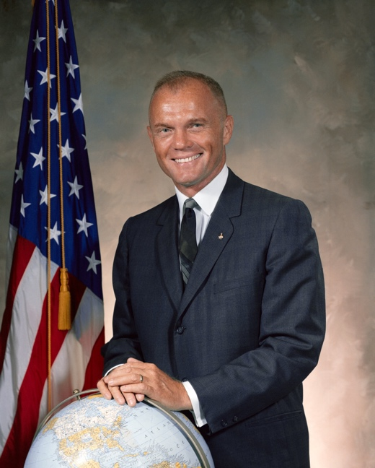
The Comprehensive Anti-Apartheid Act of 1986 applied economic sanctions to the South African economy, most notably at state-owned enterprises, but also covering much of its private sector. This was in response to South Africa’s apartheid policy and was passed in the 99th Congress, the first of President Reagan’s second term. The sanctions were designed to target key South African industries, such as agriculture and mining, and banned South African Airways, the national airline, from American airports. The sanctions were to be lifted only when five pro-democracy preconditions were met, which they controversially were in 1991.

The House of Representatives initially passed a blanket bill ruling out all investment and business relations with South Africa. This was heavily tempered by the Senate. These changes were accepted without amendment when it returned to the House. Throughout consideration of the Senate bill, its sponsor, Senator Richard Lugar (R-IN), made clear he wanted a bill with large and bipartisan support to send a clear message to South Africa. This approach led Lugar to change the House bill, winning over many Republicans and conservative Democrats in the Senate.

President Reagan had thus far undertaken a policy of “constructive engagement” (Ungar and Vale 1985) regarding South Africa, seeing free markets and US commerce as a vehicle for change. Critics of this policy accused Reagan of not wanting to hurt US businesses, or relations with an anti-communist nation, and prioritizing the relationship above ending the apartheid system. Although complex and multi-faceted, much of the debate centered around the delegation of foreign policy authority, with Congress taking the unusual step of overriding the veto by the president, 313-83 in the House and 78-21 in the Senate. The House of Representatives saw seven amendments for its initial bill, three of which received roll calls, while the Senate debated 47 amendments, 20 of which received roll call votes.
“...Where South Africa is concerned, the administration has used quiet diplomacy as an excuse for closing its ears to the cries of those who suffer. As a result, constructive engagement has led only to the destructive enragement of the majority of South Africa’s population.” – Senator John Glenn (D-OH) (above) (Congressional Record, August 14, 1986, 99th Congress, 21537).

The Comprehensive Anti-Apartheid Act of 1986 was listed as landmark by Stathis (2003, 2014), Mayhew (1991, 2005) and was ranked as the third most influential enactment of the 99th Congress (1985-1986) by Clinton and Lapinski (2006).

Background

The 99th Congress was elected in 1984 and sat from 1985-1986. While President Reagan was overwhelmingly returned to office, his coat tails did not extend to Congress. Republicans held a majority in the Senate of 53-47 (reduced from 55-45 during the previous Congress), and Senator Bob Dole (R-KS) was the majority leader. In the House of Representatives, Democrats retained a large majority – 71 seats – in spite of losing 16 districts. The Speaker of the House of Representatives was Tip O’Neill (D-MA).

The 1980s were a difficult time for American foreign policy as Soviet influence was still a worldwide phenomenon and the fight against communism remained a major American battle. Africa was one of the centers of the Cold War (Dunning 2004), and South Africa remained fastidiously anti-Communist with a strong military and spy network, making it a sensible American ally (Bowman 1982). On top of that it was a vital U.S. trading partner, exporting many minerals and agricultural items (Hopkins 1985), which lessened U.S. reliance on communist nations that offered similar products. U.S. farmers were also happy with the cash trade of the South African market for agriculture, which was also one of the few nations that showed a positive trade balance in this industry.

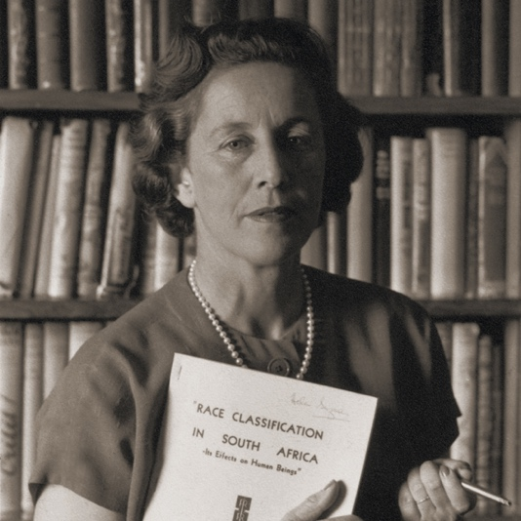
At the same time, however, the whites-only South African government had implemented a social policy named apartheid, which divided the country along racial lines. Only white citizens, who made up less than 10% of the citizenry were allowed to vote, which, according to a 1960 census, excluded the 68% of the population that was black, 9.4% that was classified “coloured”, and 3% “Asiatic” (Steinberg 1967). Although apartheid was described by its supporters as an almost “separate but equal” idea, it stripped all other race groups of basic human rights, including voting, movement, expression and organizing, education, healthcare and more (Mandela 1995). Marriages between races were made illegal (Pogrund 1981), and the infamous Suppression of Communism Act (Clark and Worger 2011) gave the government authority to act on spurious charges within loose legal constraints. Non-white South Africans were forced from their homes into areas designated for them, while 80% of the country’s land, including where those homes were, was restricted for white people who made up less than 9% of the population. Thousands of people were murdered fighting the system (Gibson and Gouws 1999), and others perished because of the conditions in which they were forced to live, which white South Africans never came into contact with.
Above: Helen Suzman was a long-time member of the South African whites-only parliament, and, at times, the only MP opposed to apartheid. Her constant arguments against apartheid meant she received a good deal of criticism, and she was harassed and spied on by security services.

Although this policy had been in place since the late 1940s, and some individual members of Congress had moved to pass legislation pushing South Africa toward reconciliation due to numerous protests in the U.S., and divestment from South Africa by some high-profile institutions, nothing saw real traction until 1985, the beginning of the 99th Congress. Then, Congress’ aims were quelled by President Ronald Reagan convincing the legislature to shelve a sanctions bill (S 995), with both a veto threat and twelve executive orders containing fewer targeted, sanctions to push South Africa toward democracy. There was much American business in South Africa at the time, which was to form a large part of the debate, with many accusing US businesses of complicity in apartheid. Most notably, Representative Adam Clayton Powell (D-NY) said in the previous decade that the US had defeated the Rome-Berlin Axis in World War II and was now duty-bound to defeat the “Cape Town-Washington, DC Axis.”

One year after Reagan convinced Congress to abandon sanctions legislation, violence and state repression in South Africa continued to occur. This time Congress disregarded a presidential veto threat, which it then overrode, and enacted tough sanctions that contributed to the eventual crumbling of the apartheid system. The president, reading the mood of the legislature, did not accompany this veto threat with specific executive orders as he did in 1985.

The nuts and bolts of the policy included barring the South African national airline, South African Airways, from operating in the U.S., forbade import of any goods produced by government-owned enterprises (also known as parastatals), banned import of agricultural and mineral products, prohibited exports of petroleum products, forbade export of munitions to South Africa, cut government cooperation except in cases of intelligence, and rescinded a tax agreement providing businesses did not have to pay dual taxes (CQ Almanac 1987).

As the New York Times reported later that year: “Many of the provisions of the law take effect immediately, while others will be gradually introduced over the next few months. For example, the import of iron, steel and agricultural products is banned immediately, while a similar ban on uranium, coal and textiles will take effect in 90 days. The ban on new investments takes effect in 45 days, and the law directs Mr. Reagan to stop all flights within 10 days” (Roberts 1986).

Sanctions were not an easy solution to the complicated problem of apartheid. There was a notable lack of unanimity coming out of South Africa, which meant both sides of the U.S. debate had South Africans to quote, and did so at length, notably leaders and associates of the African National Congress (ANC), who were for sanctions, leaders of the white parliamentary opposition (most often Helen Suzman) who were against anything that could harm the economy, and Inkatha who were against it. Suzman, at one point, said: “Unpalatable as it may be to the sanctions lobby, the most practicable way to get rid of apartheid and to achieve a nonracial democratic society in South Africa is through an expanding, flourishing economy.”

This legislation, enjoying bipartisan support throughout, easily passed a Democratic House of Representatives and a Republican Senate.

Initial House Consideration (June 18, 1986)

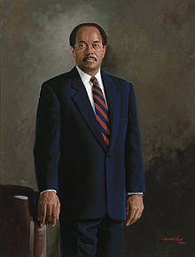
On the 21st of May 1986, Rep. William Gray (D-PA) introduced HR 4868, “A bill to prohibit loans to, other investments in, and certain other activities with respect to, South Africa, and for other purposes.” The bill was co-sponsored by 30 other members of the House, and shortly thereafter saw an additional 86 members attach their names, some of whom have since had prolonged careers in the legislature. The bill was referred on the day Gray introduced it to the committees on Foreign Affairs; Banking, Finance and Urban Affairs; Ways and Means; and Public Works and Transportation. The bill was approved by the House Foreign Affairs Committee on June 10th, 27-14, having been approved by the Africa Subcommittee on June 4th. Ways and Means approved the bill on June 11th, on a voice vote. The other two committees declined to mark up their own versions.

Referral to the Rules Committee took place on June 17th. The rule, Hres 478, was brought to the floor on June 18th, 1986. It limited general debate time to two and a half hours. The rule waived several points of order and permitted seven amendments included a full-text substitute. Supporters characterized the rule as “modified open” and opponents criticized it for shutting out amending opportunities. The rule was adopted on the floor on a vote of 287-127.

Debate began on June 19th, in the Committee of the Whole, with Representatives Howard Wolpe (D-MI) and Mark Siljander (R-MI) each given 52 and a half minutes, while Dan Rostenkowski (D-IL), Phil Crane (R-IL), Fernand St. Germain (D-RI), Chalmers Wylie (R-OH), Norman Mineta (D-CA), and Gene Snyder (R-KY) each had 7 and a half minutes.

Wolpe opened debate by discussing a recently assembled group of international heavyweights called the Eminent Persons Group, founded at a meeting of Commonwealth nations, which travelled to South Africa and met with the government, and subsequently recommended sanctions against the apartheid regime. In a letter to Senator Ted Kennedy (D-MA), two members of the Eminent Persons Group wrote, “If the major Western states which have trade weight with South Africa really seek to bring pressure to bear on the South African Government, those decisions towards greater violence may be deferred and may be made unnecessary. That pressure can only be evidenced through sanctions.” Wolpe also mentioned other counties that had recently ramped up sanctions, including Canada, Australia, Norway, Sweden and Denmark.
Above: House Budget Committee Chairman William Gray (D-PA) had introduced a more modest South African sanctions bill (HR 1460) in 1985. The measure passed both chambers, but a conference report was abandoned in the Senate after President Reagan imposed a number of sanctions through executive order.

Wolpe attempted to pre-empt the arguments against sanctions, and refuted the notion that the sanctions could backfire, saying the modest restrictions already in place had caused “shifting sands and internal debate”. While factually this was correct (Lemon 1984), the changes were viewed to be cosmetic in nature. For example, Rep. Michael Barnes (D-MD) asked, “Some here today will say that there has been progress... But what about the Group Areas Act…What about the violence, the killings, the cross-border raids?”

The accusation Wolpe was countering stemmed from a South African political breakaway group, the Conservative Party, which spun off the National Party government and pressured it from the right, largely on the basis of potentially winding down some aspects of apartheid. It eventually became the official opposition as during apartheid’s final breaths. Wolpe also tried to get in front of a major point of the debate: that black South Africans would be hurt the most if the South African economy was hurt. “This paternalistic attitude must be reexamined,” he said, “Representative black leaders themselves are telling us clearly that their people are willing to suffer additional sacrifices occasioned by these sanctions to help avert the greater tragedy of a massive bloodbath and to help end an evil system that has endured for hundreds of years.” Rep. Toby Roth (R-WI) claimed sanctions do not discriminate between black and white South Africans, and cited Karen House of the Wall Street Journal who he said wrote, “It is easier to sit in America and argue the moral justification of applying economic pressure against South Africa than it is to walk through Soweto and see the mounting practical effects.”

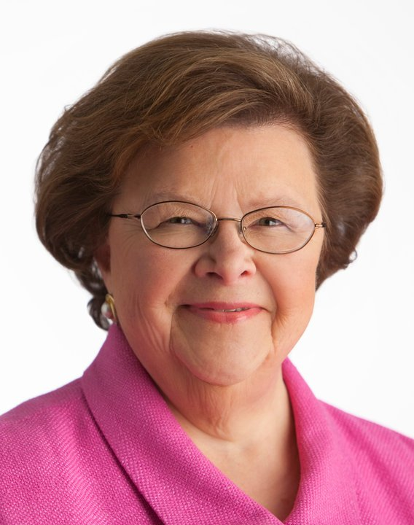
One of the most-repeated arguments against the bill was about communism and focused on the presence of the South African Communist Party in the South African freedom movement, including in the military wing of the African National Congress, the most high-profile of the organizations involved in the struggle for freedom. Multiple opponents of the bill decried support for anything resembling communism and accused Democratic supporters of the legislation of sympathizing with the ideology.

According to multiple sources, communists dominated the leadership of the ANC, but other experts disagreed, calling the ANC pragmatic. Oft repeated in this argument was that the horror of apartheid was pushing the resistance in South Africa toward communism, and that if the US did not help, the Soviet Union would.

The most common refrain, however, came in the form of whether or not South Africa was being singled out. Supporters of the anti-apartheid legislation were forced to argue repeatedly why they were fighting for sanctions against South Africa, and not against communist countries and declared enemies of the US, like North Korea. “If a fellow on a block beats his wife, we condemn that,” said Rep. Bud Shuster (R-PA), “but if on the same block there are other men that beat their wives but starve their children too, and we simply say nothing about that, then it raises fundamental questions about our fairness.”
“Apartheid enslaves black South Africans. It is evil. The United States has been an accessory to this evil because the President and this Congress refuse to cut all United States ties to South Africa.” – Rep. Barbara Mikulski (D-MD) (above) (Congressional Record, June 18, 1986, 99th Congress, 14229).

Rep. Stephen Solarz (D-NY), responded, “We hear from our friends on the other side of the aisle that sanctions are historically ineffectual. Yet I did not hear them opposing the far more stringent sanctions that President Reagan imposed against Nicaragua or the comprehensive sanctions which he imposed against Libya.” Gray pushed back against any idea that South Africa was changing and described the bill as being full of “incentives, not penalties” – in other words, the sanctions would all fall away if the South African government would negotiate. He also argued against the idea that economic sanctions would destroy black South African employment, saying it misdiagnosed the problem: “The people in South Africa are not going to funerals because of lack of jobs.”

The effectiveness of sanctions was not viewed universally, and neither were congressional attitudes toward South Africa, which was an important anti-communist nation. “Let’s not destroy our friends in an effort to help them,” said Rep. Bob Livingston (R-LA). Crane added that he had visited South Africa and met with opponents of sanctions, including the National Union of Clothing Workers, and two union federations.

Siljander was upset about the way the bill was dealt with in committee, and his comments gave signs of what was to come. As a member of the Subcommittee on Africa, he noted, the bill was pushed into the full Foreign Relations Committee and then had major provisions changed before a quick vote was carried out, essentially bringing it to the floor to coincide with the tenth anniversary of the Soweto Riots, “seizing political and media opportunities in a manipulative way.” On top of this, Siljander also argued with Gray, who had earlier asserted that being against this bill was a pro-apartheid position. This particular argument was to be repeated often, with many speakers’ first utterances declaring themselves against apartheid before daring to criticize the bill.

Opponents were concerned about the economic impact these sanctions could have on the US. While Roth claimed Reagan’s executive order of the previous year had taken into account some concerns, notably about trade in computers, he said, “All this bill will do is increase our deficits and shoot American businesses in the foot.” Rep. Henry Hyde (R-IL) added, “One way to solve, in my opinion, the problems of racial discrimination in South Africa is through more corporate investments accompanied by strict application of the Sullivan principles.” US business could be used as a weapon against apartheid, claimed Rep. Bob Lagomarsino (R-CA): “They have taken the lead in challenging the South African Government's discriminatory laws and practices in and out of the workplace while improving the standard of living for the blacks.”

Seven amendments were permitted on the floor by the Rules Committee, the first two of which were from Rep. Danny Burton (R-IN), of three he had proffered to the Rules Committee the day before. After initial confusion about which amendment was rejected, Burton was permitted time to debate his point that no money appropriated in the bill should be permitted to the ANC, while the freedom organization had communists in its leadership. Wolpe called it a meaningless amendment, as no funds were to be directed to the ANC anyway, and it passed 365-49 in the early afternoon of June 18th. Burton’s second amendment, debated right after his first, was to exempt American companies that operated in South Africa under the Sullivan Principles from the sanctions. It was rejected 150-286, with the main line of argument that it was to set up a way for American companies to get around the sanctions and make the bill ineffectual.

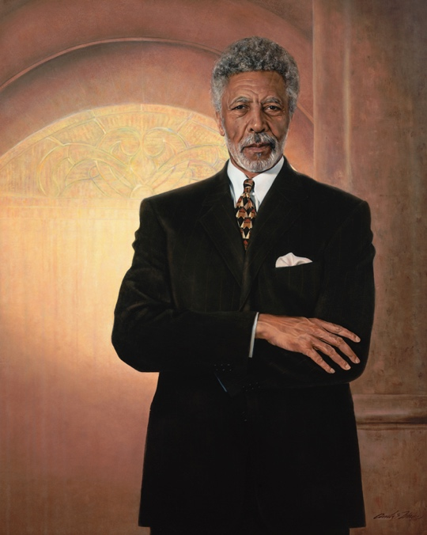
There were five other amendments, but only one more was debated on the floor, as Rep. Ron Dellums (D-CA) introduced an amendment, co-sponsored by 45 other members, as a substitute for the bill sponsored by Gray. Viewing Gray’s bill as “too weak,” Dellums’ substitute would prohibit any US company from doing any business in South Africa. Dellums, an original co-founder of the Congressional Black Caucus in 1971, had offered this amendment to HR 1460 in the previous session. It was overwhelmingly defeated, 77-346. He also had also introduced it as a standalone bill in the previous session (HR 997), which went no further after referral to committee.

This time, however, the piece of legislation won over many members who had voted against a year earlier. Members referred to Dellums’ proposal as a more effective solution and even conservative opponents of the bill praised Dellums’ approach as being “more honest.” A number of members who opposed the previous Dellums amendment announced their support because of changing events. While several Democrats, including Representatives Don Bonker (D-WA), Daniel Mica (D-FL) and Dante Fascell (D-FL) opposed the Dellums measure during debate, some for strategic purposes and others suggesting it was “too strong,” the substitute passed by voice in the Committee of the Whole.
Rep. Ron Dellums (D-CA) (above) viewed the House bill as a "step forward," but also "“inadequate in response to what is evolving in South Africa at the very moment (Congressional Record, June 18, 1986, 99th Congress, 14276).” His full-text substitute amendment was adopted by voice vote.

Final passage of the bill was then agreed to by a voice vote on June 18th, 1986. Numerous sources suggested election-year considerations led more-moderate Democrats to not ask for a roll call vote on the Dellums substitute. Conversely, they also suggested conservative Republican opponents, like Burton, Walker and Siljander, wanted the Dellums measure to pass to ensure “the worst bill possible.” They felt the Dellums substitute was a “killer amendment” that would doom the sanctions bill.

Before the bill even made it to the Senate, South Africa’s foreign minister Pik Botha said, “It is clear that the American House of Representatives do not give a fig for black communities of South Africa” (Iams 1986).

Initial Senate Consideration (August 14-15, 1986)

On July 30th, Senator Richard Lugar (R-IN) with Senators Mitch McConnell (R-KY) and David Durenberger (R-MN), introduced bill S 2701, “a bill to provide a comprehensive policy for the United States in opposition to the system of apartheid in South Africa, and for other purposes.” It was referred to the Committee on Foreign Relations, which was chaired by Lugar.
The same day this bill was introduced, it was amended on the floor to forbid any US intelligence agency from sharing information with the South African government about the ANC or any other anti-government organizations unless it credibly indicated likelihood of violent action.

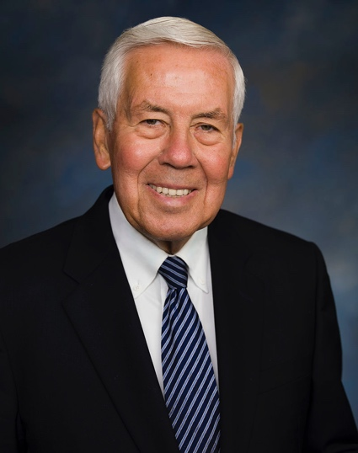
After initially being forced to abandon debate on the bill due to a little-enforced rule limiting committees to meetings of two hours in length after the full Senate is in session (Walsh 1986), the Foreign Relations Committee reconvened the following day and approved the bill on August 1st, 1986, 15-2, with no votes from Jesse Helms (R-NC) and Larry Pressler (R-SD). During committee debate Helms denounced the bill, saying, “Here we go again, kicking a friend in the teeth because they don't do what we want them to do” (CQ Almanac 1987). While other committee members had opposed many parts of the bill, they did vote to send it to the floor. Lugar was credited with getting the bill through committee “with sheer political muscle” (CQ Almanac 1987). Members of both parties tried to change the bill – liberal Democrats to strengthen it and some Republicans to weaken it – but Lugar marshaled the committee to keep the bill acceptable to many legislators.
Senator Richard Lugar (R-IN) (above) sponsored the Senate bill and was credited with getting the measure through committee "with sheer political muscle." (CQ Almanac 1987).

The bill that came out of the Senate Foreign Relations committee, in direct contrast to the bill that passed the House of Representatives, contained targeted sanctions that would not destabilize the economy of South Africa.

On August 9th, 1986, Dole asked for, and received, unanimous consent that on August 13, the Senate proceed to consider a cloture motion on S 2701. The UCA structured the debate on S 2701. Debate on S 2701 eventually began around 9am on August 14th, with a series of 47 amendments, 20 of which received roll call votes. Dole called for, and received, unanimous consent that Rule XXII would not be enforced.

Having deferred to the president the previous year – “We argued that a premium should be placed on the American Government speaking with one voice” – Lugar admitted that the state of South Africa had worsened, and specific sanctions by the United States would be appropriate policy. He made clear he did not intend to cripple the South African economy as he wished to avoid hurting black South Africans. Senators who backed a stronger bill didn’t buy this premise at all, with Senator John Glenn (D-OH) saying, “The administration, for its part, argues we should refrain from enacting sanctions because they would hurt the blacks in South Africa. That argument makes about as much sense as saying that Abraham Lincoln should not have issued the Emancipation Proclamation because it put 4-million slaves out of work.”

Senator Clairborne Pell (D-RI) criticized the president’s policy of “constructive engagement”, adding that it “led white South Africa to believe we are sympathetic to their cause, while leading blacks to think that we are not supporting their struggle against apartheid.” Senator Lowell Weicker (R-CT) echoed this, saying, “[the] greatest pro-Communist force existent in South Africa is the policy of constructive engagement.” Weicker almost presciently predicted the bill’s eventual outcome, calling for a bill that could receive at least 67 votes in order to override a presidential veto.

One of the major criticisms of the bill is that it was being used to promote protectionism, and more than one amendment seemed to indicate that possibility. Senator Alan Cranston (D-CA) successfully added an amendment (67 votes to 29) to ban textile imports from South Africa, which were up 139% in 1985. Although Cranston’s amendment failed in committee, it succeeded on the floor. Lugar again invoked protectionism when disagreeing with a reworked and subsequently accepted amendment by Senator Ted Kennedy (D-MA), which sought to ban imports of South African agriculture, exports of American petroleum products to South Africa, and end some financial maneuverability South Africa received from US institutions.

Senator Malcolm Wallop (R-WY) repeated concerns of House members who questioned the bill supporters’ motivations, and called out what he saw as a double standard, focusing on South Africa and not other oppressive regimes: “I suggest, Mr. President, that what we are looking at is middle-class, comfortable white senators playing up to the black population of America, and the liberal population of America,” adding that other countries in Africa were worse than South Africa. As if to prove his point, Wallop added an amendment to apply the whole bill to the Soviet Union, which predictably failed.

Senator Larry Pressler (R-SD) was one of the most vocal opponents of this legislation and said sanctions would prolong apartheid, push the South African government to the right, and would cause a civil war. His successful amendment aimed to help out the US gold mining industry by forbidding the US president to sell any (because it would drop the price of gold, and South Africa’s low cost in mining compared to the US would give it a market advantage). Senator Steve Symms (R-ID), who was against the bill, worried about a ban on imports forcing the US to rely on communist countries and won at least part of the argument when he successfully introduced an amendment which said no provisions of the act could be enforced if it led to US reliance on communist countries for coal, or critical materials. Senator Don Nickles (R-OK) introduced an amendment to protect American farmers from the brunt of the sanctions, who would be hindered under the current terms of the bill; the amendment passed 55-44.

Senator Chris Dodd (D-CT) introduced an amendment to halt the purchase of goods from South Africa’s state-owned companies, but Dole criticized the amendment because the US had recently won a grain contract, precisely because South Africa had retaliated through trade against Australia for introducing sanctions (CQAlmanac 1987). Dole changed the language of his amendment to be listed as something the president could consider implementing a year after the bill’s passage.

An amendment by Helms caused a lengthy debate, as it raised, like in the House, the specter of communism in the South African struggle movement, and violent actions undertaken therein. The amendment called for the ANC and the Pan Africanist Congress, another organization, to renounce terrorism or the US would support negotiations without them. Helms felt the sanctions affected only the South African government: “In my own judgment it is tactically wrong to impose sanctions whose burden falls only on one party to the negotiations.” Lugar supported the amendment, but more liberal senators were having none of it: Weicker responded, “I rise in opposition to the amendment, principally, on the basis that it tries to equate the violence and the hurt imposed by apartheid with the activities of resistance by those to whom the hurts are being done.” Pell added, “it makes the US policy toward apartheid dependent really on the actions of the ANC.” Finally, Cranston stated that “it equates the oppressors with the oppressed.”
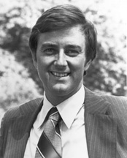
While more moderate and conservative senators lined up behind it, Kennedy called it a “killer amendment”. The pushback resulted in changing the amendment to apportion blame more in tune with reality and it overcame liberal detractors, 67-31. Compromise was motivated by time: Helms was prepared to hold the bill up if his amendment wasn’t accepted; he summarily declined to introduce 14 other amendments when this was accepted. The concerns expressed by Helms, however, were iterated by other more conservative senators, with Senator Jeremiah Denton (R-AL) seeking to prohibit any funds going to anyone involved in the practice of “necklacing”, and getting into the bill a clause that called for an investigative report on the ANC within 180 days of the bill being enacted.
Above: Arguably the bill's most vocal opponent in the Senate, Senator Larry Pressler (R-SD) argued that sanctions would prolong apartheid, push the South African government to the right and cause a civil war.

The Senate also saw debate about the role of the president in conducting foreign policy, although it was more specifically directed than in the House. An amendment by Senator John Heinz (R-PA) called for a congressional vote before the president was able to modify these sanctions, but Senator Nancy Kassebaum (R-KS) said it was dealt with in committee. A changed amendment in this vein was later passed, but a similar amendment by Senator William Proxmire (D-WI) was defeated.

Some amendments passed easily: Senator Orrin Hatch’s (R-UT) to provide assistance to economically disadvantaged South Africans, Senator Carl Levin’s (D-MI) for congressional disapproval of munitions sales as well as expressing a wish for the US ambassador to South Africa to meet with Nelson Mandela, Senator John Chafee (R-RI) for expressing that the United Nations Security Council should echo the US sanctions, Symms’ to ban Soviet gold coins, Kennedy’s to limit military cooperation, and an effort by Kassebaum and Senator Paul Sarbanes (D-MD) to rescind landing rights for South African Airways.

Many of these amendments were introduced on August 14th, but as debate went well after midnight, were voted on August 15th when debate resumed at around 10am.

A mimic of the House’s bill was rejected when a Cranston amendment, which would have prohibited all trade with South Africa, was tabled 65-33. The tabling motion, offered by Lugar, essentially killed the proposal. Cranston argued on its behalf forcefully: “Let me say this just very briefly: in confronting the evil of apartheid, half way measures are not really satisfactory. Really, we would not trade with Adolf Hitler in his day. We should not trade with South Africa in this day. We would not profit from Naziism; we should not profit from racism, oppression, apartheid.”

A cloture motion on S 2701 had been agreed to 89-11 on August 13th. This followed a fractious cloture vote over another bill on an aid package to the Contras in Nicaragua, during which some logrolling occurred. While Democrats did not support an aid package to the Contras, Senator Claiborne Pell (D-RI), ranking member of the Foreign Relations Committee admitted, “I voted for cloture on Contra aid as did other Senators and as will other Senators when the vote comes up. The reason why we did that is without those votes we would not be having a vote on the South Africa issue.”

On August 15th, Lugar moved on the floor to fold the text of S. 2701 into H.R. 4868, which received no objection. While the debate was fractious at times, the Senate passed a comprehensively considered bill H.R. 4868, by a vote of 84 to 14, on August 15th, 1986, at around 8.20pm.

Secondary House Consideration (September 12, 1986)

While the House was initially keen to pass a strong bill, the leadership decided not to go to conference, although the Senate had already picked conferees. This was a deliberate strategy by Lugar who picked Helms, an opponent of the bill, for the conference committee. Both Lugar and Helms (two of the three proposed Senate conferees) said they would accept no changes to the bill, rendering the conference ineffective. Lugar also wanted to avoid conference and get the bill to the president’s desk, so that Reagan would be unable to use a pocket veto.

On September 12th, 1986, the Rules Committee permitted one hour of debate, split between the chair, Rep. Dante Fascell (D-FL) and ranking member, Rep. William Broomfield (R-MI) of the Foreign Affairs Committee. The House passed a rule, Hres 548 by a vote of 292 to 92 on the morning of September 12th, 1986. Hres 548 provided for a motion to take up HR 4868 and agree to the Senate amendment.

A new facet to the bill, however, was the extent to which this bill would undermine state and local governments whose anti-Apartheid laws went further. Lugar rejected the ability of state and local governments to do this, which did not sit well in the House. The leadership of the House Foreign Relations Committee decided to add a statement to the bill indicating opposition: “It is not the intent of the House of Representatives that the bill limit, preempt, or affect, in any fashion, the authority of any State or local government… to restrict or otherwise regulate any financial or commercial activity respecting South Africa.”

Leadership presented the Senate-debated version of HR 4686 to the floor. This wasn’t a popular move, and Dellums went as far as saying that after the election (less than two months from the debate) the House could attempt to pass further sanctions on South Africa. Much of this round of debate mimicked the first one, with concerns about communism and important South African imports.

The chamber, however, agreed to the Senate’s amendments overwhelmingly, 308-77, on September 12th, 1986.

Presidential Veto (September 26, 1986)
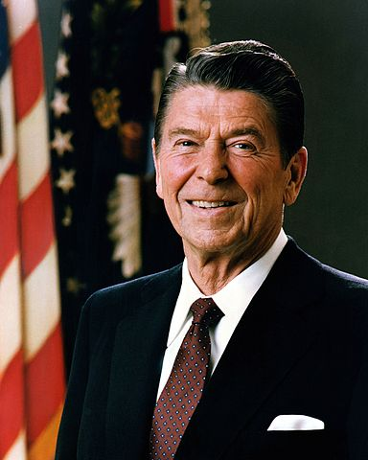
On September 26th, the last possible day he could, having spent the intervening time trying to sway friendly senators, President Ronald Reagan (R-CA) vetoed the bill. The House received a letter from the president “returning herewith without my approval HR 4868, the Comprehensive Anti-Apartheid Act of 1986,” in which he also indicated he would sign further executive orders if the veto was sustained. Reagan also appointed a black ambassador to South Africa on September 30th, Edward Perkins, to try and stem the enthusiasm of both chambers to fall in line with public opinion against South Africa.

Reagan made clear he had no problem with the purpose of the bill but believed it “would seriously impede the prospects for a peaceful end to apartheid and the establishment of a free and open society for all in South Africa.” He said the sanctions targeted labor-intensive industries and therefore would affect black workers who would become “the first victims of American sanctions.” “Punitive economic sanctions would contribute directly and measurably to the misery of people who already have suffered enough.”
Above: President Reagan.

Reagan added concerns that the sanctions would affect neighboring countries whose economies were dependent on South Africa and said return sanctions by South Africa could make it worse. While rejecting this bill, Reagan said he was prepared to work with Congress where they overlapped, “[keeping] the United States at arms distance from the South African regime, while keeping America's beneficent influence at work.” He added, “Let us not forget our purpose. It is not to damage or destroy an economy, but to help the black majority of South Africa and southern Africa enjoy a greater share of the material blessings and bounties their labor has helped to produce-as they secure as well their legitimate political rights.”

House Override (September 29th, 1986)

The House debated the president’s veto on September 29th and saw few new arguments, even by opponents of the bill who focused a lot of their attention on agriculture. Representative Ron Marlenee (R-MT) said, “What a confusing world this congress creates… subsidizing our enemy so they will take grain, and yet a trading partner that takes cash, that has taken more grain than the Soviet Union, is going to be essentially embargoed.” Rep. William Dannemeyer (R-CA) said the sanctions would cause problems for American exporters.

On the other hand, Solarz said it was hard to take Reagan’s concern for black South Africans seriously, adding, “his expressions of concern make crocodile tears seem like Perrier water”. Rep. Gary Ackerman (D-NY) added the rest of the world would be emboldened if America moved: “The leading nations of the world have balked at implementing any strict measure against Pretoria because of the United States’ unwillingness to do so.”

The House overrode President Reagan’s veto 313-83 on September 29th, 1986. 82 Republicans joined 234 Democrats in support, with four Democrats joining 82 Republicans in opposition. As the figure below from voteview.com demonstrates, the vote was fairly ideological.

Source: Voteview.com (99th House, rcnum 829).

Senate Override (October 1-2, 1986)

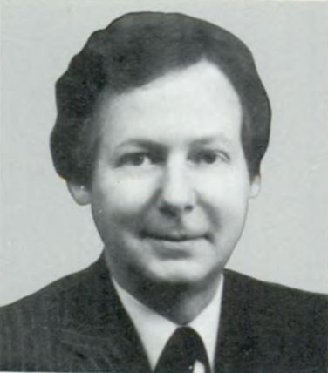
Pressler again led the charge against the bill, with even a tussle with Kennedy not affecting the forcefulness of his opposition. He listed eight ways in which the Comprehensive Anti-Apartheid Act was flawed: 1) the bill misrepresented public opinion, 2) sanctions don’t bring forth democracy, 3) sanctions will eliminate black jobs, 4) sanctions will hurt South Africa’s neighbors, 5) Europe has backtracked from sanctions, 6) the specter of retaliation by South Africa, 7) progress has been made in South Africa, such as the tri-cameral parliament, and 8) implications of the bill extending beyond apartheid.
Above: Freshman Senator Mitch McConnell (R-KY), who argued: "Because I have chosen to stand with those who struggle for freedom, I must stand apart from my President."

Senator Strom Thurmond (R-SC) agreed the bill would hurt black South Africans, but added he was concerned about mineral imports to the US and its effect on the economy. Senator Jim Broyhill (R-NC) cast aspersions on the economic effect of the US, but said it would dash the South African economy. Helms threw everything at this debate, including fabrications about what life was like for black South Africans, and how guilty white people felt. At one point he admitted he had spoken with South Africa’s foreign minister, and Kennedy accused him of bribery, with potentially greater grain exports to South Africa if the Senate failed to override Reagan’s veto. Although Helms denied it, Kennedy kept pushing, which led Helms to accuse Kennedy of sympathizing with the Soviet Union taking over Africa “and all of its minerals”.

The argument to override the veto was predicated largely on a moral basis, with most proponents arguing it was the right thing to do. Senator Joe Biden (D-DE) lamented that Reagan didn’t use his “remarkable prestige and determination” to deal with South Africa. The veto, however, was still overridden easily, 78-21 on October 2nd, 1986, and the bill became law (99 PL 440).

Although the veto was successfully overridden, Senators were very careful to mention that it was not an easy decision to overrule the president, and that may have had a small effect, as the final vote was closer than the initial Senate consideration. Of the six who changed their vote, one was Senate Majority Leader Bob Dole (R-KS). The figure below from voteview.com plots the ideological spread on the Senate vote:

Source: Voteview.com (99th Senate, rcnum 692).

Aftermath

Assessing the direct impact of sanctions on South Africa is not easy (Kaempfer and Lowenberg 1986), because these sanctions were just one piece of the anti-apartheid movement, which was made up of many moving local and international pieces, and because of the time lag in economic impact. In 1985, South African President PW Botha had underwhelmed the international community when he announced reforms to apartheid that fell far below expectations, and international creditors began withdrawing, which affected the value of the South African rand, causing it to drop. Later that year the European Economic Community applied some moderate sanctions before the aforementioned Reagan executive orders, which persuaded Congress to shelve its bill.

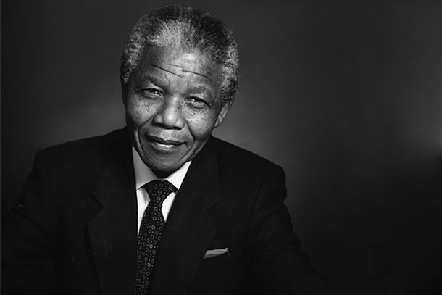
The US sanctions encouraged other countries to sanction South Africa, including the members of the Commonwealth (Klotz 1995). While the measurable effect of the sanctions was small (Levy 1999), they came simultaneously with uneasy economic times for the South African economy (Battersby 1988), during which the costs of borrowing were increasing, and magnifying their impact. This was picked up by freedom leaders throughout the years to democracy in 1994, including Nelson Mandela after he was released from prison in 1990, who insisted that sanctions remain while negotiations went on with the National Party government.
The South African economy took a substantial hit after the bill was imposed, leading the government to contemplate releasing Nelson Mandela (above).

The sanctions were lifted in July 1991 by President George H. W. Bush (R-TX). Despite both anti-apartheid and some congressional pressure to maintain them, Bush said, “progress has definitely been made… I firmly believe that this progress is irreversible.” South Africa was supposed to fulfill five conditions before the sanctions were removed, and the State Department declared it had fulfilled four (repeal of segregationist laws, removal of the state of emergency, permitted political parties and initiated negotiations). The fifth condition was the release of political prisoners, but the administration said the US does not consider people convicted of violent crime to be political prisoners (Kempster 1991).

Other economic experts believe sanctions did work, and did so because South Africa needed to be part of the international economy, and because the apartheid economy was deficiently organized (Lowenberg 1997). And while the economic impact of sanctions was not reflected in GDP, it helped drive up the costs of maintaining the apartheid idea and closed down foreign investment due to low investor confidence. Capital outflows from 1986 to 1991 totaled R16-billion, around 2% of GDP (Hefti and Staehelin-Witt 2005). Although this process began earlier than the sanctions did – South Africa underwent recession in 1984 and 1985 – in the public eye it was easy to link the two.

Exports to the USA from South Africa dropped by nearly $500 million in the first nine months of 1987, year on year. The stuttering economy also affected black employment, which, already combined with a strong internal movement against apartheid, increased public anger at the system. As the New York Times reported in November 1988, “Pretoria's decision-in-principle to contemplate the release of Nelson R. Mandela, the jailed African National Congress leader, might well be connected with the desperate need to regain access to international capital markets” (Battersby 1988).

While it is difficult to ascribe the direct economic effect of sanctions, the public and psychological effects were more tangible, and highlighted the isolation of South Africa which wanted to, and was dependent on, trade with the rest of the world (Keating 2013). The freedom movement seized upon South Africa’s less than popular international status and used it to increase support, while at the same time trade sanctions were pushing the cost of imports up, which affected the economy in a manner some of the congressional opponents of the bill predicted: white unemployment barely moved while black South Africans felt the impact.

While it is likely that the apartheid government would have fallen at some point anyway, the sanctions played a part both financially, and in ramping up support for freedom in South Africa.

References

Battersby, John D. 1988. "Sanctions Squeeze South Africa." New York Times, November 13, 1988.

Bowman, Larry W. 1982. "The Strategic Importance of South Africa to the United States: An Appraisal and Policy Analysis." African Affairs 81 (323):159-191.

Clark, Nancy L, and William H Worger. 2011. South Africa : the rise and fall of apartheid. 2 ed, Seminar studies in history. Harlow, England: Longman/Pearson, 2011.

Clinton, Joshua and John Lapinski. 2006. “Measuring Legislative Accomplishment, 1877-1994,'' American Journal of Political Science 50(1): 232-249.

CQ Almanac. 1987. "Hill Overrides Veto of South Africa Sanctions." Congressional Quarterly 42:259-373.

Dunning, Thad. 2004. "Conditioning the Effects of Aid: Cold War Politics, Donor Credibility, and Democracy in Africa." International Organization 58 (2):409-423.

Gibson, James L., and Amanda Gouws. 1999. "Truth and Reconciliation in South Africa: Attributions of Blame and the Struggle over Apartheid." The American Political Science Review 93 (3):501-517.

Hefti, Christoph, and E. Staehelin-Witt. 2005. Economic Sanctions against South Africa and the Importance of Switzerland In Abteilung Programme; Nationale Forschungsprogramme. Bern: Swiss National Science Foundation.

Hopkins, Sheila M. 1985. "An Analysis of U.S.-South African Relations in the 1980s: Has Engagement Been Constructive?" Journal of Comparative Business and Capital Market Law 7:89-115.

Iams, John. 1986. "Security forces accidently shot and killed a 4-year-old girl." UPI, June 20, 1986.

Kaempfer, William H., and Anton D. Lowenberg. 1986. "A Model of the Political Economy of International Investment Sanctions: The Case of South Africa." Kyklos 39 (3):377-396.

Keating, Joshua. 2013. "Why Did International Sanctions Work on South Africa but Not Other Dictatorships?" Slate, December 6, 2013.

Kempster, Norman. 1991. "Bush Lifts Economic Sanctions on S. Africa : Apartheid: He sees 'irreversible' progress by Pretoria. Opponents in Congress plan no effort to undo the move." LA Times, July 11, 1991.

Klotz, Audie. 1995. "Norms Reconstituting Interests: Global Racial Equality and U.S. Sanctions Against South Africa." International Organization 49 (3):451-478.

Lemon, Anthony. 1984. "The Indian and Coloured Elections: Co-optation Rejected?" South Africa International 15 (2):84-107.

Levy, Philip I. 1999. "Sanctions on South Africa: What Did They Do?" The American Economic Review 89 (2):415-420.

Lowenberg, Anton D. 1997. "Why South Africa's apartheid economy failed." Contemporary Economic Policy 15 (3):62-72.

Mandela, Nelson. 1995. Long Walk to Freedom. Boston, MA: Little, Brown.

Mayhew, David R. 1991. Divided We Govern: Party Control, Lawmaking and Investigating: 1946-1990. New Haven, CT: Yale University Press.

Mayhew, David R. 2005. Divided We Govern: Party Control, Lawmaking and Investigating: 1946-2002. New Haven, CT: Yale University Press.

Pogrund, Benjamin. 1981. "South Africa Stalls." The New Republic, 12-16.

Poole, Keith and Howard Rosenthal. 1997. Congress: A Political-Economic History of Roll Call Voting. New York, NY: Oxford University Press.

Roberts, Steven V. 1986. "Senate, 78 to 21, Overrides Reagan’s Veto and Imposes Sanctions on South Africa." New York Times.

Stathis, Stephen W. 2003. Landmark Legislation 1774-2002: Major U.S. Acts and Treaties. Washington, D.C.: CQ Press.

Stathis, Stephen W. 2014. Landmark Legislation, 1774-2012: Major U.S. Acts and Treaties, 2nd Edition. Washington: CQ Press

Steinberg, S.H. 1967. The Statesman's Year-Book, 1967–1968. 104th ed. London: Macmillan.

Ungar, Sanford J., and Peter Vale. 1985. "South Africa: Why Constructive Engagement Failed." Foreign Affairs 64 (2):234-258.

Walsh, Edward. 1986. "Senate Foreign Relations Committee Forced To Delay Sanctions Action." Washington Post, August 1, 1986.

Apartheid, translated from Afrikaans literally means “apart-ness” and was a political system designed to keep the races separate, and overwhelmingly favored white citizens.
Freshman Mitch McConnell (R-KY), elected in 1984, was to play a significant part in the passage of the Comprehensive Anti-Apartheid Act of 1986.
In the first session of the 99th Congress, Gray introduced HR 1460, which imposed more modest sanctions on South Africa. That bill, considered under an open rule (Hres 174), passed the House 296-129 on June 5, 1985. 56 House Republicans joined 240 House Democrats in support, while six Democrats joined 123 Republicans in opposition (Voteview 99th House rcnum 130) (Poole and Rosenthal 1997). Lugar’s Senate bill, S. 995, was even more limited. HR 1460 passed the Senate in lieu of S 995 on July 11, 1985, 80-12. The conference report was agreed to in the House on August 1, 1985, 380-48 (considered under Hres 251). Before the report was adopted in the Senate, Reagan imposed a number of sanctions on South Africa via an executive order. This led Senate Republicans to pull their support for the conference report, Cloture on a motion to proceed to the report failed 11-88 on September 12, 1985.
Cape Town is one of three capitals of South Africa, and is the location of parliament. Members of Congress more commonly refer to Pretoria as the capital, and it is where most nations have a diplomatic presence.
Helen Suzman was a long-time member of the South African whites only parliament, and, at times, the only MP opposed to apartheid. She was also often the only English and female member, and Jewish, in a body dominated by protestant Afrikaans men. Her constant arguments against apartheid meant she received a good deal of criticism, and was harassed and spied on by security services. She is credited with being one of the influences on Nelson Mandela to maintain a market economy instead of radically changing the way South Africa functioned. Inkatha was a Zulu organization, now a political party in South Africa (the IFP), headed by Mangosuthu Buthelezi, and based in the province that was then called Natal. Buthelezi was affiliated with liberation politics as a young man, but left to work in a government department that pertained to black South Africans in 1951. He was elected CEO of the Zulu Territorial Authority, a homeland set up by the South African government in the northern part of the province. Buthelezi’s position as CEO meant he was reliant on the existence of the South African government, and his supporters clashed, often violently, with anti-Apartheid organizations.
For a discussion of Gray’s first session bill, HR 1460, see footnote 3.
One hour and forty-five minutes was to be shared among the Democratic and Republican leadership of the Committee on Foreign Affairs, with the rest equally dispersed among the leadership of the Public Works and Transportation Committee; Banking, Finance and Urban Affairs Committee; and the Ways and Means Committee.
Points of order for contravening the Congressional Budget Act of 1974, which forbade consideration of legislation that reduced revenue below an agreed-upon floor, were waived, as were points of order against the bill for breaking clause 2(1)(6) of House rule XI, which requires committee reports be available for three days before consideration.
Rep. Trent Lott (R-MS) pointed out the rule only allowed amendments from five different members and criticized the House for “considering a bill designed to promote human rights in South Africa under a procedure which denies the basic rights of 430 democratically elected Members of the United States House of Representatives [to offer amendments] (Congressional Record, June 18, 1986, 99th Congress, 14223).”
The previous question was ordered by voice vote. 48 Republicans joined 238 Democrats in voting for the rule, while four Democrats joined 123 Republicans in opposition (Voteview 99th House rcnum 598) (Poole and Rosenthal 1997).
The allotted time was spread among senior committee officials: Howard Wolpe was Chair of the Subcommittee on Africa of the House Foreign Affairs Committee and Dan Siljander was its Ranking Member. Dan Rostenkowski was the Chair of Ways and Means, and Phil Crane was Ranking Member. Fernand St Germain was Chair of Banking Finance and Urban Affairs and that committee’s Ranking Member was Chalmers Wiley. Norman Mineta was Chair of the Aviation Subcommittee of the House Committee on Transportation, and Gene Snyder was its Ranking Member.
The group included former Australian Prime Minister Malcolm Fraser, and former Nigerian head of state Olusegun Obasanjo, who signed the letter to Senator Ted Kennedy.
Notably absent was the United Kingdom, another major trading partner of South Africa.
The Group Areas Act defined where South Africans were forced to live, dependent on their race, in urban settings.
For example a “tricameral parliament” which allowed South Africans designated “coloured” and “Indian” to participate in a minor role, but excluded blacks (Lemon 1984).
Soweto (formed from the words “South Western Townships”) was a major urban area designated for black South Africans in Johannesburg, and is where many dispossessed blacks were sent when the government forced them out of their homes.
On 16 June 1976, an estimated 20,000 students protested in response to the introduction of Afrikaans as the medium of instruction in schools. Many were killed in violent confrontations with police. Cover ups by the government mean that to this day we still do not know how many students died.
A set of corporate codes of conduct developed by Reverend Leon Sullivan promoting social responsibility.
Dellums stated that while the sanctions in Gray’s bill were a “are a step forward,” they were also “inadequate in response to what is evolving in South Africa at the very moment (Congressional Record, June 18, 1986, 99th Congress, 14276).”
See Voteview 99th House rcnum 128 (Poole and Rosenthal 1997).
Specifically, Rep. Robert Walker (R-PA) asserted that “It seems to me that what we are doing here is talking about a wishy-washy incremental approach versus an approach that is at least tough and honest (Congressional Record, June 18, 1986, 99th Congress, 14279).”
For example, Rep. Stephen Solarz (D-NY) asserted he “changed my mind because of the South African raids against Zambia, Zimbabwe, and Botswana. I changed my mind because of the re-imposition by the South African Government of the state of emergency (Congressional Record, June 18, 1986, 99th Congress, 14280).”
Bonker suggested the Dellums substitute would lead to “a failure on the House floor that would send the wrong message to South Africa (Congressional Record, June 18, 1986, 99th Congress, 14278).”
Specifically, the Washington Post noted that: “[Burton and Siljander], who led opposition to sanctions legislation on the House floor, said the milder sanctions measure had been certin to pass and that they hoped to kill the issue by approval of ‘the worst possible bill’ (Walsh, Edward. 1986. “House Would Require U.S. Disinvestment from South Africa,” The Washington Post, June 19).” Siljander predicted the measure would die in the Senate and CQ Almanac (1987) quoted him as saying Dellums bill was a “kiss of death.” (See also Dickenson, James R. 1986. “Dellums: Exoneration is His,” The Washington Post, June 20.) Walker (R-PA), said he preferred Dellums substitute because it would make Reagan’s inevitable veto easier to sustain (Greenberger, Robert S. 1986. “House Takes Tough Stance on South Africa,” The Wall Street Journal, June 19.) And in an op-ed, the Wall Street Journal was skeptical of the prospect of Dellum’s success, arguing it “passed by voice vote in a largely empty House. It probably has gone as far as it will go (“The House Blunderbuss,” The Wall Street Journal, June 20, 1986.)
For a discussion of Lugar’s first session bill, S 995, see footnote 3.
See the Congressional Record, 99th Congress, August 9, 1986, 20235-20237. The unanimous consent agreement was viewed as a compromise between conservatives who wanted quick action on legislation that would send additional aid to Nicaragua’s counterrevolutionary forces and moderates and liberals who prioritized South African sanctions. Members were pressing for action on both issues by proposing them as amendments to a debt ceiling extension (see Roberts, Steven V. 1986. “Harsh Words on Floor Between Dole and Byrd,” The New York Times, August 6; “Debt-Limit Mayhew,” The Wall Street Journal, August 7, 1986.)
Necklacing was a process of putting a tire filled with gasoline around a victim’s head and setting it alight.
Voteview.com (99th House, rcnum 829): https://voteview.com/rollcall/RH0990829

